**Anatomie postcrânienne d'os longs de colobinés (Mammalia, Primates) des dépôts plio-pleistocènes du Groupe de l'Omo (Formation de Shungura et d'Usno, campagnes 1967-2018, basse vallée de l'Omo, Éthiopie).**

**Postcranial anatomy of the long bones of colobines (Mammalia, Primates) from the Plio-Pleistocene Omo Group deposits (Shungura Formation and Usno Formation, 1967-2018 field campaigns, Lower Omo Valley, Ethiopia)**

**Colobine postcranials from the Plio-Pleistocene Omo Group**

**Laurent PALLAS**

Laboratoire Paléontologie Évolution Paléoécosystèmes Paléoprimatologie, UMR 7262 PALEVOPRIM, CNRS & Université de Poitiers, 6 rue Michel Brunet, 86073 Poitiers (France)

and

Laboratory of Physical Anthropology, Kyoto University (Japan)

laurent.pallas01@univ-poitiers.fr (corresponding author)

**Guillaume DAVER**

Laboratoire Paléontologie Évolution Paléoécosystèmes Paléoprimatologie, UMR 7262 PALEVOPRIM, CNRS & Université de Poitiers, 6 rue Michel Brunet, 86073 Poitiers (France)

guillaume.daver@univ-poitiers.fr

**Gildas MERCERON**

Laboratoire Paléontologie Évolution Paléoécosystèmes Paléoprimatologie, UMR 7262 PALEVOPRIM, CNRS & Université de Poitiers, 6 rue Michel Brunet, 86073 Poitiers (France)

gildas.merceron@univ-poitiers.fr

**Jean-Renaud BOISSERIE**

Laboratoire Paléontologie Évolution Paléoécosystèmes Paléoprimatologie, UMR 7262 PALEVOPRIM, CNRS & Université de Poitiers, 6 rue Michel Brunet, 86073 Poitiers (France)

and

Centre Français des Études Éthiopiennes, UAR 3132 CFEE, CNRS & Ministère de l’Europe et des affaires étrangères, Addis Ababa, PO BOX 5554 (Ethiopia)

jean.renaud.boisserie@univ-poitiers.fr

**RÉSUMÉ**

Nos connaissances sur la diversité taxonomique et fonctionnelle de la faune de colobinés fossiles (Colobinae Jerdon, 1867) de la basse vallée de l'Omo sont établies uniquement sur la base de restes crâniodentaires. Nous décrivons ici des spécimens postcrâniens de colobinés fossiles et nous établissons un aperçu approfondi de leur anatomie fonctionnelle et de leur taxonomie. Des comparaisons quantitatives et qualitatives avec des spécimens de colobinés fossiles d'Afrique orientale précédemment décrits nous ont permis d'identifier des morphologies postcraniennes similaires à celles des espèces de grande taille *Paracolobus mutiwa* Leakey, 1982 et *Rhinocolobus turkanaensis* Leakey, 1982 et à une espèce plus petite du genre *Colobus* Illiger, 1811. Nos résultats fonctionnels mettent en évidence chez *Paracolobus* *mutiwa* une exploitation possible des substrats terrestres et arboricoles et des aptitudes jusque là insoupconnées au grimper au niveau de son membre antérieur. En ce qui concerne *Rhinocolobus,* ce travail confirme, grâce à un échantillon de comparison étendu, l'anatomie particulière du coude de ce taxon et ses préférences locomotrices pour des substrats arboricoles. Ce travail rapporte également des spécimens de fémur, humérus et tibia présentant des traits arboricoles et similaires en taille et morphologie au genre *Colobus* dans le Membre L de la Formation de Shungura. En apportant de nouvelles données sur la paléocommunauté de colobinés de Shungura, nos résultats contribuent à une meilleure compréhension du contexte biotique qui entoure l'évolution des faunes de mammifères plio-pléistocènes de la Dépression du Turkana et ouvre la voie pour de futures analyses écomorphologiques.

Mots-clés : *Rhinocolobus*, *Paracolobus*, *Colobus*, Turkana, Écomorphologie

**ABSTRACT**

Our knowledge of the functional and taxonomic diversity of the fossil colobine fauna (Colobinae Jerdon, 1867) from the Lower Omo Valley is based only on craniodental remains. Here we describe postcranial specimens of fossil colobines from the Usno and Shungura Formations, and provide in-depth insights into their functional anatomy and taxonomy. Comparisons with previously described fossil colobine specimens from eastern Africa led us to identify specimens similar to *Paracolobus mutiwa* Leakey, 1982 and *Rhinocolobus turkanaensis* Leakey, 1982. Our results highlight the mixed locomotor substrate preferences of *Paracolobus mutiwa* and add new insights regarding its locomotor behaviors by identifying anatomical characteristics of the forelimb associated with climbing. Postcranial remains reminiscent of *Rhinocolobus* confirm the peculiar elbow morphology of this taxon and its apparent preference for arboreal substrates. We also document femoral, humeral, and tibial specimens with arboreal traits similar in size and morphology to extant *Colobus* Illiger, 1811 in Member L of the Shungura Formation. By providing these new data on the colobine paleocommunity from Shungura, our results contribute to the understanding of the biotic context surrounding Plio-Pleistocene faunas of the Turkana Depression and pave the way for future ecomorphological analyses.

Keywords: *Rhinocolobus*, *Paracolobus*, *Colobus*, Turkana, Ecomorphology

## INTRODUCTION

The postcranial morphology of extant African colobine monkeys (i.e., Colobini Jerdon, 1867) differs from that of the cercopithecines (i.e., Cercopithecinae Gray, 1821; Harrison 1989, Benefit 1999), reflecting at least in part their more arboreal locomotory habitus (Kingdon & Groves 2013). The fossil record suggests that the evolutionary history of colobine locomotion was more complex than it may appear from this comparison of living taxa. Early African colobines from the Late Miocene display arboreal adaptations (Table 1; Hlusko 2007, Frost *et al.* 2008, Gilbert *et al.* 2010, Nakatsukasa *et al.* 2010). Yet, some early African and Eurasian colobines demonstrate a terrestrial habitus, challenging the hypothesis of colobines being stenotopic primates restricted to an arboreal niche (Table 1; Youlatos *et al.* 2012, Pallas *et al.* 2019). Among the Plio-Pleistocene taxa from the Omo-Turkana Depression (Fig. 1A), *Rhinocolobus turkanaensis* was primarily arboreal and possibly suspensory (Table 1 and Fig. 1B; Jablonski & Leakey 2008a), whereas *Paracolobus mutiwa* has been hypothesized to be more adapted to ground dwelling (Table 1 and Fig.1B; Ting 2001, Anderson 2021). The postcranial anatomy of *Cercopithecoides williamsi* Mollet, 1947 and *Cercopithecoides coronatus* Broom and Robinson, 1948 (see also Leakey, 1982) also indicates frequent use of terrestrial substrates (Table 1, Fig. 1A, and Appendix 2A-B; Birchette 1981, Jablonski & Leakey 2008a). Finally, fossils similar in size and morphology to extant *Colobus guereza* Rüppell, 1835 were described from Pleistocene deposits of the Turkana and Afar Depression (Table 1 and Fig. 1A-B; Frost, 2001, Jablonski & Leakey 2008a, Frost & Alemseged 2007, Brasil et al., 2023). Fossil *Colobus* specimens from the Pleistocene sites of Asbole and Okote Member of the Koobi Fora Formation all shows postcranial anatomy consistent with significant use of arboreal substrates. Collectively, Plio-Pleistocene colobine fossil taxa demonstrate significant diversity, both in terms of locomotor substrate preferences and positional behaviors among fossil colobines (Table 1).

The last 25 years have witnessed the publication of numerous studies of early eastern and central African colobines, including associated partial skeletons. These fossils provide a strong comparative dataset on which to base description of new specimens (Frost & Delson 2002, Leakey *et al.* 2003, Hlusko 2006, Frost & Alemseged 2007, Hlukso 2007, Jablonski & Leakey 2008a&b, Gilbert *et al.* 2010, Nakatsukasa *et al.* 2010, Frost 2014, Pallas *et al.* 2019). Despite all these new fossil data, the postcranial anatomy of *P. mutiwa* is currently known from only one individual (i.e., KNM-WT 16827, a male provisionally described in Harris *et al.* 1988, and thoroughly described in Anderson 2021), which precludes assessment of the range of variation for this species. Similarly, the postcranial anatomy of *R. turkanaensis* is represented only by male specimens (i.e., KNM-ER 1542 and the putative male KNM-ER 16 in Jablonski & Leakey 2008b). In addition, gaps in colobine evolutionary history remain. While fossil specimens from the Koobi Fora Formation (Upper Burgi, KBS and Okote members) have contributed greatly to the understanding of early colobine paleoecology and paleobiology, little is known before and after this 1.945 Ma - 1.383 Ma time interval (Fig. 1A and Appendix 2; Jablonski & Leakey 2008a and b). In the research presented here, we fill in these two gaps in colobine evolutionary history with postcranial remains from the Member C to the upper part of Member G of the Shungura Formation (ca. 2.92 Ma - 1.89 Ma) and from Member L (1.38 Ma - 1.09 Ma; Fig. 1A, B). We also describe several fossil specimens similar in morphology and size to *R. turkanaensis*, *P. mutiwa* and *Colobus* Illiger, 1811, adding new data on the morphological variation (including size and sexual dimorphism) and functional adaptations of these colobines.

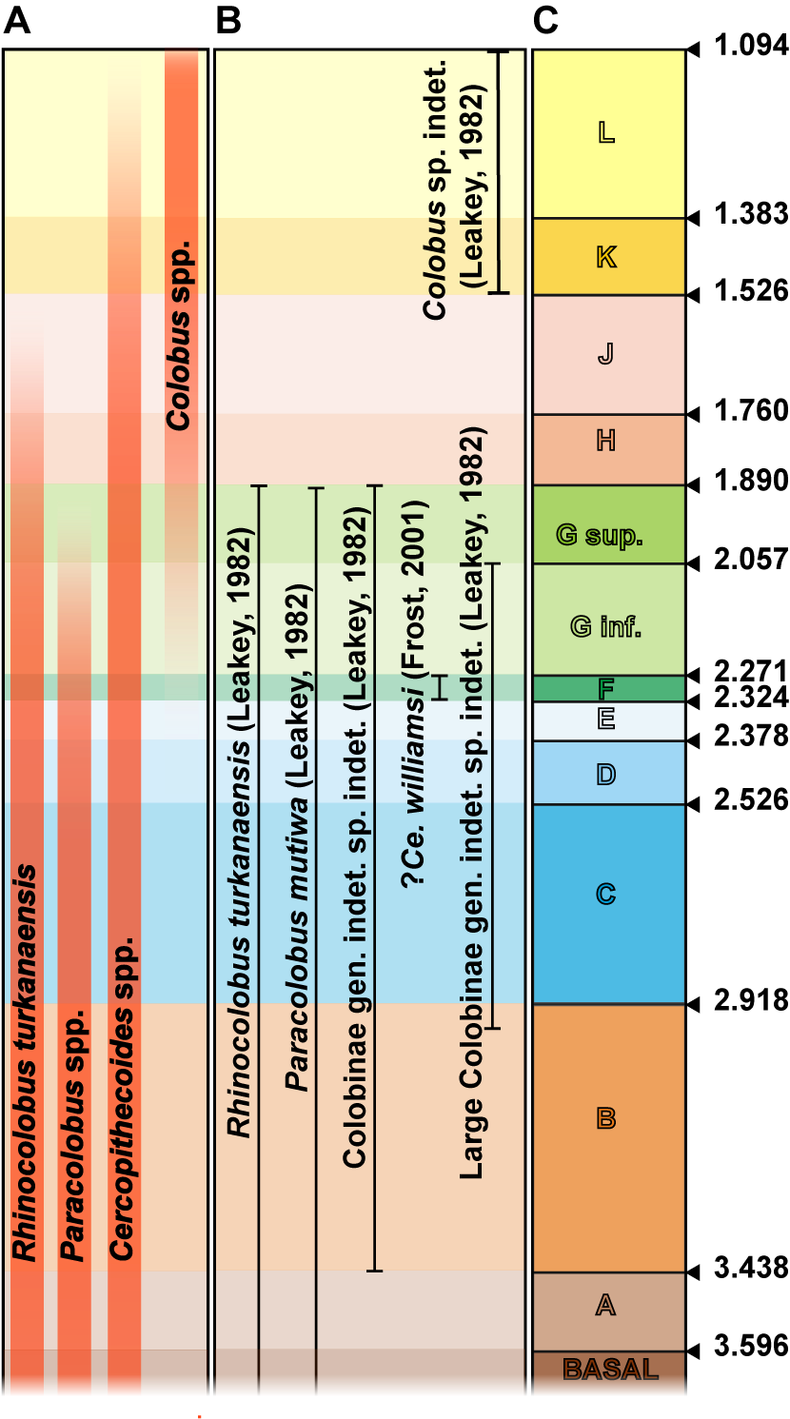

**Fig. 1.** – A) Chronostratigraphic distribution of Plio-Pleistocene colobines from eastern Africa, B) chronostratigraphic distribution of Plio-Pleistocene colobines from the Shungura Formation, and C)chronostratigraphic framework of the Shungura Formation. Abbreviations: Fm: Formation, Mb: Member.

**Table 1.** – Paleoecological and contextual information regarding the early colobines discussed in this study.

|  |  |  |  |  |
| --- | --- | --- | --- | --- |
| **Taxa** | **Geographical and temporal settings** | **Anatomical elements** | **Hypothetical locomotion** | **Accession numbers and references** |
| *Microcolobus* sp. | Nakali Fm., Kenya.9.9 Ma – 9.8 Ma. | Partial skeleton (KNM-NA 47915 and -NA 47916). | Arboreal substrate preferences (Nakatsukasa *et al.* 2010). | **KNM-NA 47915/16** (Nakatsukasa *et al.* 2010). |
| *Paracolobus enkorikae* | Lemudong’o Fm., Kenya. ca. 6 Ma. | Hum. dist. | Arboreal substrate preferences (Hlukso 2007). | **KNM-NK 4470** (Hlukso 2007). |
| *Rhinocolobus turkanaensis* & 1cf. *Rhinocolobus* sp. | Koobi Fora Fm., Kenya. Hadar Fm., Ethiopia. Laetoli Fm., Tanzania.ca. 4 Ma – 1.6 Ma. | Partial skeleton (KNM-ER 1542). Isolated elements: hum. prox. and dist.; uln. prox. and dist.; rad. prox.; tibia prox. and dist., fem. prox. & dist. | Arboreal substrate preferences with leaping, climbing (Harrison 2011, Laird *et al.* 2018), possibly suspensory behaviors (Jablonski & Leakey 2008b). | **KNM-ER 1542**, **KNM-ER 16**, **KNM-ER 5488**, **KNM-ER 45613**, **KNM-ER 45611**, EP-1100/12, LAET 74-247, LAET 76-3870, **A.L. 300-1** (Frost & Delson 2002, Jablonski & Leakey 2008b, Harrison 2011, Laird *et al.* 2018) |
| *P. mutiwa* | Nachukui Fm., Kenya.ca. 2.6 Ma. | Partial skeleton (KNM-WT 16827). | Mixed substrate preferences, poor leaping abilities (Ting 2001) | **KNM-WT 16827** (Anderson 2021, Ting 2001) |
| *P. chemeroni* | Chemeron Fm., Kenya.ca. 3.0 Ma – 2.5 Ma. | Partial skeleton (KNM-BC 3). | Mixed substrate preferences with prominent climbing, moderate leaping and possibly arm-swinging behaviors (Birchette 1982, Ting 2001) | **KNM-BC 3** (Birchette 1982, Ting 2001) |
| *Kuseracolobus hafu* | Assa Issie Fm., Ethiopia.ca. 3.8 Ma – 4.4Ma. | Partial skeleton (ASI-VP 2/59). | Arboreal substrate preferences (Hlusko 2006) | **ASI-VP 2/59b&c** (casts) (Hlusko 2006) |
| *K. aramisi* | Middle Awash Research Area, Ethiopia.ca. 4 Ma – 5 Ma. | Isolated elements: hum. dist., astr. dist. | Arboreal substrate preferences (Frost *et al.* 2007, White *et al.* 2009) | DID-VP-1/78, AMW-VP-1/76, KUS-VP-1/43, (Frost *et al.* 2007, White *et al.* 2009) |
| 3*Cercopithecoides coronatus* | Koobi Fora Fm., Kenya.2ca. 2 Ma. | Partial skeleton (KNM-ER 176). Isolated element: hum. dist. | Terrestrial substrate preferences, adaptations of the forelimb to manual foraging (Frost & Delson 2002, Jablonski & Leakey 2008b) | **KNM-ER 176**, **A.L. 577-1** (Frost & Delson, 2002, Jablonski & Leakey 2008b) |

**Table 1** **(following).** – Paleoecological and contextual information regarding the early colobines discussed in this study.

|  |  |  |  |  |
| --- | --- | --- | --- | --- |
| **Taxa** | **Geographical and temporal settings** | **Anatomical elements** | **Hypothetical locomotion** | **Accession numbers and references** |
| *Ce. williamsi* | Koobi Fora Fm., Kenya.1ca. 2 Ma. | Partial skeleton (KNM-ER 4420). | Terrestrial substrate preferences (Jablonski & Leakey 2008b) | **KNM-ER 4420** (Jablonski & Leakey 2008b) |
| *Ce. meaveae* | Hadar Fm., Ethiopia.ca. 3 Ma. | Partial skeleton (AL 2-64). | Terrestrial substrate preferences (Frost & Delson 2002) | **A.L. 2-64**, A.L. 222-14 (Frost & Delson 2002) |
| *Ce. bruneti* | Toros-Menalla, Chad.ca. 7 Ma. | Partial skeleton unassociated (TM 266 03-100). Isolated element: fem. | Mixed-substrate preferences (Pallas *et al.* 2019) | **TM 266 03-100, TM 266-03-307** (Pallas *et al.* 2019) |
| *Co. freedmani* | Koobi Fora Fm., Kenya.ca. 2 Ma4. | Partial skeleton. Isolated elements: hum. dist. | Arboreal substrate preferences (Jablonski & Leakey 2008a) | **KNM-ER 5896**, **KNM-ER 857**, **KNM-ER 841**, **KNM-ER 71** (Jablonski & Leakey 2008a) |
| *Co.* sp. | Asbole, Ethiopia.ca. 600 ka. | Partial skeleton. Isolated elements: uln. prox., rad. prox., fem. prox., hum. dist. and prox. | Arboreal substrate preferences (Frost & Alemseged 2007) | **ASB-42A**, **ASB-254**, **ASB-210**, **ASB-137**, **ASB-129**, **ASB-91**, **ASB-233-18** (Frost & Alemseged 2007) |
| Cercopithecidae indet.3 | Lemudong’o Fm., Kenya.ca. 6 Ma. | Isolated element: hum. dist. | Arboreal substrate preferences (Hlusko 2007). | **KNM-NK 41028, KNM-NK 41169, KNM-NK 41413** (Hlukso 2007) |
| Cercopithecidae indet. | Konso Fm., Ethiopia.ca. 1.45 Ma. | Isolated element: hum. prox. | NA. | **KGA 4-418** (Frost 2014) |

Bold specimens were studied by the first author and integrated in the analysis.

1 See Frost et al. (2022) for the reevaluation of the taxonomic status of the cf. *Rhinocolobus* sp. from Laetoli to cf. *Kuseracolobus* sp.

2 Dates given for the associated partial skeleton (Jablonski *et al.* 2008a, 2008b).

3 See Frost et al. (2022) for the reevaluation of the taxonomic status of *Ce. kimeui* to *Ce. coronatus*

4 Fossil specimens from Lemudong’o are stated as possibly being conspecific with *P. enkorikae* (Hlusko 2007).

THE SHUNGURA FORMATION AND USNO FORMATION

The Shungura Formation is divided in twelve geologic members (Fig. 1C; Heinzelin 1983). Apart from members E and H, each member is stratigraphically delineated by tuffs dated by radiochronology or magnetostratigraphy, with unit delineation based on lithological content (Fig. 1C and Appendix 2C; Brown & Heinzelin 1983, Feibel *et al.* 1989, McDougall & Brown 2008, McDougall *et al.* 2012, Kidane *et al.* 2014). The Usno Formation is located northeast of Shungura. Most of the fossil vertebrates from Usno derive from the White Sands and Brown Sands localities and are stratigraphically placed in the U-12-2 and U-12-3 horizons (Heinzelin 1983). These horizons correlate with the units B-1 and B-2 of the Shungura Formation (Heinzelin 1983).

The Omo Group deposits in the Lower Omo Valley record a sedimentological sequence spanning roughly 2.90 million years, providing an incredible window into the evolutionary history of vertebrates in eastern Africa (Howell & Coppens 1974, Boisserie *et al.* 2008, 2010). The Shungura time interval (ca. 3.75 Ma - ca. 1.09 Ma; Fig. 1C) documents significant paleoecological, paleoenvironmental and phyletic changes (e.g., in hominins, the emergence of the genera *Homo* Linnaeus, 1758 and *Paranthropus* Broom, 1938) that occurred in the context of climatic fluctuations (Bobe & Leakey, 2009; Maslin & Trauth, 2009; Reed & Russak, 2009). Renewed fieldwork by the Omo Group Research Expedition (OGRE) has brought forth new contextual and integrative data regarding paleoenvironmental changes and ecological dynamics of Plio-Pleistocene landscapes and faunas (Bibi *et al.* 2012, Souron *et al.* 2012, Blondel *et al.* 2018, Martin et al. 2018, Rowan *et al.* 2018). At Shungura and Usno, these biotic and abiotic events are embedded in a calibrated and accurate temporal framework. Among the biotic evidence are numerous well-preserved postcranial colobine specimens.

THE FOSSIL COLOBINES FROM USNO AND SHUNGURA

The Usno and Shungura formations have yielded abundant cercopithecid remains (e.g., relative abundance of up to 53 % in Member C among specimens collected in the OGRE fieldwork according to Boisserie *et al.* 2010). Although colobines are less well represented compared to cercopithecines, this assemblage nonetheless reveals a diversity of colobine taxa (Fig. 1B). At least five colobine taxa are currently documented in Shungura and Usno: *P. mutiwa, R. turkanaensis*, *C.* cf. *williamsi*, aff. *Colobus* sp. and several unidentified dental specimens. Among them, two large morphs (i.e., *P. mutiwa* and *R. turkanaensis*) were confidently described at Shungura based on isolated dental, cranial and gnathic specimens (Leakey 1987). A partial mandible from the Member F was provisionally assigned to *C. williamsi* by Frost (2001). The taxonomic status of smaller craniodental morphs has remained uncertain (i.e., *Colobus* sp. indet. and Colobinae gen. indet. sp. indet. according to Leakey 1987 and *Colobus* cf. *angolensis* according to Frost 2001).

Knowledge regarding the taxonomy and paleoecology of the colobines from the Usno and Shungura deposits is, to date, primarily derived from analyses of the craniodental remains. No complete analysis of the fossil colobine postcrania from the Omo has yet been published (but see Anderson’s 2019 PhD dissertation). Following the results obtained on the craniodental data, we expect to find postcranial specimens similar in size and morphology to *R. turkanaensis*, *P. mutiwa* and *Colobus*. We also expect these specimens to show morphological adaptations in line with the use of arboreal substrates for *R. turkanaensis* and *Colobus* but terrestrial substrates for *P. mutiwa*.

Here, we describe *n* = 32 postcranial specimens that include forelimb (humerus, ulna and radius) and hindlimb (femur and tibia) remains of fossil colobines in the size range of *P. mutiwa*, *R. turkanaensis* and *Colobus*. Fossils were collected between 2008 and 2016 by the OGRE and between 1967 and 1974 by the IORE (International Omo Research Expedition). We provide tentative taxonomic assignments for some of these postcranial specimens to *R. turkanaensis*, *P. mutiwa* and *Colobus*. Several specimens that do not match with the morphology of the above taxa are also considered in this study. Besides describing fossil specimens, we infer their substrate preferences and locomotor behaviors based on qualitative and quantitative traits. Specifically, we are assessing the terrestrial substrate preferences of *P. mutiwa*, the arboreal and suspensory behaviors of *R. turkanaensis*, and the arboreal and leaping behaviors of early *Colobus*. The results are organized according to anatomical elements (e.g., proximal humerus, humeral diaphysis, and distal humerus) and morphotypes are deduced for each anatomical parts given the results of the functional analyses. The concordances between our functional analyses, estimates of body size and mass, and the hypothesized locomotion of published fossil colobines (Table 1) allows us to assign the isolated postcranial specimens with a reasonable level of confidence. These data and analyses provide new information on the paleoecology and functional anatomy of the Plio-Pleistocene colobines from the Turkana Depression.

## 

## MATERIALS AND METHODS

Paleontological sample

The comparative paleontological sample used in this study spans the last 10 million years of colobine evolutionary history focusing on fossils from eastern and central Africa (Table 1). We describe *n* = 32 postcranial specimens from Member B to Member L of the Shungura Formation and the White Sands and Brown Sands localities of the Usno Formation (Table 2). The spatial localization of the Shungura colobines included in this study can be found in Appendix 3. Historically, fossils collected by the IORE begin with the suffix L- (when collected and registered by American team members) or OMO- (when collected and registered by French team members). New fossils collected by the OGRE are referenced using the suffix OMO- with numbering starting at 10.000 to avoid confusion with specimens collected by the IORE.

**Table 2.** – Chronostratigraphical context, skeletal elements and taxonomy of the specimens from Shungura and Usno described in this study.

|  |  |  |  |  |  |
| --- | --- | --- | --- | --- | --- |
| **Specimens** | **Formation** | **Members and units** | **Skeletal elements** | **Taxonomy** | **Figures** |
| B-818A | Usno | Brown sands locality (B-2) | Uln. prox. (right) | Colobinae gen. indet. and sp. indet. | SOM Figure S13 |
| W 7-477B | Usno | White sands locality (B-2) | Fem. prox. (left) | *Paracolobus* cf. *mutiwa* | Figure 20 |
| P 732-1 | Shungura | Mb. B (B-0/B-2) | Ulna. prox. (right) | Colobinae gen. indet. and sp. indet. | SOM Figure S13 |
| OMO 3/O-1968-1410 | Shungura | Mb. B (B-12) | Hum. dist. (left) | aff. Colobinae | Figure 11 |
| L 107-4 | Shungura | Mb. C (C?) | Uln. prox. (right) | *Paracolobus* cf. *mutiwa* | Figure 17 |
| L 373-3 | Shungura | Mb. C (C-1) | Uln. prox. (left) | *Rhinocolobus* cf. *turkanaensis* | Figure 15 |
| L 32-144 | Shungura | Mb. C (C-5/C-7) | Uln. prox. (left) | *Paracolobus* cf*. mutiwa* | SOM Figure S13 |
| OMO 18-1967-135 | Shungura | Mb. C (C-8) | Hum. dist. (left) | Colobinae gen. indet. and sp. indet | Figure 14 |
| OMO 165-1973-608 | Shungura | Mb. C (C-5/C-9) | Hum. dist. (left) | Colobinae gen. indet. and sp. indet. | Figure 14 |
| L 78-10031 | Shungura | Mb. C (C-8) | Hum. dist. (left) | *Rhinocolobus* cf. *turkanaensis* | Figure 11 |
| OMO 18-1971-702 | Shungura | Mb. C (C-8) | Hum. dist. (left) | Colobinae gen. indet. and sp. indet. | Figure 14 |
| OMO 18/inf-10063 | Shungura | Mb. C (C-4/C-8) | Hum. prox. (left) | Colobinae gen. indet. and sp. indet. | Figure 6 |
| L 293-10004 | Shungura | Mb. C (C-4) | Uln. prox. (right) | *Paracolobus cf. mutiwa* | Figure 11 |
| OMO 294-10006 | Shungura | Mb. C (C-9) | Hum. dist. (right) | aff. Colobinae | Figure 11 |
| L 5/6-41 | Shungura | Mb. E (E-3/E-4) | Hum. dist. (left) | *Paracolobus* cf. *mutiwa* | Figure 8 |
| OMO 70-10042 | Shungura | Mb. E (E-3) | Hum. dist. and prox. (right) | *Paracolobus* cf. *mutiwa* | Figure 8 |
| OMO 176-10006 | Shungura | Mb. E (E-1) | Hum. dist. (left) | *Paracolobus* cf. *mutiwa* | Figure 8 |
| L 236-1a and -1b | Shungura | Mb. E (E-4) | Uln. prox. and rad. prox. (right) | *Paracolobus* cf. *mutiwa* | Figures 17 and 18 |
| OMO 57/4-1972-164 | Shungura | Mb. E (E-4) | Ulna prox. (left) | *Rhinocolobus* cf. *turkanaensis* | Figure 15 |
| L 7-15 | Shungura | Mb. G (G-4/G-8) | Hum. dist. (right) | *Paracolobus* cf. *mutiwa* | Figure 10 |

**Table 2 (following). –** Chronostratigraphical context and anatomical and taxonomical information of the specimens from Shungura and Usno described in this study.

|  |  |  |  |  |  |
| --- | --- | --- | --- | --- | --- |
| **Specimens** | **Formation** | **Members and units** | **Skeletal elements** | ***Taxonomy*** | **Figures** |
| OMO 222-1973-2751 | Shungura | Mb. G (G-7) | Hum. dist. (left) | *Paracolobus* cf. *mutiwa* | Figure 10 |
| OMO 2-10029 | Shungura | Mb. G (G-29) | Rad. prox. (left) | *Rhinocolobus* cf. *turkanaensis* | Figure 18 |
| OMO 75/N-1971-728 | Shungura | Mb. G (G-12/G-13) | Fem. prox. (right) | *Rhinocolobus* cf. *turkanaensis* | Figure 20 |
| OMO 50-1973-4450 | Shungura | Mb. G (G-3/G-13) | Fem. prox. (right) | *Rhinocolobus* cf. *turkanaensis* | Figure 20 |
| F 500-1 | Shungura | Mb. G (G-28) | Hum. (right) | *Rhinocolobus* cf. *turkanaensis* | Figure 10 |
| F 501-1 | Shungura | Mb. G (G-27/G-28) | Hum. prox. (left) | Colobinae gen. indet. and sp. indet. | Figure 6 |
| OMO 342-10019 | Shungura | Mb. L (L-9) | Fem. prox. (left) | cf. *Colobus* sp. indet. | Figure 23 |
| OMO 342-10335 | Shungura | Mb. L (L-9) | Hum. prox. (left) | cf. *Colobus* sp. indet. | Figure 9 |
| OMO 342-10298 | Shungura | Mb. L (L-9) | Fem. prox. (left) | cf. *Colobus* sp. indet. | Figure 23 |
| OMO 342-10344 | Shungura | Mb. L (L-9) | Fem. prox. (right) | cf. *Colobus* sp. indet. | Figure 23 |
| OMO 342-10052 | Shungura | Mb. L (L-9) | Hum. prox. (right) | cf. *Colobus* sp. indet. | Figure 9 |
| OMO 377-10024 | Shungura | Mb. L (L-7) | Tib. dist. & prox. (right) | cf. *Colobus* sp. indet. | Figure 24 |

Neontological sample

We used a large neontological comparative dataset from European and African museums. This dataset includes *n* = 105 individual skeletons representing *n* = 9 cercopithecid genera (*Colobus* Illiger, 1811; *Nasalis* Geoffroy Saint-Hilaire, 1812; *Papio* Erxleben, 1777; *Piliocolobus* Rochebrune, 1877; *Presbyti*s Eschscholtz, 1821; *Procolobus* Rochebrune, 1877; *Pygathrix* Geoffroy Saint-Hilaire, 1812; *Trachypithecus* Reichenbach, 1862; and *Semnopithecus* Desmarest, 1822), including *n* = 18 species (see Table 3). This sample comprises colobines from the African tribe (Colobini) and Asian tribes (Presbytini), it includes taxa with various substrate preferences and locomotor behaviors (e.g., the arboreal suspensor *Pygathrix* and the partly terrestrial quadruped *Semnopithecus*) and with distinct body masses (e.g., the small bodied *Presbytis* and the large bodied *Semnopithecus*). For each sample, information regarding the sex and provenience (wild, captive or unknown) of the specimens are listed in Table 3. Information regarding the accession numbers of the extant specimens can be found in Appendix 39. All the specimens included were adult (epiphysis fused) and non-pathological.

Qualitative comparisons between fossil colobines and extant cercopithecids focused on *n* = 4 extant taxa with known locomotor and postural behaviors (i.e., *Colobus guereza*, *Nasalis larvatus* Wurmb, 1787; *Semnopithecus entellus* Dufresne, 1797; and *Papio hamadryas* Linnaeus, 1758). *Colobus guereza* is a predominantly arboreal quadrupedal African colobine that frequently engages in leaping and climbing (Rose 1979, Gebo & Chapman 1995, 2000, Fashing, 2016). *Nasalis larvatus*, an Asian colobine, is also a predominantly arboreal quadruped, with bouts of terrestriality (Matsuda *et al.* 2017, Kawabe & Mano 1972), and that engages in leaping and climbing (Yeager *et al.* 2016). *N. larvatus* also incorporates a significant amount of suspension in its locomotor repertoire compared to *Co. guereza* (Yeager *et al.* 2016, Bismark 2010). *Semnopithecus entellus* is an Asian colobine with mixed substrate preferences and higher frequencies of quadrupedal ground walking and running compared to *Co. guereza* and *N. larvatus* (Rahman *et al.* 2015). Leaping and climbing are nevertheless documented as part of the locomotor repertoire of *S. entellus* (Ripley 1967, McQuinn 2016). *Papio hamadryas* is an African papionin with terrestrial substrate preferences (Swedell & Chowdhury 2016), and although climbing and leaping are included in its locomotor repertoire, these behaviors are observed at much lower frequencies than in *Co. guereza*, *N. larvatus* and *S. entellus* (Swedell & Chowdhury 2016).

**Table 3.** – Size, provenance, taxonomy and sex of the extant sample of cercopithecids included in this study.

|  |  |  |  |
| --- | --- | --- | --- |
| **Taxa &**  **Total number of specimens** | **Repositories** | **Sex**  **♂ / ♀/ unknown** | **Provenience:**  **wild / captive / unknown** |
| *Colobus* spp.1  N = 21 | RMCA, MNHN | 12 / 7 / 1 | 15 / 2 / 3 |
| *Piliocolobus* spp.2  N = 17 | RMCA, MNHN, NMB, UZH-MA | 4 / 11 / 2 | 11 / 6 / 0 |
| *Procolobus verus*  N = 2 | MNHN, UZH-MA | 1 / 1 / 0 | 1 / 1 / 0 |
| *Nasalis larvatus*  N = 23 | UZH-MA, MNHN, NMB, BSZM | 7 / 14 / 2 | 19 / 3 / 1 |
| *Pygathrix nemaeus*  N = 7 | MNHN, UZH-MA, NMB | 2 / 4 / 1 | 1 / 6 / 0 |
| *Semnopithecus* sspp.3  N = 8 | MNHN, UZH-MA, NMB, KNM | 1 / 3 / 4 | 7 / 1 / 0 |
| *Trachypithecus* spp.4  N = 9 | MNHN, UZH-MA, NMB | 2 / 3 / 4 | 6 / 3 / 0 |
| *Presbytis* spp.  N = 2 | MNHN, UZH-MA | 1 / 1 / 0 | 2 / 0 |
| **Subtotal Colobinae N = 77** | | | |
| *Papio* spp.5  N = 32 | MNHN, UZH-MA, NMB, MHNL, NME | 14 / 8 / 10 | 7 / 13 / 12 |
| **Total N = 106** | | | |

1 *Colobus angolensis cottoni* (n = 3), *Colobus angolensis ruwenzorii* (n = 1), *Colobus angolensis palliatus* (n = 1), *Colobus angolensis angolensis* (n = 1), *Colobus angolensis* sspp. indet. (n = 1), *Colobus guereza occidentalis* (n = 6), *Colobus guereza guereza* (n = 1), *Colobus guereza caudatus* (n = 2), *Colobus guereza* sspp. indet. (n = 4).

2 *Piliocolobus rufomitratus langi* (n = 1), *Piliocolobus rufomitratus ellioti* (n = 3), *Piliocolobus rufomitratus foai* (n = 1), *Piliocolobus rufomitratus tholloni* (n = 1), *Piliocolobus rufomitratus oustaleti* (n = 1), *Pilicolobus badius temminckii* (n = 1), *Pilicolobus badius* sspp. indet. (n = 5); *Piliocolobus rufomitratus* ssp. indet. (n = 2); Piliocolobus kirkii (n = 2)

3 *Semnopithecus entellus* (n = 6), *Semnopithecus* sp. indet. (n = 2)

4 *Trachypithecus auratus* (n = 2), *Trachypithecus cristatus* (n = 2), *Trachypithecus johnii* (n = 2), *Trachypithecus phayrei* (n = 3).

5 *Papio anubis* (n = 11), *Papio cynocephalus* (n = 3), *Papio hamadryas* (n = 12), *Papio papio* (n = 4), *P. ursinus* (n = 1), Papio sp. indet. (n = 1).

Minimal number of individuals (MNI) for *Papio* sp. indet. coming from the Egyptian archeological sites: humerus MNI = 6; femur MNI = 12; radius MNI = 4; tibia MNI = 9; ulna MNI = 2; astragalus MNI = 7. Not included in the table count.

Morphometrics

Linear and angular measurements were collected on the humerus (*n* = 27 measurements; Table 4), ulna (*n* = 14 measurements; Table 5), radius (*n* = 6 measurements; Table 5), and femur (*n* = 13 measurements; Table 6). Only linear measurements were taken for the tibia (*n* = 10 measurements; Table 6). Measurements are shown in Figs 2 - 4. We acquired all the measurements with a Mitutoyo Digimatic Calliper CD-8’’CX on original specimens and on a cast replica for *Kuseracolobus hafu* Hlusko, 2006. Data for *N. larvatus* from the Bavarian Zoologische Staatssammlung München (BZSM) collection and used in the GM comparison were taken on 3D models using the Avizo software. Angles were measured with ImageJv1.50e from photographs of the original specimens and on a cast replica for *K. hafu*.

**Table 4. –** Humeral measurements

|  |  |  |
| --- | --- | --- |
| Abbreviations | | Description |
| HPEML | **Width of the proximal humeral epiphysis.**  Distance from the most lateral point of the greater tuberosity to the most medial point of lesser tuberosity. | |
| BGML | **Width of the bicipital groove of the humerus.**  Distance from the most anteriorly projected lateral and medial point of the groove. | |
| HHSI | **Height of the humeral head.**  Distance from the most distal point of the humeral head to its most proximal point. | |
| HHAP | **Length of the humeral head.**  Distance from the most anterior point of the humeral head to its most posterior point. | |
| HHMD | **Width of the humeral head.**  Distance from the most medial point to the most lateral point of the humeral head (taken posterior to the tuberosities). | |
| LTSI | **Height of the lesser tuberosity of the humerus.**  Distance from the most proximal point of the tuberosity to its most distal point. | |
| LTAP | **Anteroposterior dimension of the lesser tuberosity of the humerus.**  Distance from the most posterior to the most anterior point of the lesser tuberosity. | |
| GTSI | **Height of the greater tuberosity of the humerus.**  Distance from the most proximal point of the tuberosity to its most distal point. | |
| GTAP | **Anteroposterior dimension of the greater tuberosity of the humerus.**  Distance from the most proximal point of the tuberosity to its most distal point. | |
| DJML | **Width of the distal articular surface of the humerus.**  Distance from the midpoint of the lateral border of the capitulum to the medial border of the trochlea. | |
| DJML2 | **Combined width of the distal articular surface and lateral epicondyle of the humerus.**  Distance from the most lateral point of the lateral epicondyle to the medial border of the trochlea. | |
| BIEPIC | **Biepicondylar width of the humerus.**  Distance from the most lateral point of the lateral epicondyle to the most medial point of the medial epicondyle. | |
| CML | **Width of the capitulum of the humerus.**  Distance from the midpoint of the lateral border of the capitulum to its most medial extension. | |
| CSI | **Height of the capitulum of the humerus.**  Distance from the most proximal to the most distal point of the capitulum. | |
| HRJML | **Width of the humeroradial joint.**  Distance from the midpoint of the lateral border of the capitulum to the adjacent point on the lateral trochlear keel. | |
| TSI | **Maximum height of the medial trochlear keel of the humerus.**  Distance from the most proximal point on the medial border of the medial trochlear keel to its most distal point. | |
| TML | **Maximum width of the trochlea of the humerus.**  Distance from the medial border of the trochlea to the adjacent point on the lateral trochlear keel. | |

**Table 4 (following). –** Humeral measurements

|  |  |
| --- | --- |
| **Abbreviations** | **Description** |
| **OFSI** | **Maximum height of the humeral olecranon fossa.**  Distance from the most proximal point to the most distal point of the fossa. |
| **OFML** | **Maximum width of the humeral olecranon fossa.**  Distance from the most medial point to the most lateral point of the fossa. |
| **MPillML** | **Minimum breadth of the medial humeral pillar of the humerus.**  Taken as mid-height of the pillar. |
| **LPillML** | **Minimum breadth of the lateral humeral pillar of the humerus.**  Taken as mid-height of the pillar. |
| **DeltML** | **Maximum breadth (mediolateral) of the shaft at the level of the deltopectoral crest of the humerus.**  Distance from the most lateral point to the most medial point of the shaft (including the enthesis of *m. teres major*). |
| **DeltAP** | **Maximum breadth (anteroposterior) of the deltopectoral crest of the humerus.**  Distance from the most anterior point to the most posterior point of the crest. |
| **MPMxAP** | **Maximum breadth of the medial part of the distal articular surface of the humerus.**  Distance from the most anterior point of the capitulum to the most posterior point of the medial humeral pillar. |
| **LPMxAP** | **Maximum breadth of the lateral part of the distal articular surface of the humerus.**  Distance from the most anterior point of the trochlea to the most posterior point of the lateral humeral pillar. |
| **ZCMinAP** | **Minimum breadth of the distal articular surface at the level of zona conoidea** |
| **MEAng (°)** | **Angulation of the medial epicondyle of the humerus (in °).**  Refer to Pallas *et al.* (2019) for a detailed protocol of acquisition. |

Measurements taken from photographs are highlighted in grey.

**Table 5. –** Ulnar and radial measurements

|  |  |
| --- | --- |
| **Abbreviations** | **Description** |
| **OPAP** | **Maximum length of the olecranon process of the ulna.**  Distance from the most posterior point of the olecranon process to its most anterior point. | |
| **OPML** | **Maximum width of the olecranon process of the ulna.**  Distance from the most medial to the most lateral point of the olecranon process (including the cresting of the flexor tubercle and the enthesis of *m. triceps brachii*). | |
| **OPSI** | **Height of the olecranon process of the ulna.**  Distance from the mid-point of the anconeal process to the mid-point of the proximal aspect of the olecranon. | |
| **OlecAng** | **Angulation of the olecranon of the ulna.**  A circle is fitted on the sigmoid notch. This circle passes by the most anterior projection of the anconeal and coronoid processes and at mid-height of the sigmoid notch. Olecranon angulation is the angle between the line that passes to the point of inflexion of the posterior part of the olecranon and a line that materializes the sagittal plane and which passes by the center of the circle. | |
| **APAP** | **Maximum projection of the anconeal process of the ulna.**  Distance from the most anterior point of the anconeal process to the adjacent point posterior to it on the shaft border of the sigmoid notch. | |
| **APML** | **Maximum width of the anconeal process of the ulna.**  Distance from the most medial point to the most lateral point of the anconeal process. | |
| **SNAPMh** | **Breadth of the shaft posterior to the mid-height of the sigmoid notch of the ulna.**  Distance from the most anterior point of the sigmoid notch at its mid-height to the adjacent point posterior to it on the shaft border of the sigmoid notch. | |
| **SNDP** | **Depth of the sigmoid notch of the ulna.**  Distance from the mid-point of sigmoid notch to the center of the circle defined in the OlecAng measurement. | |
| **SNSI** | **Height of the sigmoid notch of the ulna.**  From the lateral border of the coronoid process to the distal margin of the anconeal process. | |
| **CPAP** | **Maximum projection of the coronoid process of the ulna.**  From the most anterior point of the coronoid process to the adjacent point posterior to it on the shaft border of the sigmoid notch. | |
| **CPML** | **Maximum width of the coronoid process of the ulna.**  From the most lateral point of the coronoid process to the point adjacent to it. | |
| **CPRNML** | **Combined width of the coronoid process and radial notch of the ulna.**  From the most lateral point of the coronoid process to the most medial point of the radial notch. | |
| **RNAP** | **Maximum anteroposterior dimension of the radial notch of the ulna.**  From the most posterior point to the most anterior point of the notch. | |
| **RNSI** | **Height of the radial notch of the ulna.**  From the most proximal point of the notch to the most distal point adjacent to it. | |

**Table 5 (following). –** Ulnar and radial measurements

|  |  |
| --- | --- |
| **Abbreviations** | **Description** |
| **RaNSI** | **Maximum length of the radial neck.**  Distance from the most superior point of the bicipital tuberosity to the point adjacent to it on the peripheral articular margin of the head. | |
| **RNShA** | **Minimum breadth of the radial neck.**  This breadth corresponds to the shortest axis of the neck. | |
| **RNLgA** | **Maximal breadth of the radial neck.**  This breadth corresponds to the longest axis of the neck. | |
| **BBLA** | **Lever arm of *m. biceps brachii*.**  Distance from the most distal point of the bicipital tuberosity to the most proximal point adjacent to it on the margin of the radial head. | |
| **BPExt** | **Maximum breadth at the level of the bicipital tuberosity**  Maximum distance from the most lateral to the most medial point of the radius at the level of the bicipital tuberosity. | |
| **RHShA** | **Radial head shortest axis.**  Maximum length of the head along its shortest axis. | |
| **RHLgA** | **Radial head longest axis.**  Maximum length of the head along its longest axis. | |

Measurements taken from photographs are highlighted in grey.

**Table 6. –** Femoral and tibial measurements

|  |  |
| --- | --- |
| **Abbreviations** | **Protocol** |
| **FPEML** | **Maximum length of the proximal epiphysis of the femur.**  Distance from the most medial point of the femoral head to the most lateral point of the *m. vastus lateralis* tubercle. |
| **FHSI** | **Maximum height of the femoral head.**  Distance from the most proximal to the most distal point of the femoral head. |
| **FHAP** | **Maximum breadth of the femoral head.**  Distance from the most anterior to the most posterior point of the femoral head. |
| **FNML** | **Maximum length of the femoral neck.**  Distance from the mid-length of the trochanteric crest to the adjacent point at mid-height of the femoral neck/femoral head junction. |
| **BNML** | **Biomechanical neck length of the femur.**  Distance from the most lateral point of the *m. vastus lateralis* tubercle to center of the femoral head (taken in posterior view). |
| **FNSI** | **Maximum height of the femoral neck.**  Distance from the most proximal to the most distal point at mid-length of the femoral neck. |
| **FNAP** | **Maximum breadth of the femoral neck.**  Distance from the most anterior to the most posterior point at mid-length of the femoral neck. |
| **FMLLT** | **Maximum width at the level of the lesser trochanter of the femur.**  Distance from the most medial point of the lesser trochanter to the lateral point adjacent to it. |
| **FBMLLT** | **Maximum width below the lesser trochanter of the femur.**  Mediolateral dimension of the shaft below the lesser trochanter. |
| **FAPLT** | **Maximum breadth at the level of the lesser trochanter of the femur.**  Distance from the most posterior point of the lesser trochanter to the most anterior point adjacent to it. |
| **FBAPLT** | **Maximum breadth below the lesser trochanter of the femur.**  Anteroposterior dimension of the shaft below the lesser trochanter. |
| **NSA** | **Collodiaphyseal angle of the femur.**  Angle between the line that passes through the diaphyseal mid-breadth at 50 % and 25 % of femoral length and the line that bisects the femoral neck (this line is perpendicular to the neck maximal height). |
| **GTProj** | **Proximal projection of the greater trochanter of the femur**  Distance defined by two lines perpendicular to the line that passes through the diaphyseal mid-breadth at 50 % and 25 % of femoral length. GTProj is measured between the most proximal point of the femoral head and the most proximal point of the greater trochanter. |
| **TPEML** | **Width of the proximal tibial epiphysis**  Distance from the most lateral to the most medial point of the proximal epiphysis. |

**Table 6 (following). –** Femoral and tibial measurements

|  |  |
| --- | --- |
| **Abbreviations** | **Protocol** |
| **MshML** | **Mediolateral dimension of the tibial shaft at mid-height** |
| **MshAP** | **Anteroposterior dimension of the tibial shaft at mid-height** |
| **DEAP** | **Maximum depth of the distal tibial epiphysis.**  Distance from the most anterior projection of the epiphysis to its most posterior projection (usually the retromalleolar notch). |
| **DEML** | **Maximum breadth of the distal tibial epiphysis.**  Distance from the most medial point of the malleolus to the most lateral point of the epiphysis. |
| **MAP** | **Maximum anteroposterior length of the tibial malleolus.**  Distance from the most anterior to the most posterior point of the malleolus. |
| **MML** | **Maximum breadth of the tibial malleolus.**  Distance from the most medial point to the most lateral point of the malleolus. |
| **TFMxML** | **Maximum width of the distal articular surface of the tibia.**  Distance between the most medial and lateral point of the distal tibial articular surface at the level of its anterior margin. |
| **TFMinML** | **Minimum width of the distal articular surface of the tibia.**  Distance between the most medial and lateral point of the distal tibial articular surface at the level of its posterior margin. |
| **TFMxAP** | **Maximum length of the distal articular surface of the tibia.**  Distance between the most anterior and posterior point of the distal tibial articular surface. |
| Measurements taken from photographs are highlighted in grey. | |

**Table 7. –** Morphometric indices and functional rationale

|  |  |  |  |
| --- | --- | --- | --- |
| **Bone** | **Name of the index** | **Formulae** | **Functional rationale** |
| Humerus | Humeral head shape index | (HHAP/HHMD)*100 | Associated with mobility of the glenohumeral joint in the coronal and sagittal planes (Harrison, 1989; Gebo and Sargis, 1994; Nakatsukasa, 1997; Arias-Martorell, 2019). |
| Humerus | Lateral projection of the humeral tuberosities | (HPEML/HHMD)*100 | Associated with the development and action of the rotator cuff muscles (Birchette, 1982; Harrison, 1989; Nakatsukasa, 1997; Dunham et al., 2017; Arias-Martorell, 2019). |
| Humerus | Relative projection of the medial epicondyle | [(BIEPIC-DJML2)/DJML]*100 | Associated with the development and action of the flexor muscles of the forearm (Harrison, 1989; Ford, 1988; Senturia, 1995; Fleagle & Simons, 1995; Ibanez-Gimeno et al., 2014). |
| Humerus | Distal epiphysis relative anteroposterior dimensions | [(LPMxAP*MPMxAP)/DJML]*100 | Associated with mobility of the humeroulnar and humeroradial joints in the coronal and sagittal planes (Schmitt, 2003; Arenson et al., 2020). |
| Humerus | Distal epiphysis relative anteroposterior dimensions at zona conoidea | (ZCMinAP/DJML) 100 | Associated with the capacity to withstand mechanical stresses at the level of the humeroradial joint (Elton et al., 2017). |
| Humerus | Humeral pillars breadth differential | (MPillML/LPillML)*100 | Associated with the capacity to withstand mechanical stresses at the level of the humeroradial and humeroulnar joints and with the development and action of *m. brachioradialis* (Fleagle & Simons, 1995; Lague et al., 2019). |
| Humerus | Relative distal development of the medial trochlear keel | (TSI/DJML)*100 | Associated with stability of the humeroulnar joint in the coronal and sagittal planes (Birchette, 1982; Harrison, 1989; Frost and Delson, 2002; Schmitt, 2003). |
| Ulna | Olecranon process relative height | (OPSI/SNSI)*100 | Associated with mobility of the humeroulnar joint in the sagittal plane and lever arm length of *m. triceps brachii* (Drapeau, 2004; Fujiwara, 2009). |
| Ulna | Coronoid and radial notch relative lateral projection | (CPRNML/SNSI)*100 | Associated with stability of humeroradial joint in pronated hand posture (Fleagle & Simons, 1995; Richmond et al., 1998) |

**Table 7 (following). –** Morphometric indices and functional rationale

|  |  |  |  |
| --- | --- | --- | --- |
| **Bone** | **Name of the index** | **Formulae** | **Functional rationale** |
| Radius | Radial neck relative elongation | (RaNSI/RHShA)*100 | Associated with the lever arm length of *m. biceps brachii* (Birchette, 1982; Rose et al., 1992). |
| Radius | Radial head shape | (RHShA/RHLgA)*100 | Associated with mobility of the humeroradial joint (Birchette, 1982; Patel, 2005). |
| Radius | Radial neck shape | (RNShA/RNLgA)*100 | Associated with the capacity to withstand mechanical stresses at the level of the radial neck (Birchette, 1982; Rose et al., 1992). |
| Femur | Relative posterior projection of lesser trochanter | [(FAPLT-FBAPLT)/FHAP]*100 | Associated with the lever arm length of *m. illiopsoas* (Ford, 1988; Anemone, 1990; Fleagle & Simons, 1995; Dagosto and Schmid, 1996; Bacon, 2001; Cooke and Tallman, 2012). |
| Femur | Relative proximal projection of greater trochanter | (GTProj/FHAP)*100 | Associated with mobility of the coxofemoral joint in the coronal and sagittal planes as well as with the lever arm length of *m. piriformis* and *m. gluteus medius* (Ford, 1988; Dagosto and Schmid, 1996; Frost and Delson, 2002). |
| Femur | Relative biomechanical neck length | (BNNL/FPEML)*100 | Associated with mobility of the coxofemoral joint in the coronal and sagittal planes as well as with the lever arm length of *m. vastus lateralis* and *m. gluteus minimus* (Dagosto and Schmid, 1996; Nakatsukasa, 1997; Cooke and Tallman, 2012). |
| Femur | Femoral neck robustness | (FNSI/FPEML)*100 | Associated with the capacity to withstand mechanical stresses at the level of the coxofemoral joint (Nakatsukasa, 1997; Cooke and Tallman, 2012). |
| Tibia | Shape of the distal tibial epiphysis | (DEML/DEAP)*100 | Associated with mobility of the crural joint in the coronal and sagittal planes (DeSilva, 2010). |
| Tibia | Shape of the tibial malleolus | (MAP/MML)*100 | Associated with the capacity to withstand mechanical stresses at the level of the crural joint (DeSilva, 2010). |

3d data acquisition

Surface scans were acquired using a Next Engine UltraHD model 2020i 3D Scanner (NextEngine, Santa Monica, USA) and an Artec Space Spider (Artec 3D, Senningerberg, Luxembourg) on original fossil specimens and on casts. Digital reconstructions of the images obtained were produced using GeomagicStudio13 (3D Systems, Rock Hill, USA). Surfaces generated from the 3D data and transverse cross-sections were obtained using Avizo Standard Edition v7.0 (Thermo Fischer Scientific, Waltham, USA).

Body mass estimation and geometric means

Body masses were inferred from postcranial and dental data (Appendix 40) using the regression equations from Ruff (2003) and Delson *et al.* (2000), respectively. For postcranial data, body masses discussed in the text were drawn only from humeral (proximal and distal) and femoral specimens as these elements are well represented in the Omo colobine sample. For body mass estimations derived from postcranial data, we used the regression parameters established on colobine data in Ruff (2003:28).

Dental measurements used to calculate body masses for the Omo specimens includes specimens from the IORE only and were taken directly from high-quality dental casts or from 3D models for *Ce.* cf. *williamsi* OMO 33-1969-369 (Appendix 40). Body masses deduced from dental data are from mesio-distal dimensions. We employ only M1-2 and M1-2 to infer body masses and in the case of complete or partial tooth rows, the mean value of the inferred body mass was used. M1-2 and M1-2 mesiodistal lengths were selected because of the variable development of the M3 hypoconulid (and hence a high coefficient of variation in M3 mesiodistal length according to Leutenegger 1971) and variation in molar basal flare (e.g., present in *Colobus* but absent in *Piliocolobus*) among colobines.

For consistency and regarding the difficult sex attribution of isolated dental specimens, we utilized the parameters of the 'All' sex equation of the colobine regression parameters provided by Delson *et al.* (2000).

To quantitatively assess the extent of sexual dimorphism in putative *Rhinocolobus* and *Paracolobus* specimens, we compared the geometric mean of the postcranial specimens from the Omo to the *R. turkanaensis* male partial skeleton KNM-ER 1542 and to the *P. mutiwa* male partial skeleton KNM-WT 16827. This comparison is obtained with the ratio of the geometric mean of the considered fossil specimen divided by the geometric mean of KNM-ER 1542 for presumed *R. turkanaensis* specimens, and KNM-WT 16827 for presumed *P. mutiwa* specimens. For example, to evaluate if the humerus OMO 222-1973-2751 is a male specimen of *P. mutiwa*, its geometric mean is divided by that of KNM-WT 16827. If it is slightly above or slightly below the male KNM-WT 16827, there is a reasonable probability that the considered fossil specimen from the Omo is a male specimen.

The estimation of the amount of sexual dimorphism of *R. turkanaensis* is based on *n* = 6 variables for the geometric mean of distal humeral specimens (CSI, TML, TMinSI, TMaxSI, DJML2 and BiEpicML) and on *n* = 7 variables for the geometric mean of proximal ulnar specimens (SNSI, OPAP, OPSI, APML, APAP, CPML and SNAPMidH). The estimation of the level of sexual dimorphism of *P. mutiwa* was based on *n* = 7 variables for the geometric mean of distal humeral specimens (HRJML, CML, CSI, TML, DJML, DJML2 and BiEpicML) and on *n* = 5 variables for proximal ulnar specimens (SNSI, APML, CPML, RNAP and RNSI). The level of sexual dimorphism of *R. turkanaensis* and *P. mutiwa* was also compared to that of *N. larvatus*, which is among the most sexually dimorphic extant colobines (Yeager *et al.* 2016). We calculated the degree of sexual dimorphism of *N. larvatus* identically to that of the fossil colobines. To infer the level of sexual dimorphism in *N. larvatus*, we selected the male *N. larvatus* ZH AS 1557 (i.e., the male baseline), we computed its GM, and all the GM of the rest of the specimens were divided by that of the *N. larvatus* male baseline ZH AS 1557.

Anatomical rationale for taxonomic attribution

Our taxonomic attributions are based on a combination of size and anatomical traits observed or reported as diagnostic of colobines. The identification of *P. mutiwa* and *R. turkanaensis* specimens are based here on in-depth comparisons with the known partial skeleton of these species. Fossil remains tentatively allocated to Colobinae gen. indet. and sp. indet. are justified by the presence of traits related to enhance mobility of the shoulder, elbow, hip, knee and ankle compared to most large cercopithecines in combination with traits identified as characteristic of colobines. To consider uncertainity in taxonomic identification, some specimens are left in open nomenclature.

A list of published traits used to justify our taxonomic rationale can be found in Table 8.

**Table 8. –** Diagnostic features of extant and fossil colobines

|  |  |  |
| --- | --- | --- |
| **Bone** | **Anatomical characteristics** | **Comments** |
| Humerus | Mediolaterally extended distal articular surface | Relatively narrow articular surface (mediolaterally) in *Pa. chemeroni* (Birchette, 1982; Anderson, 2021) |
| Humerus | Shallow lateral trochlear keel | Marked lateral trochlear keel observed in *Ce. williamsi* (Frost and Delson, 2002) |
| Humerus | Moderately retroflexed medial epicondyle | Retroflexed medial epicondyle observed in *Cercopithecoides* spp. (Frost and Delson, 2002; Pallas et al., 2019) |
| Ulna | Straight or anteflexed olecranon | Retroflexed olecranon observed in *Ce. williamsi* (Birchette, 1982) |
| Radius | Moderately developed radial interosseous crest | Sharp radial interosseous crest observed in *P. mutiwa* and *Ce. williamsi* |
| Femur | Robust femoral neck | Shallow neck in *Ce. meaveae* |
| Femur | Absence or moderate extension of the greater trochanter above the femoral head | Proximally extended greater trochanter in *Ce. williamsi* and *Pa. mutiwa* (Frost and Delson, 2002; Anderson, 2021) |

Statistical analyses

All statistical analyses were performed with R v.3.5.0 (R Core Team 2018) with a level of significance set at 0.05. Sexes were pooled in each analysis due to sample size limitations.

As a prerequisite to statistical tests, homoscedasticity (Bartlett test) and normality (Shapiro-Wilk test) were tested in each extant sample (i.e., Colobinae and *Papio* spp.). More precisely, we tested for each sample the null hypothesis of a homogenous variance and normal distribution of the data. Results of these tests can be found in Appendix 39. Parametric (t-test) or non-parametric (Wilcoxon-Mann-Whitney) tests were then used to assess the level of significance of the differences between *Papio* spp. and extant colobines for each morphometric index.

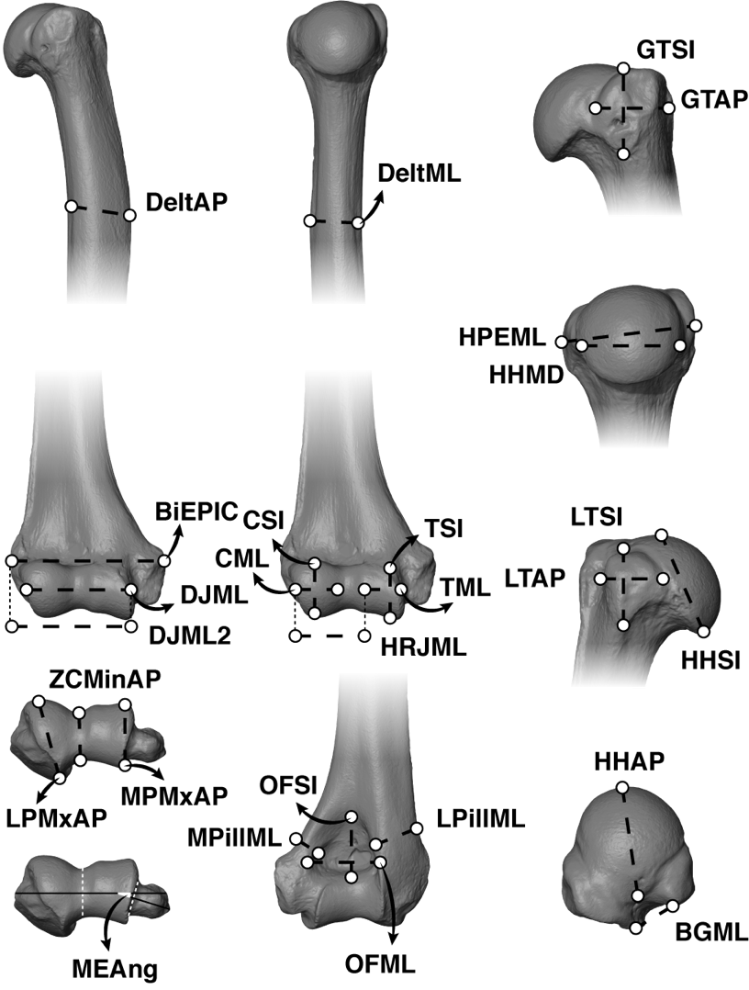

**Fig. 2**. – Humeral measurements as illustrated in *Nasalis larvatus*

Abbreviations: Ant: Anterior, Lat: Lateral, Me: Medial, Prox: Proximal, HPEML: width of the proximal humeral epiphysis, BGML: width of the bicipital groove of the humerus, HHSI: height of the humeral head, HHAP: length of the humeral head, HHMD: width of the humeral head, LTSI: height of the lesser tuberosity of the humerus, LTAP: anteroposterior dimension of the lesser tuberosity of the humerus, GTSI: height of the greater tuberosity of the humerus, GTAP: anteroposterior dimension of the greater tuberosity of the humerus, DJML: width of the distal articular surface of the humerus, DJML2: combined width of the distal articular surface and lateral epicondyle of the humerus, BIEPIC: biepicondylar width of the humerus, CML: width of the capitulum of the humerus, CSI: Height of the capitulum of the humerus, HRJML: width of the humeroradial joint, TSI: maximum height of the medial trochlear keel of the humerus, TML: maximum width of the trochlea of the humerus, OFSI: maximum height of the humeral olecranon fossa, OFML: maximum width of the humeral olecranon fossa, MPillML: maximum breadth of the medial humeral pillar of the humerus, LPillML: minimum breadth of the lateral humeral pillar of the humerus, DeltML: maximum breadth (mediolateral) of the shaft at the level of the deltopectoral crest of the humerus, DeltAP: maximum breadth (anteroposterior) of the deltopectoral crest of the humerus, MPMxAP: Maximum breadth of the medial part of the distal articular surface of the humerus, LPMxAP: Maximum breadth of the lateral part of the distal articular surface of the humerus, ZCMinAP: Minimum breadth of the distal articular surface at the level of zona conoidea, MEAng: Angulation of the medial epicondyle of the humerus.

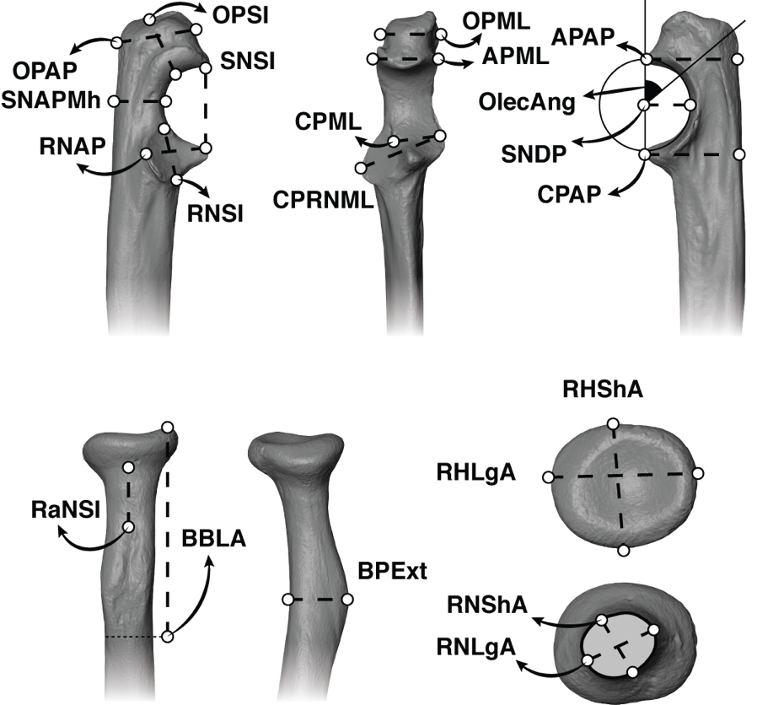

**Fig. 3**. – Ulnar and radial measurements as illustrated in *Nasalis larvatus*

Abbreviations: Ant: Anterior, Lat: Lateral, Med: Medial, Prox: Proximal, OPAP: Maximum length of the olecranon process of the ulna, OPML: Maximum width of the olecranon process of the ulna, OPSI: Height of the olecranon process of the ulna, OlecAng: Angulation of the olecranon of the ulna, APAP: Maximum projection of the anconeal process of the ulna, APML: Maximum width of the anconeal process of the ulna, SNAPMh: Breadth of the shaft posterior to the mid-height of the sigmoid notch of the ulna, SNDP: Depth of the sigmoid notch of the ulna, SNSI: Height of the sigmoid notch of the ulna, CPAP: Maximum projection of the coronoid process of the ulna, CPRNML: Combined width of the coronoid process and radial notch of the ulna, RNAP: Maximum anteroposterior dimension of the radial notch the ulna, RNSI: Height of the radial notch of the ulna, RaNSI: Maximum length of the radial neck, RNShA: Minimum breadth of the radial neck, RNLgA: Maximal breadth of the radial neck, BBLA: Lever arm of *m. biceps brachii*, BPExt: Maximum breadth at the level of the bicipital tuberosity, RHShA: radial head shortest axis, RHLgA: Radial head longest axis.

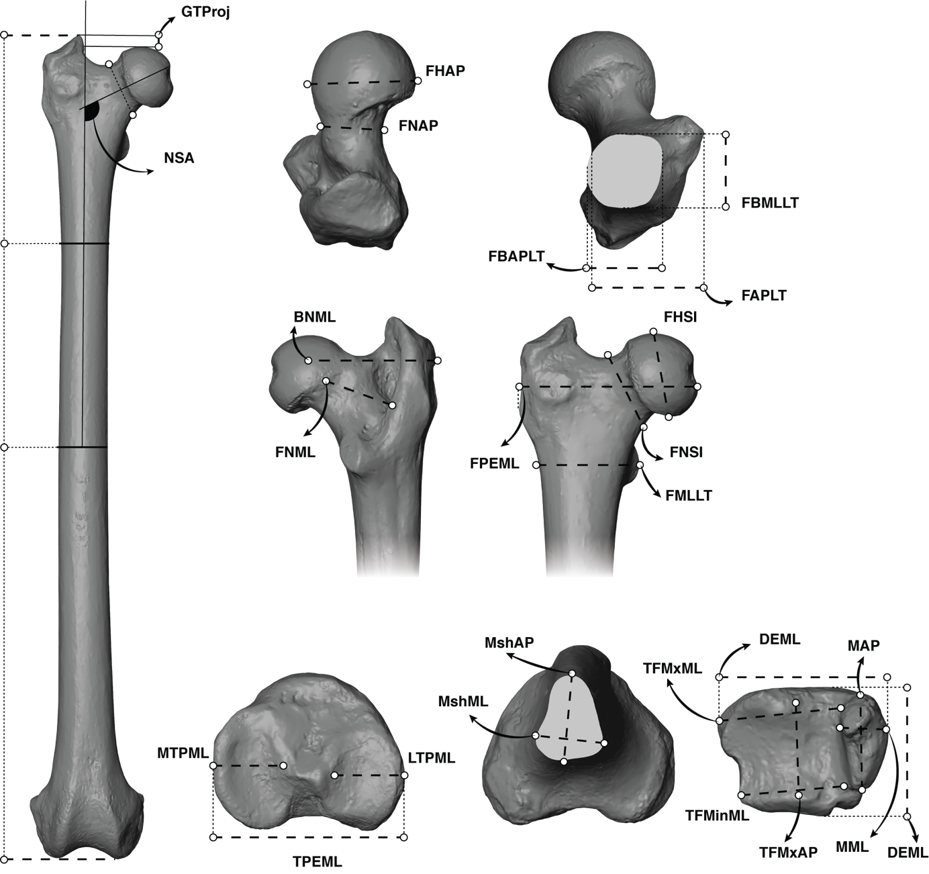

**Fig. 4**. – Femoral and tibial measurements as illustrated in *Nasalis larvatus*

Abbreviations: Ant: Anterior, Lat: Lateral, Med: Medial, Prox: Proximal, FPEML: Maximum length of the proximal epiphysis of the femur, FHSI: Maximum height of the femoral head, FHAP: Maximum breadth of the femoral head, FNML: Maximum length of the femoral neck, BNML: Biomechanical neck length of the femur, FNSI: Maximum height of the femoral neck, FNAP: Maximum breadth of the femoral neck, FMLLT: Maximum width at the level of the lesser trochanter of the femur, FBMLLT: Maximum width below the lesser trochanter of the femur, FAPLT: Maximum breadth at the level of the lesser trochanter of the femur, FBAPLT: Maximum breadth below the lesser trochanter of the femur, NSA: Collodiaphyseal angle of the femur, GTProj: Proximal projection of the greater trochanter of the femur, TPEML: Width of the proximal tibial epiphysis, MshML: Mediolateral dimension of the tibial shaft at mid-height, MshAP: Anteroposterior dimension of the tibial shaft at mid-height, DEAP: Maximum depth of the distal tibial epiphysis, DEML: Maximum breadth of the distal epiphysis, MAP: Maximum anteroposterior length of the tibial malleolus, MML: Maximum breadth of the tibial malleolus, TFMxML: Maximum width of the distal articular surface of the tibia, TFMinML: Minimum width of the distal articular surface of the tibia, TFMxAP: Maximum length of the distal articular surface of the tibia.

## ABBREVIATIONS AND ACRONYMS

Abbreviations

*Anatomical parts and orientation*

Ant: Anterior, Dent: Dental, Dist: Distal, Hum: Humerus, Fem: Femur, Lat: Lateral, Med: Medial, Prox: Proximal, Post: Posterior, Rad: Radius, Tib: Tibia, Uln: Ulna.

*Other abbreviations*

Aff: *Species* *affinis*, Cf: *Confer*, Gen: Genus, Indet: Indeterminate, IORE: International Omo Research Expedition, Fm: Formation, Kg: Kilogram, Mb: Member, MNI: Minimal number of individual, NA: Not available, OGRE: Omo Group Research Expedition, Sh: Shungura, Sp: Species, Spec: Specimen, Us: Usno

Institutional acronyms

## A.L.: Afar Locality, AMW: Amba West, ASB: Asbole, BC: Baringo County, CDA: Collodiaphyseal angle, DID: Digiba Dora, ER: East Rudolf, ITA: Intertuberosity angle, KGA: Konso Gardula Area, KNM: Kenya National Museum, KUS: Kuseralee, LAET: Laetoli, MHNL: Museum d'Histoire Naturelle de Lyon (Musée des Confluences), MNHN: Muséum Nationale d’Histoire Naturelle, NA: Nakali, NK: Narok, NMB: Naturhistorisches Museum Basel, NME: National Museum of Ethiopia, RMCA: Royal Museum for Central Africa, TM: Toros-Ménalla, UZH-MA: University of Zurich-Museum of Anthropology, VP: Vertebrate Paleontology, WT: West Turkana

Measurement abbreviations

## See Tables 4-6.

## RESULTS

Systematic palaeontology

Order PRIMATES Linnaeus, 1758

Suborder HAPLORHINI Pocock, 1918

Superfamily CERCOPITHECOIDEA Gray, 1821

Family CERCOPITHECIDAE Gray, 1821

Subfamily COLOBINAE Blyth, 1863

aff. Colobinae

Referred material. — OMO 3/0-1968-1410, and OMO 294-10006. See also Table 2.

Colobinae gen. indet. sp. indet.

Referred material. — B-818A, P 732-1, OMO 18-1967-135, OMO 165-1973-608, OMO 18-1971-702, OMO 18inf-10063, and F 501-1. See also Table 2.

Genus *Paracolobus* Leakey, 1969

Type species . — *Paracolobus chemeroni* Leakey, 1969

Other included species. — *Paracolobus* *mutiwa* Leakey, 1982, and *Paracolobus* *enkorikae* Hlusko, 2007.

Occurence in Africa. — The earliest occurrence of the genus is asserted by Late Miocene specimens of *Paracolobus* *enkorikae* in Lemudong'o (Narok County, Kenya) and the latest occurrence is securely documented by the holotype of *Paracolobus mutiwa* KNM-ER 3843 at ca. 1.87 Ma in the Koobi Fora Formation (Lake Turkana, Kenya).

*Paracolobus* cf. *mutiwa* (Figs 8; 10; 11; 17; 20 and Appendix 13)

Referred material. — W 7-477b, L 107-4, L 32-144, L 293-10004, L 5/6-41, OMO 70-10042, OMO 176-10006, L 236-1a&b, L 7-15, and OMO 222-1973-2751. See also Table 2.

Genus *Rhinocolobus* Leakey, 1982

Type species. — *Rhinocolobus turkanaensis* Leakey, 1992

Occurence in Africa. — The earliest and latest occurrences of the genus is asserted by isolated teeth from the Usno Fm. (ca. 3.4 Ma) and KBS Mb. of the Koobi Fora Formation (ca. 1.6 Ma), respectively.

*Rhinocolobus* cf. *turkanaensis* (Figs 11; 15; 18; 20)

Referred material. — L 373-3, L 78-10031, OMO 57/4-1972-164, OMO 2-10029, OMO 75/N-1971-728, OMO 50-1973-4450, and F 500-1. See also Table 2.

Genus *Colobus* Illiger, 1811

Type species. — *Colobus polykomos* Zimmerman, 1780

Other included species. — *Colobus* *satanas* Waterhouse, 1838: *Colobus* *angolensis* Sclater, 1860: *Colobus* *vellerosus* Geoffroy, 1830: *Colobus* *guereza* Rüppell, 1835: and *Colobus* *freedmani* Jablonski & Leakey, 2008.

Occurence in Africa. — The earliest securely attested occurrence of the genus is from the KBS Mb. of the Koobi Formation (ca. 1.9 Ma). The extant distribution of *Colobus* is restricted to the African equatorial zone.

Cf. *Colobus* sp. indet. (Figs 9; 23; 24)

Referred material. — OMO 342-10019, OMO 342-10335, OMO 342-10298, OMO 342-10344, OMO 342-10052, and OMO 377-10024. See also Table 2.

A detailed anatomical description of the colobine specimens considered in this study can be found in Appendix 1.

Qualitative and quantitative comparative anatomy

*Comparative anatomy of the humeral proximal epiphyses*

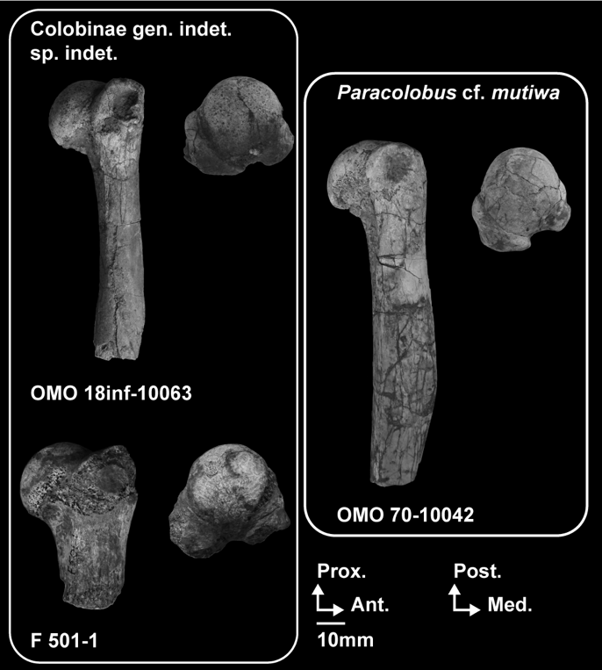There is a total of *n* = 5 proximal humerii identified here as colobine from the Omo. These include three large proximal humeri from members C (OMO 18/inf-10063), E (OMO 70-10042) and from the upper part of Member G (F 501-1) plus two smaller individuals from Member L. They are comparable in absolute size to *R. turkanaensis* (KNM-ER 1542), *Ce. williamsi*, *Ce. coronatus* and *P. chemeroni* Leakey, 1969 (Table 9 and Appendix 40).

**Fig. 5**. – Photographs of the proximal humeral anatomy of large fossil colobines from Shungura. Scale: 10 mm. Abbreviations: Ant: Anterior, Lat: Lateral, Post: Posterior, Prox: Proximal.

**Table 9. –** Measurements (in mm) of the proximal humeral specimens.

|  |  |  |  |  |  |  |  |  |  |  |
| --- | --- | --- | --- | --- | --- | --- | --- | --- | --- | --- |
|  |  | **HHSI** | **HHAP** | **HHMD** | **HPEML** | **GTAP** | **GTSI** | **LTAP** | **LTSI** | **BGML** |
| cf. *Colobus* sp. indet. | OMO 342-10052 | 12.9 | 15.9 | 16.1 | 19.8 | 14.5 | 10.8 | 9.8 |  | 5.7 |
| OMO 342-10335 | 12.6 | 16.9 | 17.2 | 22.7 | 16.3 | 12.6 | 10.9 | 12.1 | 7.5 |
| Colobinae gen. indet. sp. indet. | OMO 18inf-10063 | 25.7 | 28.0 | ~28.6 | 38.7 | 27.6 | 24.2 |  | 19.3 | ~8.3 |
| F 501-1 | 26.4 | 30.6 | 31.0 | 40.0 |  |  |  | ~18.8 |  |
| *P.* cf. *mutiwa* | OMO 70-10042 | 24.3 | 28.0 | 25.9 | 32.2 | 24.1 | 17.3 | 16.7 | 15.6 | 10.3 |

F 501-1 and OMO 18/inf-10063 (Fig. 5 and Appendix 4) show typical anatomical traits of the mobile glenohumeral joint of arboreal colobines (Appendix 4): a mediolaterally enlarged humeral head with a well-marked convexity on its anterior and proximal aspects; an obtuse bituberosity angle with tuberosities aligned in the coronal plane and a greater tuberosity that does not extend markedly above the proximal articular surface (Table 10; Rose 1988, Harrison 1989, Gebo & Sargis 1994, Nakatsukasa 1994, Arias-Martorell 2019).

**Fig. 6**. – Violin plots and boxplots of proximal humeral morphometric indices of extant and extinct colobines, and extant *Papio* spp. Morphologies associated with minimum and maximum values are shown on the margins of the graph. A.)Humeral head shape index in extant colobines (*n* = 52), *Papio* spp. (*n* = 16), and fossil colobines, and B.) Lateral humeral tuberosities development index in extant colobines (*n* = 52), *Papio* spp. (*n* = 17) and fossil colobines. Means (red diamonds), medians (black rectangles), first quartile and third quartile are plotted. When there are significant differences between taxa (*p* < 0.05), the associated *p*-values are given.

**Table 10. –** Qualitative and quantitative (mean, standard deviation and sample size) morphological observations of the proximal humeral morphology of extant cercopithecids and early colobines.

|  |  |  |  |  |
| --- | --- | --- | --- | --- |
| **Taxa**  **(in bold, Omo taxa)** | **Shape of the humeral head** | **Proximal projection of the greater tuberosity** | **Morphology of the surgical neck** | **Intertuberosity angle (ITA) and lateral projection of the tuberosities** |
| **1Colobinae gen. indet. sp. indet.** | **Rounded** | **Moderate** | **Rounded for F 501-1 but elliptical and excavated for OMO 18/inf-10063** | **Obtuse ITA and laterally projected tuberosities** |
| **2cf. *Colobus* sp. indet.** | **Rounded** | **Low** | **Elliptical and excavated** | **Obtuse ITA and non-projected tuberosities** |
| **3*P.* cf. *mutiwa*** | **Elliptical** | **Moderate** | **Elliptical and excavated** | **Acute ITA and non-projected tuberosities** |
| *P. chemeroni* | Rounded | Moderate | Elliptical | Acute ITA and non-projected tuberosities |
| *P. mutiwa* | NA. | NA. | Elliptical and excavated | NA. |
| *Ce. williamsi* | Elliptical | Moderate | Elliptical | Acute ITA and laterally projected tuberosities |
| *Ce. meaveae* | Elliptical | Moderate | Elliptical | Acute ITA and laterally projected tuberosities |
| *Ce. coronatus* | Rounded | Moderate | Elliptical | Obtuse ITA |
| *Ce. bruneti* | NA. | NA. | Elliptical | NA. |
| *R. turkanaensis* | Rounded | Moderate | Rounded | Obtuse ITA and laterally projected tuberosities |
| *Co. freedmani* | Elliptical | Moderate | Elliptical and excavated | Acute ITA and laterally projected tuberosities |
| *Co.* sp. indet. Asbole | Rounded | Low | Elliptical and excavated | Obtuse ITA and non-projected tuberosities |
| *Colobus* spp. | Rounded  (***µ* =** 106.4 ± 4.2, *n* = 16; Figure 6A) | Low | Elliptical and excavated | Obtuse ITA  Laterally projected tuberosities (***µ* =** 122.5 ± 4.8, *n* = 16; Figure 6B) |
| *Nasalis larvatus* | Rounded  (***µ* =** 102.8 ± 3.3, *n* = 6; Figure 6A) | Low | Elliptical with moderate excavation | Obtuse ITA  Non-projected tuberosities (***µ* =** 118.5 ± 4.8, *n* = 6; Figure 6B) |
| *Semnopithecus* spp. | Elliptical  (***µ* =** 101.1 ± 6.7, *n* = 5; Figure 6A) | Moderate | Elliptical with moderate excavation | Acute ITA  Laterally projected tuberosities (***µ* =** 122.4 ± 6.9, *n* = 5; Figure 6B) |
| *Papio* spp. | Rounded  (***µ* =** 110.5 ± 5.4, *n* = 15; Figure 6A) | Marked | Elliptical with moderate excavation | Acute ITA  Laterally projected tuberosities (***µ* =** 126.0 ± 5.9, *n* = 16; Figure 6B) |

1Colobinae gen. indet. sp. indet. include the following specimens: OMO 18inf-10063 and F 501-1.

2*P.* cf. *mutiwa* include the following specimens: OMO 70-10042 and OMO 222-1973-2751.

3cf. *Colobus* sp. indet. include the following specimens: OMO 342-10335 and OMO 342-10052.

Significant differences are detected between extant colobines and *Papio* spp. regarding the relative mediolateral enlargement of the articular surface of the humeral head (*p* < 0.01, Fig. 6A). OMO 18inf-10063 and F 501-1 present index values reflecting a mediolaterally enlarged and spherical humeral head (Fig. 6A and Table 10), as in *Ce. coronatus* (Fig. 6A) and *R. turkanaensis* (specimen KNM-ER 1542 in Fig. 6A, see also Appendix 6). OMO 18inf-10063 and F 501-1, with index values of 97.97 and 98.96, respectively, are outside the range of variation of *Colobus* spp. (µ = 106.4 ± 4.2, Table 10), and *Nasalis larvatus* (µ = 102.8 ± 3.3, Table 10) but are in the range of variation of *Semnopithecus* spp. (µ = 101.1 ± 6.7, Table 9 and Appendix 5).

OMO 70-10042, with an index value of 108.1 (Fig. 6A), departs from the morphological pattern of OMO 18inf-10063 and F 501-1, but is consistent with the anteroposteriorly elongated and hemispherical humeral head seen in *Papio* spp., *P. chemeroni* and *Ce. williamsi* (Fig. 6A, Table 10, Appendixes 5 and 6). Although closer to the mean value of the *Papio* spp. humeral head shape index (µ = 110.5 ± 5.4, Table 10), OMO 70-10042 is nonetheless within the range of variation of *Colobus* spp.

No significant differences are found between extant colobines and *Papio* spp. regarding the lateral projections of the humeral tuberosities (Fig. 6B and Table 10). However, the enlarged and laterally projected tuberosities of OMO 18inf-10063 (index value of 135.47) compared to F 501-1 (index value of 129.13) and OMO 70-10042 (index value of 124.2) are noteworthy (Fig. 6B). OMO 18inf-10063 is outside the range of variation of *Papio* spp., *Colobus* spp., *Nasalis* *larvatus* and *Semnopithecus* spp. (Table 10).

Two proximal humeral specimens of fossil colobines were recovered from the upper part of Member L (Fig. 7 and Appendix 7). They are similar in size to extant *Pilicolobus* spp. and *Colobus* spp. but also to *Colobus freedmani* Jablonski & Leakey, 2008, *Colobus* sp. indet. from Asbole, and an indeterminate cercopithecid from Konso (Appendix 40).

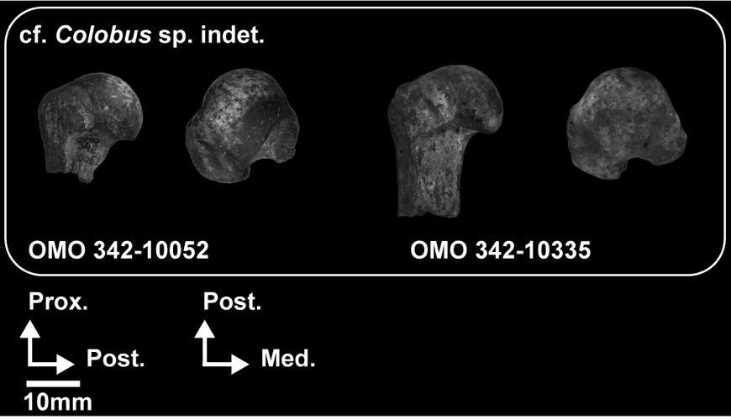**Fig. 7**. – Photographs of the proximal humeral anatomy of *Colobus* specimens from Member L. Scale: 10 mm. Abbreviations: Med: Medial, Lat: Lateral, Prox: Proximal, Post: Posterior.

Similar to OMO 18/inf-10063 and F 501-1, the Member L specimens exhibit osteological correlates of a mobile glenohumeral joint (Fig. 6A and Table 10). The Omo specimens from Member L are reminiscent of the *Colobus* sp. from Asbole in humeral head shape morphology but are quantitatively distinct from the Konso specimen KGA 4-418 and from *Colobus freedmani* (Fig. 6A and B; Appendix 7 and 8). Indeed, with humeral head shape index values of 97.40 for OMO 342-10335 and 99.12 for OMO 342-10052, they are in the range of variation of the Asbole specimens (index values of 97.11 for ASB 129 and 102.91 for ASB 137), *Nasalis* *larvatus*, and *Semnopithecus* spp. (Table 10). The index value of the lateral projection of the humeral tuberosities of OMO 342-10052 (index value of 123.44) is quite similar to that of the Asbole specimen ASB 129 (index value of 117.29) while OMO 342-10335 shows a higher index value (index value of 131.99), and hence more developed tuberosities (Fig. 6B). In relative development of the humeral tuberosities, OMO 342-10335 is most similar to the Konso specimen KGA 4-418 (Fig. 6B). The relative lateral development of the humeral tuberosities of OMO 342-10335 and OMO 342-10052 are in the range of variation of *Co. guereza* (µ = 122.5 ± 4.8, Table 10).

Qualitatively, the angle formed by the tuberosities (bituberosity angle following Rose, 1989) is obtuse in F 501-1 and OMO 18inf-10063, similarly to *R. turkanaensis*, *P. mutiwa* and *Ce. coronatus* but unlike *P. chemeroni* and *Ce. williamsi* (Table 10 and Appendix 6). Obtuse intertuberosity angle are also seen in *Co. guereza* and *N. larvatus* (Appendix 5 and Table 10) while acute intertuberosity angle are more characteristic of *Papio* and *S. entellus* (Appendix 5 and Table 10). The intertuberosity angle is obtuse in OMO 342-10335 and OMO 342-10052 and conforms with the pattern seen in *Co. guereza* and *N. larvatus* (Appendix 5 and Table 10). Obtuse angles are also seen in fossil specimens from Asbole, Konso and *Co. freedmani* (Appendix 8).

In cross-section, the humeral surgical neck of the Omo colobines is variable in shape, as previously documented in extant cercopithecids (Fleagle & Simons 1982a,Rose 1989, Gebo & Sargis 1994, Nakatsukasa 1994). Omo colobines displays either elliptical (OMO 70-10042 in Appendix 9) or rounded (F 501-1 in Appendix 6 and F 500-1 in Appendix 11) cross-sections. The elliptical (anteroposteriorly extended) cross-section of OMO 70-10042 (Appendix 9) is similar to that of *Papio hamadryas* and *Semnopithecus entellus* (Appendix 5). It is also similar to *P. chemeroni*, *Ce. coronatus* and *Ce. williamsi* (Appendix 6). The rounded anterior portion of the cross-sections of F 501-1 and F 500-1 are similar to *R. turkanaensis* KNM-ER 1542 (Appendix 6). The cross-sections of OMO 18inf-10063 and OMO 222-1973-2751 are elliptical, with a long axis set mediolaterally, as in *Colobus guereza* and *Nasalis larvatus*, and closely matching the morphology of *P. mutiwa* (Appendix 6). The small sized specimens from Member L present a cross-sectional shape distinct from the smooth and rounded one of the large specimen F 501-1. The proximal metaphysis of Member L specimens is pinched posteriorly and flanked by extensive excavations (Table 10), as seen in OMO 342-10335 and OMO 342-10052 (Appendix 7), for the *m. teres major* medially and presumably *m. deltoideus* and *m. coracobrachialis* laterally (Nakatsukasa 1994, Rose 1989). The morphology of the Member L specimens is reminiscent of *Colobus* (Table 10) and qualitatively distinct from most extant African arboreal cercopithecines (*Cercopithecus* and *Lophocebus* in Appendix 10).

*Comparative anatomy of the humeral diaphysis*

There are *n* = 5 specimens identified as colobines that preserves a significant portion of the humeral diaphysis. Four are from large bodied specimens and one is from a medium sized specimen.

As can be observed in the cross-sections set at the surgical neck, the deltopectoral crest is well pronounced proximally in the small specimens of the Member L (Fig. 7) and OMO 70-10042 (Fig. 5) whereas it shows a low relief on OMO 18/inf-10063 (Fig. 5), indicating a more distal development of the deltopectoral crest in the latter specimen. The deltopectoral crests of F 500-1 and OMO 222-1973-2751 (Fig. 8) are well preserved and not as pronounced anteroposteriorly as those observed in extant *Papio* spp. and *Ce. williamsi* (Appendix 5 and 6) but are quite similar to that of *P. mutiwa* (Appendix 11). The distal extension of the deltopectoral crest of F 500-1 and OMO 222-1973-2751 is not as pronounced as that of *Papio* (Table 11 and Appendix 5).

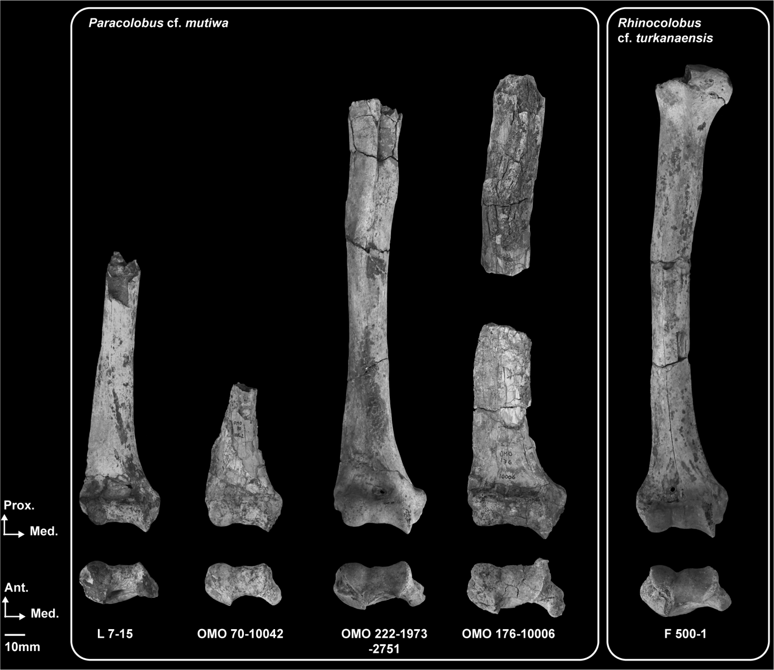The enthesis of the *m. teres major* is well marked in F 500-1 and OMO 222-1973-2751 (Fig. 8 and Table 11) but faint in OMO 70-10042 (Fig. 5 and Table 11). A raised crest is seen on the insertion site of the *m. teres major* in *Ce. williamsi*, *R. turkanaensis* and *P. mutiwa* but not in *P. chemeroni* (Appendix 5 and 11). The *m. teres major* enthesis is salient in extant colobines but usually faintly expressed in *Papio* (Table 11 and Appendix 5).

**Fig. 8**. – Photographs of the humeral anatomy of presumed specimens of *Paracolobus mutiwa* and *Rhinocolobus turkanaensis*. Scale: 10 mm. Abbreviations: Ant: Anterior, Lat: Lateral, Med: Medial, Prox: Proximal.

**Table 11. –** Qualitative and quantitative morphological observations of the diaphyseal humeral morphology of extant cercopithecids and early colobines.

|  |  |  |  |  |
| --- | --- | --- | --- | --- |
| **Taxa**  **(in bold, Omo taxa)** | **Development of the *m. teres major* enthesis** | **Diaphyseal elongation** | **Deltopectoral crest extension** | **Supracondylar crest development** |
| **1*R.* cf. *turkanaensis*** | **Moderate** | **Moderate** | **Proximally restricted** | **Moderate** |
| **2cf. *Colobus* sp. indet.** | **NA.** | **NA.** | **Proximally restricted** | **NA.** |
| **3*P.* cf. *mutiwa*** | **Moderate (OMO 70-10042) to marked (OMO 222-1973-2751)** | **Moderate** | **Proximally restricted** | **Marked** |
| *P. chemeroni* | Poor | Marked | Proximally restricted | Poorly developed |
| *P. mutiwa* | NA. | Moderate | NA. | Marked |
| *Ce. williamsi* | Marked | Reduced | Proximally restricted | Moderate |
| *Ce. meaveae* | NA. | NA. | NA. | Poorly developed |
| *Ce. coronatus* | NA. | NA. | NA. | Poorly developed |
| *Ce. bruneti* | Moderate | Moderate | Proximally restricted | Poorly developed |
| *R. turkanaensis* | Marked | NA. | NA. | Poorly developed |
| *Co. freedmani* | Poor | Moderate | Proximally restricted | Poorly developed |
| *Co.* sp. indet. Asbole | Poor | NA. | Proximally restricted | Poorly developed |
| *Colobus* spp. | Moderate to marked | Moderate | Proximally restricted | Poorly developed |
| *Nasalis larvatus* | Moderate to marked | Highly elongated | Proximally restricted | Poorly developed |
| *Semnopithecus* spp. | Moderate to marked | Moderate | Proximally restricted | Poorly developed |
| *Papio* spp. | Poor to moderate | Moderate | Distally extended | Poorly developed |
|  | | | | |

1*R.* cf. *turkanaensis* indet. include F 500-1.

2 cf. *Colobus* sp. indet. include the following specimens: OMO 342-10335 and OMO 342-10052.

3*P.* cf. *mutiwa* include the following specimens: OMO 70-10042, OMO 222-1973-2751, OMO 176-10006 and L 7-15.

The diaphyses of F 500-1 and OMO 222-1973-2751 (Fig. 8 and Appendix 12) are not as elongated as in arboreal and suspensory species such as *N. larvatus* and *Py. nemaeus* (Table 11 and Appendix 5; Birchette 1982, Rose et al. 1992, Schmitt 1998, Su & Jablonski 2009). Indeed, the humeral diaphyseal portion of those large fossil colobines is shortened compared to most extant colobines. Although buttressed, none of the Omo colobines have a shaft as robust and short as that of *Ce. williamsi* or as gracile as that of *P. chemeroni* (Appendix 11). In diaphyseal proportion and robustness, F 500-1 and OMO 222-1973-2751 are similar to *P. mutiwa* (Appendix 11 and Table 11).

Transverse cross-sections through mid-diaphysis reveal a pinched anterior side in F 500-1 and OMO 222-1973-2751 (Appendix 12) that may be a byproduct of a developed deltopectoral crest proximal to mid-diaphyseal level (Fig. 8). They also differ from the elliptical shape (with a long axis set anteroposteriorly) of cursorial and terrestrial cercopithecids (Gebo & Sargis 1994, Patel *et al.* 2013, Pallas *et al.* 2019).

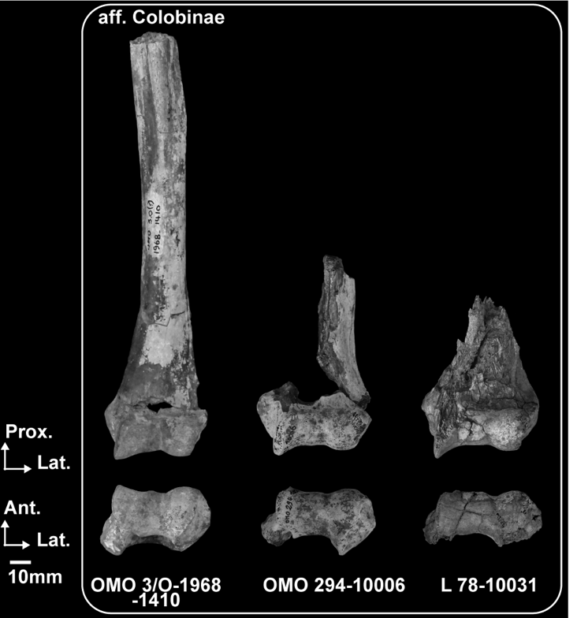OMO 3/O-1968-1410 has a well-developed deltopectoral crest and an elliptical cross-section at mid-shaft (Fig. 9 and Appendix 13) reminiscent of the condition seen in *Papio* (Appendix 5) but distinct from other Omo specimens.

**Fig. 9**. – Photographs of the humeral anatomy of presumed fossil colobines. Scale: 10 mm. Abbreviations: Ant: Anterior, Lat: Lateral, Med: Medial, Prox: Proximal.

A developed lateral supracondylar crest (insertion site of the *m. brachioradialis*)is present in OMO 222-1973-2751, OMO 70-10042, OMO 176-10006 (Fig. 8, Table 11 and Appendix 9), L 5/6-41 (Appendix 9) and L 7-15 (Fig. 8 and Appendix 12). This enlarged enthesis for the *m. brachioradialis* differs from that of *P. chemeroni*, and *Kuseracolobus hafu* (Appendix 14) but is similar to *P. mutiwa* (Appendix 14). Only a faint lateral supracondylar crest is discernable on F 500-1, OMO 3/O-1968-1410 and OMO 294-10006 (Figs 8; 9). This condition is akin to that of extant *Colobus* and *Nasalis* but contrast with the moderately developed lateral supracondylar crests observed in *Papio* (Table 11 and Appendix 5).

The large, excavated supra-articular fossae seen in OMO 222-1973-2751, OMO 70-10042, OMO 176-10006, L 7-15 (Fig. 8) and L 5/6-41 (Table 12 and Appendix 9) contrast with the weakly excavated coronoid fossae of OMO 3/O-1968-1410 (Fig. 9) and F 500-1 (Fig. 8). While both coronoid and radial fossae are excavated in the formers, there is a substantial depth difference between these fossae in *P. chemeroni*, *K. hafu*, *Co. freedmani*, *Ce. bruneti* Pallas *et al.*, 2019 and *Microcolobus* Benefit and Pickford, 1986 (Table 12, Appendixes 14 and 15). OMO 222-1973-2751, OMO 70-10042, OMO 176-10006, L 7-15 and L 5/6-41 are more similar to *P. mutiwa* and *R. turkanaensis* (Appendix 14) in this respect than to the taxa mentionned above (Table 12). The morphology of the supra-articular fossae of extant *Colobus* and *Nasalis* shows a depth differential in favor of the radial fossa as in OMO 3/O-1968-1410 and F 500-1, whereas both fossae are deep in *Papio* (Table 12 and Appendix 5).

*Comparative anatomy of the humeral distal epiphysis*

A total of *n* = 10 specimens identified here as colobine adequately preserves the distal humeral epiphysis. Five specimens are from medium sized colobine and five are from large sized colobines.

Significant differences are observed between extant colobines and *Papio* spp. regarding the angulation of the medial epicondyle (*p* < 0.01, Fig. 10A), the relative projection of the medial epicondyle (*p* < 0.05, Fig. 10A), the relative anteroposterior dimension of the distal epiphysis (*p* < 0.01, Fig. 10B), and the relative anteroposterior dimension of the zona conoidea (*p* < 0.01, Fig. 10B). Extant colobines also differs from *Papio* spp. in having humeral pillars unequal in width (*p* < 0.01, Fig. 11A), and a moderate distal extension of the medial trochlear keels (*p* < 0.01, Fig. 11B).

OMO 3/O-1968-1410 is similar to terrestrial and semiterrestrial cercopithecids in exhibiting a deep articular surface at the level of zona conoidea (Fig. 10B), a robust medial pillar (Fig. 11A), acutely angled humeral pillars, a retroflexed medial epicondyle (Fig. 10A), and an anteriorly projecting medial trochlear keel (Table 12). More precisely, OMO 3/O-1968-1410 present a relative depth of the articular surface at the level of zona conoidea of 50.12 and fits outside the range of variation of *Co. guereza*, *N. larvatus* and *S. entellus* but within that of 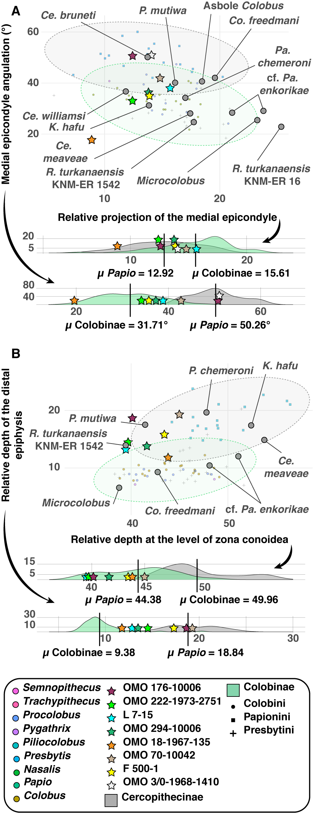*Papio* (µ = 49.2 ± 3.4, Table 12).

**Fig. 10**. (previous page) – Scatterplots of distal humeral indices of extant and extinct colobines and extant *Papio* spp. 95 % normal confidence ellipses (given a multivariate normal distribution) are drawn for colobines and *Papio* spp. Kernel density estimates are given for each axis below the scatterplots. A.) Regression of medial epicondyle angulation on the relative projection of the medial epicondyle in extant colobines (*n* = 51), *Papio* spp. (*n* = 19) and fossil colobines. B.)Relative anteroposterior dimensions of the humeral distal articular surface regressed on the relative anteroposterior dimension of the humeral distal articular surface at the zona conoïdea in extant colobines (*n* = 56), *Papio* spp. (*n* = 19) and fossil colobines.

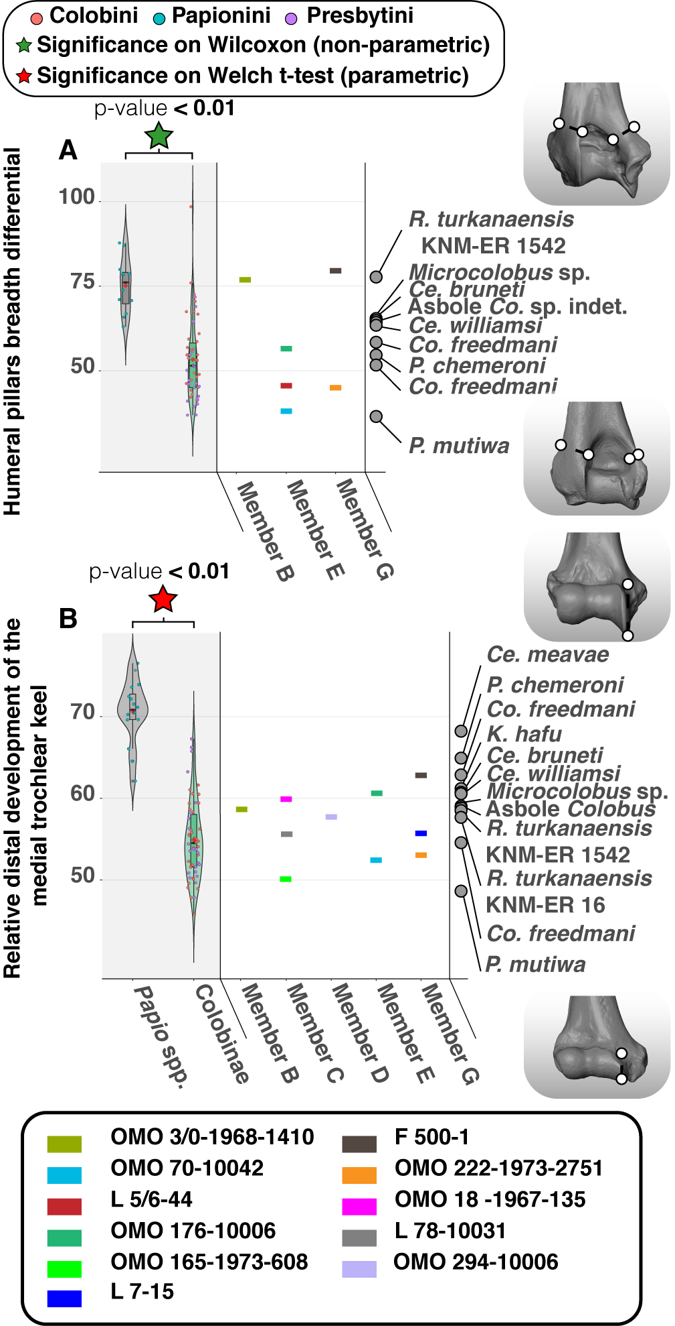

**Fig. 11**. (previous page) – Violin plots and boxplots of distal humeral morphometric indices of extant and extinct colobines and extant *Papio* spp. Morphologies associated with minimum and maximum values are shown on the right of the graph. A.*)* Humeral pillars breadth differential in extant colobines (*n* = 50), *Papio* spp. (*n* = 13), and fossil colobines, and B.)Relative distal development of the medial trochlear keel in extant colobines (*n* = 54), *Papio* spp. (*n* = 17) and fossil colobines. Means (red diamonds), medians (black rectangles), first quartile and third quartile plotted. When there are significant differences between taxa (*p* < 0.05), the associated *p*-values are given.

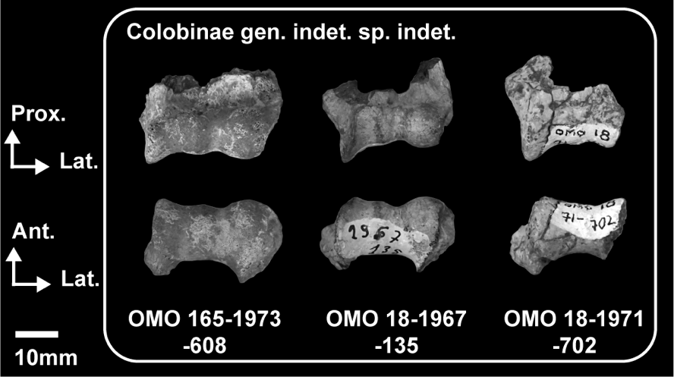The relative robustness of its medial pillar (76.82) is also outside the range of variation of *Co. guereza*, *N. larvatus* and *S. entellus* but within that of *Papio* (µ = 75.1 ± 8.0, Table 12). Nevertheless, OMO 3/O-1968-1410 also has a large posterior trochlear articular surface, a poorly distally extended medial trochlear keel (Fig. 11B) and a globular capitulum that demonstrate a morphologically distinct humeroulnar and humeroradial joints compared to *Papio*. The mediolaterally restricted articular surface of OMO 3/O-1968-1410 and its anteroposterior depth at the level of zona conoidea are similar to *Cercopithecoides meaveae* Frost & Delson, 2002 and *K. hafu* but different from those of *Paracolobus mutiwa* and *Rhinocolobus turkanaensis* (Appendix 14).

**Fig. 12**. – Photographs of the humeral anatomy of medium-sized colobines from Member C. Scale: 10 mm. Abbreviations: Ant: Anterior, Lat: Lateral, Med: Medial, Prox: Proximal.

Most of the Omo colobines present medial epicondyles facing medially or slightly posteriorly, as seen in extant colobines apart from *S. entellus*. OMO 176-10006 (Fig. 8) and OMO 3/O-1968-1410 (Fig. 9) shows a condition very similar to *Ce. bruneti* and *S. entellus* (Fig. 10A).

**Table 12. –** Qualitative and quantitative morphological observations of the distal humeral morphology of extant cercopithecids and early colobines.

|  |  |  |  |  |  |  |  |
| --- | --- | --- | --- | --- | --- | --- | --- |
| **Taxa**  **(in bold, Omo taxa)** | **Coronoid fossa depth** | **Humeral pillars morphology (angulation and breadth differential)** | **Trochlea mediolateral enlargement** | **Medial trochlear keel anterior and distal extension** | **Anteroposterior (at the level of zona conoidea) depth of the distal articular surface** | **Shape of the capitulum and depth of the zona conoidea** | **Angulation and development of the medial epicondyle** |
| **1*R.* cf. *turkanaensis*** | **Shallow** | **Angulated with a poor to moderate breadth differential** | **Moderately enlarged** | **Moderate to marked anterior and distal extensions** | **Shallow articular surface** | **Spherical and deep** | **Medialized and moderately developed** |
| **2Colobinae gen. indet. and sp. indet.** | **Shallow** | **NA.** | **Weakly enlarged** | **Moderate to marked anterior and distal extensions** | **Deep articular surface** | **Spherical and deep** | **Medialized and weakly developed** |
| **3*P.* cf. *mutiwa*** | **Deep** | **Angulated with a marked breadth differential** | **Moderate to markedly enlarged** | **Moderate to marked anterior and distal extensions** | **Shallow articular surface** | **Spherical and deep** | **Moderately retroflexed and markedly developed** |
| *P. chemeroni* | Shallow | Angulated with a marked breadth differential | Moderately enlarged | Moderate anterior and distal extensions | Deep articular surface | Spherical and deep | Medialized and moderately developed |
| *P. mutiwa* | Deep | Angulated with a marked breadth differential | Markedly enlarged | Moderate anterior and distal extensions | Shallow articular surface | Spherical and deep | Moderately retroflexed and markedly developed |
| *Ce. williamsi* | NA. | Angulated and possibly with a moderate breadth differential | Weakly enlarged | Marked anterior and distal extensions | Deep articular surface | Flat and shallow | Retroflexed and weakly developed |
| *Ce. meaveae* | NA. | Angulated with a marked breadth differential | Weakly enlarged | Marked anterior and distal extensions | Deep articular surface | Flat and shallow | Medialized and weakly developed |
| *Ce. coronatus* | NA. | Angulated with a moderate breadth differential | Weakly enlarged | Marked anterior and distal extensions | Deep articular surface | Spherical and deep | Retroflexed and weakly developed |
| *Ce. bruneti* | Shallow | Angulated with a poor breadth differential | Weakly enlarged | Marked anterior and distal extensions | Shallow articular surface | NA. | Retroflexed and weakly developed |
| *R. turkanaensis* | Shallow | Angulated with a poor breadth differential | Moderate to markedly enlarged | Moderate to marked anterior and distal extensions | Shallow articular surface | Spherical and deep | Medialized and markedly developed |
| *K. hafu* | Shallow | Straight with a marked breadth differential | Weakly enlarged | Moderate anterior and distal extensions | Deep articular surface | Spherical and deep | Medialized and weakly developed |

**Table 12 (following). –** Qualitative and quantitative morphological observations of the distal humeral morphology of extant cercopithecids and early colobines.

|  |  |  |  |  |  |  |  |
| --- | --- | --- | --- | --- | --- | --- | --- |
| **Taxa** | **Coronoid fossa depth** | **Humeral pillars morphology (angulation and breadth differential)** | **Trochlea mediolateral enlargement** | **Medial trochlear keel anterior and distal extension** | **Anteroposterior (at the level of zona conoidea) depth of the distal articular surface** | **Shape of the capitulum and depth of the zona conoidea** | **Angulation and development of the medial epicondyle** |
| *Co. freedmani* | Shallow | Angulated with a moderate breadth differential | Markedly enlarged | Marked anterior and distal extensions | Shallow articular surface | Spherical and deep | Moderately retroflexed and markedly developed |
| *Microcolobus* sp. | Shallow | Straight with a marked breadth differential | Markedly enlarged | Moderate anterior and distal extensions | Shallow articular surface | Spherical and deep | Medialized and markedly developed |
| *Co.* sp. indet. Asbole | Shallow | Angulated with a moderate breadth differential | Markedly enlarged | Moderate anterior and distal extensions | Shallow articular surface | Spherical and deep | Medialized and markedly developed |
| *Colobus* spp. | Shallow | Angulated with a moderate to marked breadth differential (***µ* =** 54.6 ± 11.9, *n* = 16; Figure 11A) | Markedly enlarged | Shallow anterior extension, and moderate distal extension (***µ* =** 54.4 ± 4.4, *n* = 16; Figure 11B) | Shallow articular surface (***µ* =** 44.0 ± 3.4, *n* = 16; Figure 10B) | Spherical and deep | Medialized (***µ* =** 32.8 ± 4.4°, *n* = 16; Figure 10A), and markedly developed epicondyle (14.9 ± 2.7, *n* = 16; Figure 10A) |
| *Nasalis larvatus* | Shallow | Straight with a marked breadth differential (***µ* =** 41.2 ± 11.9, *n* = 6; Figure 11A) | Weakly enlarged | Shallow anterior extension, and shallow distal extension (***µ* =** 52.0 ± 3.3, *n* = 6; Figure 11B) | Deep articular surface (***µ* =** 46.6 ± 2.8, *n* = 6; Figure 10B) | Spherical and deep | Medialized (***µ =*** 28.3 ± 3.7°, *n* = 6; Figure 10A), and weakly developed epicondyle (***µ =*** 12.6 ± 4.0, *n* = 6; Figure 10A) |
| *Semnopithecus* spp. | Shallow | Angulated with a moderate to marked breadth differential (***µ* =** 55.4 ± 6.2, *n* = 5; Figure 11A) | Weakly enlarged | Moderate to marked anterior extension, and moderate to marked distal extension (***µ* =** 66.6 ± 1.3, *n* = 5; Figure 11B) | Deep articular surface (***µ* =** 47.3 ± 2.5, *n* = 5; Figure 10B) | Spherical and shallow | Moderately retroflexed epicondyle (***µ =*** 36.4 ± 7.0°, *n* = 3; Figure 10A), and moderately developed epicondyle (***µ =*** 16.7 ± 1.8, *n* = 3; Figure 10A) |
| *Papio* spp. | Deep | Straight with a poor breadth differential (***µ* =** 75.1 ± 8.0, *n* = 12; Figure 11A) | Weakly to moderately enlarged | Marked anterior extension, and marked distal extension (***µ* =** 70.6 ± 3.8, *n* = 16; Figure 11B) | Deep articular surface (***µ* =** 49.2 ± 3.4, *n* = 18; Figure 10B) | Flat and shallow | Retroflexed epicondyle (***µ =*** 49.7 ± 5.3°, *n* = 18; Figure 10A), and weakly developed epicondyle (***µ =*** 13.6 ± 3.3, *n* = 3; Figure 10A) |

1*R.* cf. *turkanaensis* indet. include F 500-1.

2 Colobinae gen. indet.sp. indet. include the following specimens: OMO 165-1973-608, OMO 18-1967-135 and OMO 18-1971-702.

3*P.* cf. *mutiwa* include the following specimens: OMO 70-10042, OMO 222-1973-2751, OMO 176-10006, L 7-15 and L 5/6-41.

Variation in the size of the medial epicondyle is observed in the Omo colobines. OMO 18-1967-135 (Fig. 12 and Appendix 16) and OMO 176-10006 (Fig. 8 and Appendix 9) illustrate extrema of this range of variation with shortened and well-developed medial epicondyles, respectively. Quantitatively, the shortened medial epicondyle of OMO 18-1967-135 is comparable to *N. larvatus* (Fig. 10A and Appendix 17A), *K. hafu* and *P. chemeroni* while the large medial epicondyle of OMO 176-10006 is reminiscent of the condition seen in extant Colobini and *P. mutiwa* (Fig. 10A and Appendix 17A). In anterior view, the medial epicondyles of OMO 176-10006, OMO 222-1973-2751 and L 7-15 are especially large and show a distinct proximal projection on their superomedial aspects, as also seen in *P. mutiwa* (Fig. 8 and Appendix 14).

The capitular tails of L 7-15 and OMO 222-1973-2751 are large and have distinct lateral projections in anterior view (Figure 8). A particular large capitular tail is also observed in *S. entellus* (Appendix 5).

Despite marked differences in absolute dimensions (Table 13 and Appendix 43), OMO 176-10006 (Fig. 8) and OMO 18-1967-135 (Fig. 12) both have distally extended medial trochlear keels in anterior view (Fig. 11B) and posteriorly projected lateral humeral pillars in inferior view, as also seen frequently in *S. entellus* and *Ce. williamsi* (Appendix 5 and 14), but seldom in *Co. guereza* and *N. larvatus* (Appendix 5). Indeed, with an index value of 60.6, OMO 176-10006 is outside the normal range of variation of *Co. guereza* (µ = 54.4 ± 4.4, Table 12) but fits with outlying *Co. guereza* specimens of our sample (e.g., the male *Co. guereza* MNHN 1904-1963).

A deep zona conoidea and a globular capitulum are seen in all Omo specimens but OMO 294-10006 (Fig. 9). The zona conoidea is well excavated in *N. larvatus* compared to the shallow zona conoidea of *S. entellus* (Appendix 5), and specimens of the latter taxa match the shallowness of the zona conoidea of OMO 294-10006 (Appendix 13). Relatively shallow zona conoidea are also observed in *Ce. williamsi* and *Ce. meaveae* (Appendix 14 and 15, and Table 12).

Narrow trochleae (i.e., weakly enlarged in Table 12) are observed in OMO 18-1967-135, OMO 18-1971-702 and OMO 165-1973-608 (Fig. 12), and contrasts with the enlarged trochlea of OMO 176-10006, L 7-15 and OMO 222-1973-2751 (Table 12). An enlarged trochlea is seen in *Co. guereza* in contrast with the mediolaterally short trochlea of *N. larvatus* and *S. entellus* (Table 12 and Appendix 5).

Proximally extended olecranon fossae, gracile medial pillars and acutely angled pillars are seen in all Omo specimens but OMO 3/O-1968-1410 (Fig. 9 and Table 12). Gracile (mediolaterally shortened) medial pillars are observed in most extant and early colobines (Fig. 11A and Table 12) and is absent in the fossil papionin *T. brumpti* (Appendix 18). *R. turkanaensis* and F 500-1, like OMO 3/O-1968-1410, stand apart from this pattern by having pillars of equal width (i.e., poor pillar breadth differential in Table 12) and a clear buttressing of the medial pillar compared to other colobines (Fig. 11A).

**Table 13. –** Measurements (in mm) of the distal humeral specimens

|  |  |  |  |  |  |  |  |  |  |  |
| --- | --- | --- | --- | --- | --- | --- | --- | --- | --- | --- |
|  | **Specimens** | **HRJML** | **CML** | **CSI** | **TML** | **TSI** | **DJML** | **DJML2** | **BIEPIC** | **OFSI** |
| Colobinae gen. indet. sp. indet. | OMO 165-1973-608 | 14.1 | 10.3 | 12.3 | 11.5 | 14.6 | 25.9 | 30.1 |  |  |
| OMO 18-1967-135 | 13.7 | 9.8 | 10.8 | 9.4 | 16.1 | 23.4 | 27.7 | 29.7 |  |
| OMO 18-1971-702 |  |  |  | 11.4 | 15.5 |  |  |  |  |
| aff. Colobinae | OMO 3/0-1968-1410 | 15.9 | 11.4 | 16.4 | 11.9 | 16.5 | 28.1 | 32.7 | 36.9 | 13.3 |
| OMO 294-10006 | 15.1 | 12.3 | 15.9 | 13.9 | 17.1 | 29.6 | ~35.4 | 41.1 |  |
| *R*. cf. *turkanaensis* | L 78-10031 | ~15.3 | ~11.8 | 15.3 | 14.0 | ~16.9 | 30.4 | 37.4 | 40.8 |  |
| F 500-1 | >18.1 | >12.3 | 16.0 | 14.9 | 20.7 | >32.9 | 38.2 | 44.6 | 14.4 |
| *P*. cf. *mutiwa* | OMO 176-10006 | 20.1 | 13.6 | 18.0 | 16.8 | 22.6 | 37.2 | 43.0 | 49.1 | 19.4 |
| OMO 70-10042 | 17.1 | 12.3 | 16.1 | 13.8 | 16.3 | 31.1 | 33.5 | 39.3 | 15.7 |
| L 5/6-41 |  |  |  |  |  |  |  |  | 18.8 |
| L 7-15 | 15.8 | 11.2 | 14.1 | 14.0 | 18.1 | 32.5 | 36.4 | 41.5 | 17.5 |
| OMO 222-1973-2751 | 17.3 | 13.2 | 16.5 | 16.7 | 18.1 | 34.2 | 39.3 | 44.9 | 16.3 |
|  |  |  |  |  |  |  |  |  |  |  |

**Table 13 (following). –** Measurements (in mm) of the distal humeral specimens

|  |  |  |  |  |  |  |  |  |  |  |  |  |  |
| --- | --- | --- | --- | --- | --- | --- | --- | --- | --- | --- | --- | --- | --- |
|  | **Specimens** | **OFML** | **LPillML** | **MPillML** | **LPMxAP** | **MPMxAP** | **ZCMinAP** | **MEAng (°)** | | **DeltAP** | | **DeltML** | |
| Colobinae gen. indet. sp. indet. | OMO 165-1973-608 | 14.5 |  |  |  |  | 15.9 |  |  | |  | |
| OMO 18-1967-135 |  |  |  | 18.5 | 16.0 | 10.3 | 17.7° |  | |  | |
| OMO 18-1971-702 |  |  |  |  |  |  |  |  | |  | |
| aff. Colobinae | OMO 3/0-1968-1410 |  | 11.1 | 8.5 |  | 23.4 | 14.1 | 51.1° | 17.8 | | 17.9 | |
| OMO 294-10006 | ~17.3 | 11.0 |  | 24.0 | 20.7 | 14.7 | 36.5° |  | |  | |
| *R*. cf. *turkanaensis* | L 78-10031 |  |  |  |  |  | 12.8 |  |  | |  | |
| F 500-1 | 19.8 | 10.1 | 8.0 | 23.9 | 21.8 | 14.3 | 35.1° | 17.6 | | 22.1 | |
| *P*. cf. *mutiwa* | OMO 176-10006 | 18.9 | 15.0 | 8.4 | 25.8 | 27.1 | 14.9 | 50.7° |  | |  | |
| OMO 70-10042 | 16.4 | 14.6 | 5.7 | 21.6 | 22.4 | 14.9 | 42.1° |  | |  | |
| L 5/6-41 | 20.7 | ~14.8 | 6.7 |  |  | 14.4 |  |  | |  | |
| L 7-15 | 19.7 | 13.8 | 3.8 | 22.6 | >19.1 | 12.8 | 38.2° |  | |  | |
| OMO 222-1973-2751 | 18.4 | 15.3 | 6.9 | 22.4 | 22.1 | 13.6 | 33.2° | 19.4 | | 19.4 | |

*Comparative anatomy of the ulnar proximal epiphysis and diaphysis*

The proximal ulnar and diaphyseal anatomy of the Lower Omo Valley colobines is represented by *n* = 7 specimens of various dimensions (Appendix 44) from Usno (B-818A) and Shungura members B (P 732-1), C (L 293-10004, L 107-4, L 32-144 and L 373-3), and E (L 236-1a and OMO 57/4-1972-164).

We found significant differences between *Papio* spp. and extant colobines for the proximal projection of the olecranon process (*p <* 0.01, Fig. 14A), notably with *Nasalis* and *Pygathrix* showing a shorter olecranon compared to extant baboons and other colobines (Appendix 19). The olecranon process of *Papio* is also significantly more retroflexed than that of extant colobines (*p* < 0.01, Fig. 14B and Appendix 19), and the lateral projection of the coronoid and radial notch is significantly more pronounced in *Papio* than in extant colobines (*p* < 0.01, Fig. 14C).

Absolutely (Fig. 13 and Table 14) and relatively (Fig. 14A) short olecranon processes are present in OMO 57/4-1972-164 and L 373-3, similar to the shortened olecranon of the odd-nosed monkeys *Nasalis* and *Pygathrix* (Table 15, Appendix 19B, and see also Su & Jablonski 2009), but distinct from extant baboons and *Co. guereza* (Table 15 and Appendix 20). Indeed, L 373-3 (with an index value of 65.82) and OMO 57/4-1972-164 (with an index value of 75.94) have index values much closer to the range of variation of *N. larvatus* (µ = 70.7 ± 9.7, Table 15, and Appendix 19B) than that of *Co. guereza* (µ = 94.6 ± 12.0, Table 15, and Appendix 19B). Shortened olecranon processes are also observed in *Ce. bruneti* (Appendix 21), *P. chemeroni*, *K. hafu* and *R. turkanaensis* (Fig. 14A and Appendix 22). The proximal part of the olecranon of OMO 57/4-1972-164 and L 373-3 is also oriented posteriorly (i.e., retroflexed, see Fig. 14B, Table 15 and Appendix 17A). Whereas the olecranon of *Papio* spp. is significantly more retroflexed than that of extant colobines (Fig. 14B), the olecranon of the suspensory *Nasalis larvatus* and *Pygathrix nemaeus* is more retroflexed than that of the arboreal quadrupeds *Colobus* and *Trachypithecus* (Appendix 19A). Overall, the morphology of the olecranon processes of OMO 57/4-1972-164 and L 373-3 matches that of suspensory colobines by presenting a short and slightly retroflexed olecranon (Table 15, and Appendix 19 and 20).

**Table 14. –** Measurements (in mm) of the ulnar specimens

|  |  |  |  |  |  |  |  |  |  |  |  |  |  |  |  |
| --- | --- | --- | --- | --- | --- | --- | --- | --- | --- | --- | --- | --- | --- | --- | --- |
|  | **Specimens** | **SNSI** | **SNDP** | **OPAP** | **OPML** | **OPSI** | **OlecAng** | **APML** | **APAP** | **CPML** | **CPAP** | **CPRNML** | **SNAPMh** | **RNAP** | **RNSI** |
| Colobinae gen. indet. sp. indet. | B-818a |  |  | 15.1 |  | 15.7 |  | 11.0 | ~18.9 |  |  |  | 10.7 |  | >8.4 |
| P 732-1 | 13.1 |  | 15.0 |  | 13.2 |  |  |  |  |  |  | 11.3 |  |  |
| *P*. cf. *mutiwa* | L 236-1a | 17.2 | 10.7 | 19.7 | 16.9 | 22.7 | 50.0° | 16.1 | 27.6 | 13.4 | 31.8 | 26.7 | 16.7 | 20.8 | 13.7 |
| L 293-10004 | 16.6 | 9.7 | 16.5 | ~11.2 | 16.2 | 55.0° | 10.6 | 20.9 | 8.9 | >22.9 | 16.0 | 13.0 | >14.7 | 10.1 |
| L 32-144 | 15.8 | 10.0 | 16.8 |  | >16.1 | 56.6° | 11.8 | 22.0 | 11.1 | 22.0 | 18.9 | 13.6 | 16.8 | 10.4 |
| L 107-4 | 17.3 | 10.8 | 25.2 | 18.3 | 25.8 | 56.7° | 16.4 | 33.6 | 18.3 | 35.9 | 26.2 | 22.8 | 20.6 | 10.7 |
| *R.* cf. *turkanaensis* | L 373-3 | 15.8 | 10.3 | 16.9 |  | 10.4 | 61.4° | 11.3 | 19.6 | 10.0 |  | 18.6 | 11.6 | >13.1 | 10.5 |
| OMO 57/4-1972-164 | 16.0 | 9.1 | 19.0 | 14.6 | 12.1 | 59.2° | 15.1 | 22.2 | 12.1 | 24.6 | 22.3 | 13.7 | 17.4 |  |

**Table 15. –** Qualitative and quantitative morphological observations of the ulnar anatomy of extant cercopithecids and early colobines.

|  |  |  |  |  |  |
| --- | --- | --- | --- | --- | --- |
| **Taxa**  **(in bold, Omo taxa)** | **Diaphyseal and olecranon angulations in the sagittal plane** | **Olecranon process proximal projection** | **Anconeal process asymmetry** | **Coronoid articular surface width and orientation** | **Radial notch subdivision** |
| **1*R.* cf. *turkanaensis*** | **Straight diaphysis, and slight olecranon retroflexion** | **Poor projection** | **Poor** | **Absence of marked differential in width of the articular surface along its length, and poor to moderate distal slanting** | **Absent** |
| **2*P.* cf. *mutiwa*** | **Straight diaphysis, and straight olecranon** | **Marked projection** | **Moderate** | **Presence of a marked to moderate differential in width of the articular surface along its length, and moderate to marked distal slanting** | **Moderate (L 293-10004) and marked subdivision (L 236-1a)** |
| *P. chemeroni* | Straight diaphysis, and straight olecranon | Moderate projection | Poor | Presence of a moderate differential in width of the articular surface along its length, and moderate distal slanting | Absent |
| *P. mutiwa* | NA. | NA. | NA. | NA. | Marked subdivision |
| *Ce. williamsi* | Curved diaphysis (posterior concavity), and retroflexed olecranon | Poor projection | Marked | Absence of a marked differential in width of the articular surface along its length, and marked distal slanting | Marked subdivision |
| *Ce. meaveae* | Retroflexed olecranon | Moderate projection | Moderate | Absence of a marked differential in width of the articular surface along its length, and moderate distal slanting | Moderate subdivision |
| *Ce. coronatus* | NA. | NA. | Moderate | NA. | Marked subdivision |
| *Ce. bruneti* | Straight diaphysis, and straight olecranon | Poor projection | Moderate | NA. | Moderate subdivision |
| *R. turkanaensis* | Straight diaphysis, and straight olecranon | Moderate projection | Poor | Presence of a moderate differential in width of the articular surface along its length, and moderate distal slanting | Absent |
| *Co. freedmani* | Curved diaphysis (anterior concavity), and anteflexed olecranon | Marked projection | Poor | Marked differential in width of the articular surface along its length, and poor distal slanting | Absent |
| *Microcolobus* sp. | Curved diaphysis (anterior concavity), and anteflexed olecranon | Marked projection | Poor | Moderate differential in width of the articular surface along its length, and poor distal slanting | Absent |
| *Co.* sp. indet. Asbole | Curved diaphysis (anterior concavity), and anteflexed olecranon | Marked projection | Poor | Marked differential in width of the articular surface along its length, and poor distal slanting | Moderate subdivision |

**Table 15 (following). –** Qualitative and quantitative morphological observations of the ulnar anatomy of extant cercopithecids and early colobines.

|  |  |  |  |  |  |
| --- | --- | --- | --- | --- | --- |
| **Taxa** | **Diaphyseal and olecranon angulations in the sagittal plane** | **Olecranon process proximal projection** | **Anconeal process asymmetry** | **Coronoid articular surface width and orientation** | **Radial notch subdivision** |
| *Colobus* spp. | Curved diaphysis (anterior concavity), and anteflexed olecranon (***µ* = 38**.7 ± 5.0°, *n* = 20; Figure 13B) | Moderate to marked projection (***µ* = 94**.6 ± 12.0, *n* = 19; Figure 13A) | Poor | Marked to moderate differential in width of the articular surface along its length, and poor to moderate distal slanting | Absent to moderate subdivision |
| *Nasalis larvatus* | Straight diaphysis, and straight to moderate retroflexion of the olecranon (***µ* = 48**.4 ± 3.4°, *n* = 9; Figure 13B) | Poor projection (***µ* = 70**.7 ± 9.7, *n* = 7; Figure 13A) | Poor | Moderate differential in width of the articular surface along its length, and poor distal slanting | Absent |
| *Semnopithecus* spp. | Straight diaphysis, and straight to moderate retroflexion of the olecranon (***µ* = 50**.8 ± 5.5°, *n* = 7; Figure 13B) | Marked projection (***µ* = 110**.7 ± 12.6, *n* = 4; Figure 13A) | Moderate | Marked differential in width of the articular surface along its length, and moderate to marked distal slanting | Moderate to marked subdivision |
| *Papio* spp. | Straight to curved diaphysis (posterior concavity), and retroflexed olecranon (***µ* = 60.3** ± 4.9°, *n* = 30; Figure 13B) | Marked projection (***µ* = 118**.7 ± 11.3, *n* = 12; Figure 13A) | Marked | Marked differential in width of the articular surface along its length, and marked distal slanting | Marked subdivision |

1*R.* cf. *turkanaensis* indet. include the following specimens: L 373-3 and OMO 57/4-1972-164.

2*P.* cf. *mutiwa* include the following specimens: L 107-4, L 236-1a, L 293-10004 and L 32-144.

Long and straight olecranon processes are observed in L 107-4, L 236-1a, and L 293-10004 (Figs 13; 14A; 14B). As such, these specimens are reminiscent of climbers and semiterrestrial primates such as *Semnopithecus entellus* (Appendix 20). Indeed, the relatively long olecranon of L 107-4 (with an index value of 149.13), L 236-1a (with an index value of 131.55) and L 293-10004 (with an index value of 97.89) are closer to *S. entellus* (µ = 110.7 ± 12.6) than to *Co. guereza* and *N. larvatus* (Table 15). The moderate proximal extension and slight retroflexion of the olecranon process of L 32-144 (Appendix 23) is also more consistent with the morphology of L 236-1a and L 293-10004 than that of L 373-3 and OMO 57/4-1972-164 (Fig. 13). None of the Omo colobines have an anteflexed olecranon, contrary to the marked anteflexion of some of their extant (*Trachypithecus* and *Colobus* in Appendix 19A and 20) and fossil counterparts (*Co. freedmani* and *Microcolobus* in Appendix 21). With a straight and moderately long olecranon process, B-818A and P 732-1 (Appendix 23) present an olecranon morphology intermediate between that of L 373-3 and L 107-4 (Fig. 14A).

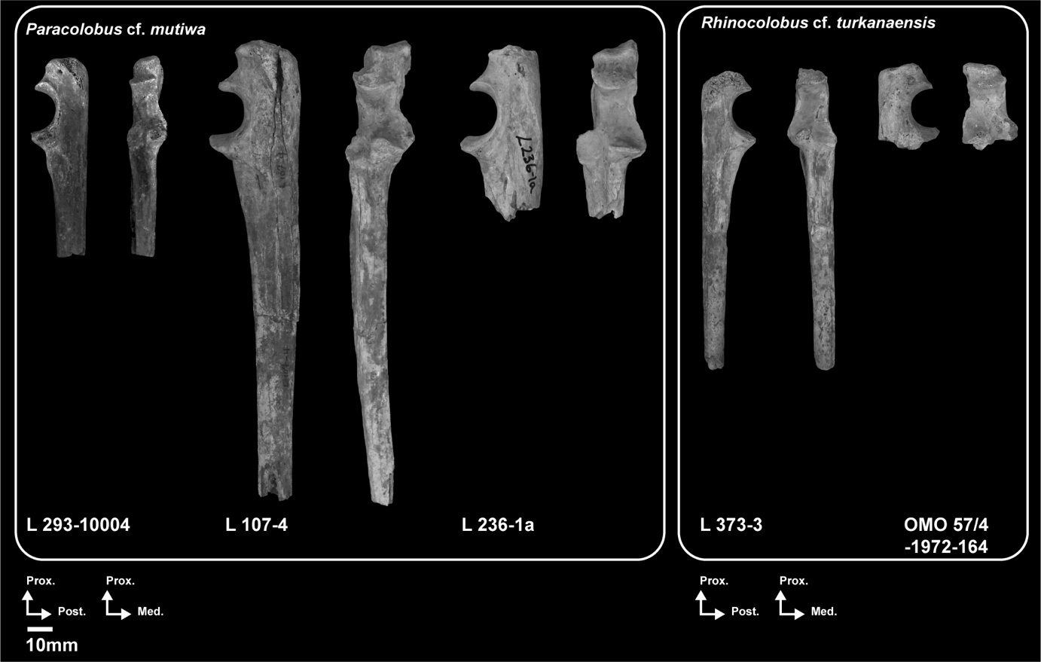

**Fig. 13**. – Photographs of the ulnar anatomy of presumed *Rhinocolobus* and *Paracolobus* specimens from Shungura. Scale: 10 mm. Abbreviations: Ant: Anterior, Lat: Lateral, Med: Medial, Prox: Proximal.

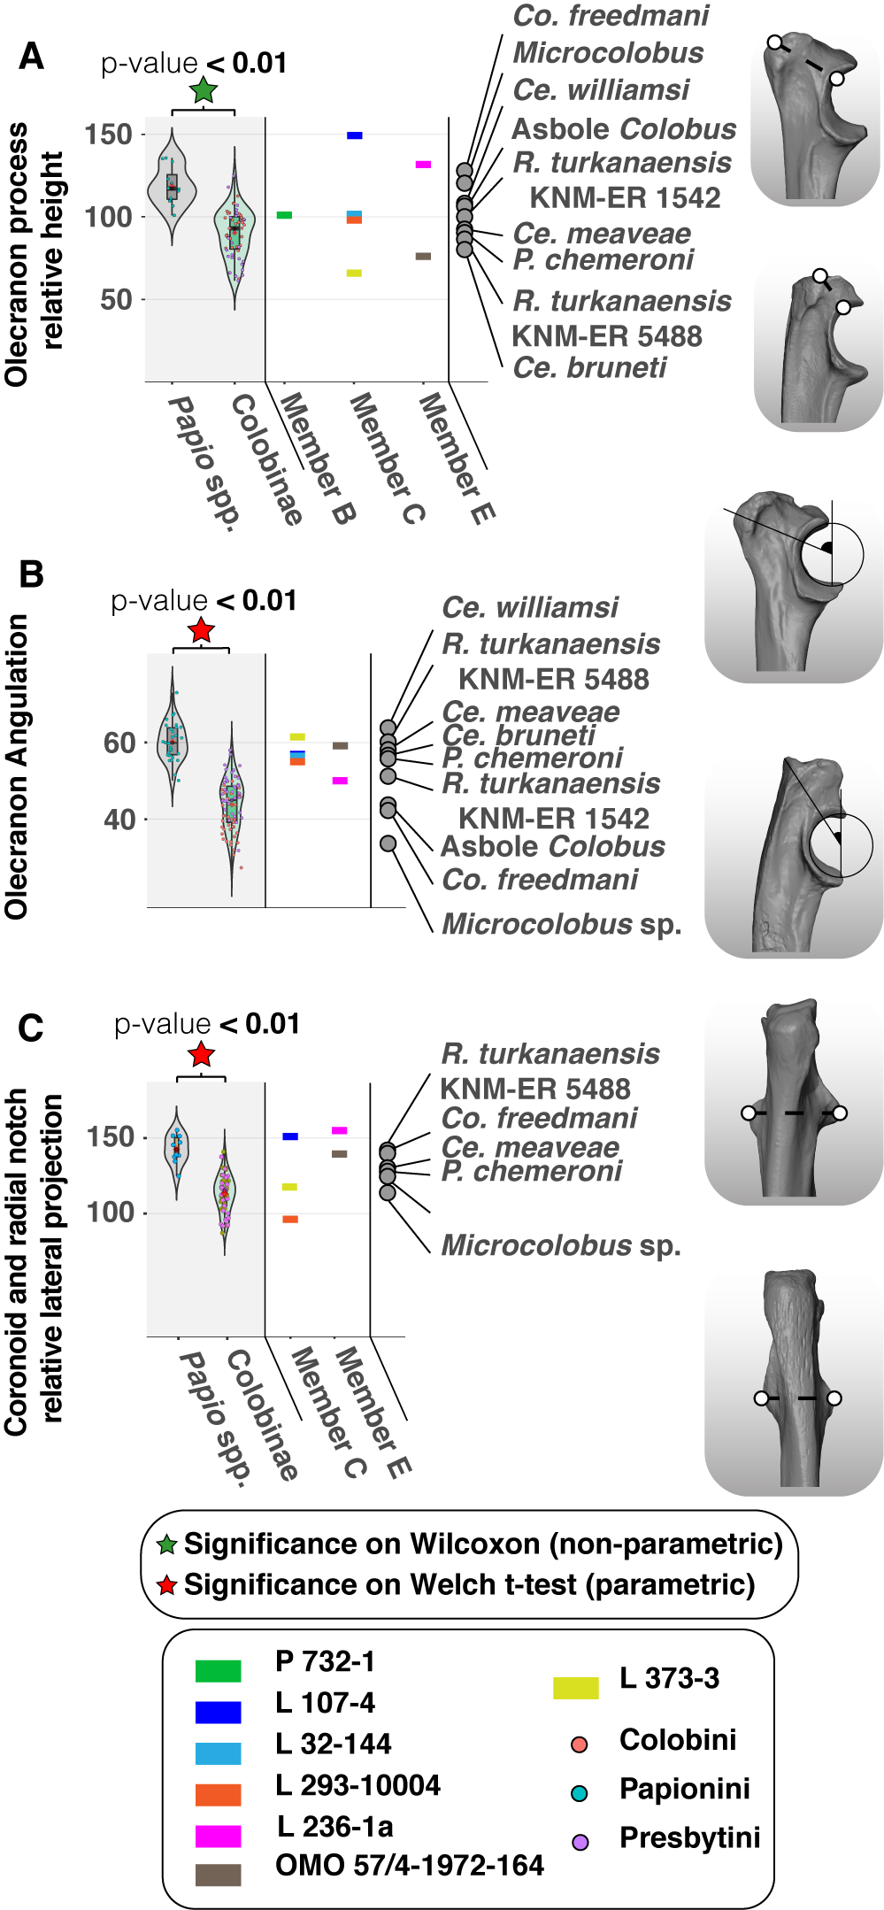None of the Omo colobines show an asymmetry of the anconeal process as pronounced as that of *Papio* and *Cercopithecoides williamsi* (Table 15, Appendix 20 and 22). A substantial elevation of the lateral crest of the anconeal compared to the medial crest of the anconeal is nonetheless visible in L 236-1a and L 107-4. The asymmetry of the anconeal process of L 236-1a and L 107-4 (Fig. 13 and Appendix 24) is more pronounced than that of *P. chemeroni*, *Ce. meaveae* and OMO 57/4-1972-164 (Fig. 13 and Appendix 25).

**Fig. 14**. – Violin plots and boxplots of proximal ulna morphometric indices of extant and extinct colobines and extant *Papio* spp. Morphologies associated with minimum and maximum values are shown on the left of the graph. A.) Relative height of the olecranon process height in extant colobines (*n* = 55), *Papio* spp. (*n* = 13) and fossil colobines, B.*)* Angulation of the olecranon in extant colobines (*n* = 76), *Papio* spp. (*n* = 31) and fossil colobines, and C.) Relative expansion of the coronoid and radial notches in extant colobines (*n* = 54), *Papio* spp. (*n* = 11) and fossil colobines. Means (red diamonds), medians (black rectangles), first quartile and third quartile are plotted. When there are significant differences between taxa (*p* < 0.05), the associated *p*-values are given.

Whereas the relief of the anconeal in anterior view is smooth in OMO 57/4-1972-164, *P. chemeroni* and *Ce. meaveae* (Appendix 22), the inferior articular surface of the anconeal is sharply angled in *R. turkanaensis* KNM-ER 1542 (Appendix 22). This marked angulation of the articular surface in anterior view is also seen in the suspensory colobine *N. larvatus* (Appendix 20).

At mid-height of the sigmoid notch, the epiphysis is lengthened anteroposteriorly in L 107-4, L 236-1a and *P. mutiwa* (Appendix 22), but contrast with the lightly built notch of OMO 57/4-1972-164 and L 373-3. The shaft is gracile in *N. larvatus* (Appendix 20), *R. turkanaensis* and *P. chemeroni* (Appendix 22) when compared with L 107-4 (Fig. 13), and *Co. guereza* (Appendix 20).

In L 373-3, the radial notch is large and undivided, whereas moderate (e.g., L 293-10004) to mark subdivisions (e.g., L 236-1a) are seen on other specimens. The marked subdivision of the radial notch of L 236-1a is akin to that of *P. mutiwa* and *Ce. williamsi* (Appendix 22). The undivided notch of L 373-3 is reminiscent of *R. turkanaensis*, *Microcolobus* and *Nasalis larvatus*. In addition, the posterior part of the notch is laterally projected and anteriorly facing in L 236-1 and L 107-4 (Fig. 14C and Appendix 24). Such a projection is also seen in *Papio* spp., *Ce. meaveae*, *R. turkanaensis* and *P. mutiwa* but is not characteristic of extant colobines (Fig. 14C).

The coronoid and anconeal processes of L 107-4 and L 236-1a project anteriorly to a greater extent than that of OMO 57/4-1972-164 and L 373-3. Such projections give a great depth to the sigmoid notch, as also seen in *Co. guereza* and *S. entellus* (Appendix 20) but unlike *N. larvatus* (Appendix 20) and *P. chemeroni* (Appendix 22). None of the Omo colobines and other large Plio-Pleistocene colobines present a more projected anconeal process compared to the coronoid process, as seen in suspensory colobines (see *N. larvatus* in Appendix 20).

The posterior portion of the coronoid process is enlarged in L 107-4 (Appendix 24) relative to its anterior portion, as in *P. chemeroni* and *Microcolobus* (Appendix 21 and 22). A more even mediolateral expansion of the coronoid is seen in OMO 57/4-1972-164 (Appendix 25), *R. turkanaensis*, *P. mutiwa* and *Ce. williamsi* (Appendix 22).

The shaft of L 107-4 is curved in the coronal plane, contrasting with the straighter shaft of L 373-3. The coronally curved shaft of L 107-4 is similar to that of *Ce. williamsi* (Appendix 22), but contrast from it by presenting a straighter shaft in the sagittal plane (Table 15 and Appendix 22).

We did not observe a pronounced concavity for the attachment sites of the digital flexors and extensors on L 373-3. This morphology contrasts with that of *S. entellus* and *Co. guereza*, but is similar to *N. larvatus* (Appendix 20). A pronounced concavity is visible on the lateral side of the shaft of L 107-4 and is reminiscent of the morphology of *Co. guereza* and *S. entellus* (Appendix 20).

A slit-like depression, extended distally, marks the attachment of the *m. brachialis* in L 373-3. The *m. brachialis* is less excavated and distally extended in the comparatively larger specimen L 107-4 and L 236-1a (Appendix 24 and 25). The shape of the *m. brachialis* enthesis of L 373-3 is more similar to *N. larvatus* and *Co. guereza* than that of *S. entellus* and *Papio* (Appendix 20).

*Comparative anatomy of the radial proximal epiphysis and diaphysis*

We identified two large-sized radial specimens from the Member E (L 236-1b) and upper part of Member G (OMO 2-10029). Both specimens show well-preserved proximal radial anatomy (Fig. 15) and correspond in absolute dimensions to *Ce. coronatus*, *Ce. williamsi* and *P. chemeroni* (Table 16 and Appendix 45).

A large part of the diaphysis is preserved in OMO 2-10029 (Fig. 15 and Appendix 26). Its well-angulated shaft is similar to extant colobines and differs from the rod-shaped diaphysis of terrestrial cercopithecids (Appendix 27) and *Ce. williamsi* (Appendix 28 and Table 17). The proximal portion of the shaft of OMO 2-10029 is noticeably more curved than *P. chemeroni* (Appendix 28). The interosseous crest of OMO 2-10029 is weakly developed as in extant colobines and differs from the blade-like morphology seen in *Papio*, *P. mutiwa* and *Ce. williamsi* (Table 17 and Appendix 27 and 28). This is well evidenced by the comparison of the elliptical cross-sectional shape of the mid-diaphysis of OMO 2-10029 (Appendix 26) which contrasts with the fairly triangular shape cross-section of *Papio hamadryas* (Appendix 27).

A significant difference is observed in relative elongation of the radial neck between *Papio* and extant colobines (*p* < 0.01, Fig. 16A). The elongated radial neck of OMO 2-10029 and L 236-1b matches that of extant colobines and differs from the short neck of extant *Papio* spp. (Fig. 16A).

Specimens OMO 2-10029 and L 236-1a also differ in the morphology of the peripheral articular margin of the radial head. The peripheral margin of the head, particularly its anteromedial part, is markedly beveled in OMO 2-10029 while this bevel is less expressed in L 236-1a (Fig. 15 and Table 17). The beveled margin of the radial head of OMO 2-10029 corresponds well to the morphology of *Ce. coronatus* (Appendix 28) and *N. larvatus* (Appendix 27).

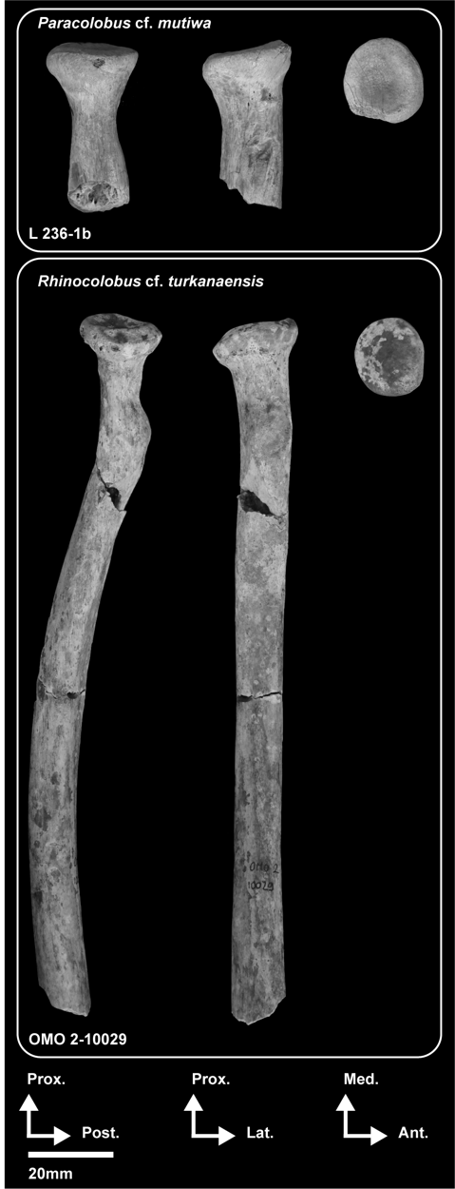The radial head shape of extant cercopithecids is variable although a more elliptical shape is observed in extant colobines compared to the rounded head of extant *Papio* spp., with a significant difference between both groups (*p* < 0.01, Fig. 16B). None of the Omo colobines have the elliptical head characteristic of *Colobus* spp. (Birchette 1982, Fig. 16B), and are more consistent with the condition typical of *Papio* spp., *Ce. coronatus* and *Ce. williamsi* (Fig. 16B).

**Fig. 15**. – Photographs of the radial anatomy of colobines from Shungura. Abbreviations: Ant: Anterior, Med: Medial, Lat: Lateral, Prox: Proximal, Post: Posterior. Scale: 20 mm.

The radial neck of extant colobines is elliptical in transverse cross-section and differs significantly from the more rounded neck of extant *Papio* spp. (*p* < 0.01, Fig. 16C). In cross-section, the radial necks of OMO 2-10029 and L 236-1a are more elliptical than those of extant *Papio* spp. and fall on the interquartile range of extant colobines (Fig. 16C).

**Fig. 16**. (previous page) – Violin plots and boxplots of proximal radius morphometric indices of extant and extinct colobines and extant *Papio* spp. Morphologies associated with minimum and maximum values are shown on the right and left of the graphs. A.) Relative elongation of the radial neck in extant colobines (*n* = 55), *Papio* spp. (*n* = 10) and fossil colobines, B.) Radial head shape in extant colobines (*n* = 52), *Papio* spp. (*n* = 13) and fossil colobines, and C.) Radial neck shape in extant colobines (*n* = 54), *Papio* spp. (*n* = 14) and fossil colobines. Means (red diamonds), medians (black rectangles), first quartile and third quartile are plotted. When

there are significant differences between taxa (*p* < 0.05), the associated *p*-values are given.

**Table 16. –** Measurements (in mm) of the radial specimens

|  |  |  |  |  |  |  |  |
| --- | --- | --- | --- | --- | --- | --- | --- |
| **Specimens** | **RNShA** | **RNLgA** | **RaNSI** | **BPExt** | **BBLA** | **RHShA** | **RHLgA** |
| L 236-1b | 10.4 | 14.3 | 11.7 |  |  | 19.1 | 21.0 |
| OMO 2-10029 | 9.8 | 13.2 | 10.7 | 12.2 | 36.0 | 18.3 | 21.0 |

**Table 17. –** Qualitative and quantitative morphological observations of the proximal radius of extant cercopithecids and early colobines.

|  |  |  |  |
| --- | --- | --- | --- |
| **Taxa**  **(in bold, Omo taxa)** | **Radial shaft angulation and development of the interosseous crest** | **Radial head bevel (development and extension)** | **Radial neck extension** |
| **1*R.* cf. *turkanaensis*** | **Angulated shaft, and poorly developed crest** | **Marked and extensive bevel** | **Long** |
| **2*P.* cf. *mutiwa*** | **NA.** | **Marked and localized bevel** | **Moderately long** |
| *P. chemeroni* | Straight shaft, and moderately developed crest | Marked and localized bevel | Moderately long |
| *P. mutiwa* | Straight shaft3, and well-developed crest | NA. | NA. |
| *Ce. williamsi* | NA. | Marked and localized bevel | Short |
| *Ce. meaveae* | NA. | Marked and localized bevel | Moderately long |
| *Ce. coronatus* | Straight | Marked and extensive bevel | Long |
| *Ce. bruneti* | Straight shaft, and poorly developed crest | Marked and localized bevel | Short |
| *Co. freedmani* | Angulated shaft, and moderately developed crest | Marked and localized bevel | Moderately long |
| *Microcolobus* sp. | Angulated shaft, and well-developed crest | Marked bevel | Short |
| *Colobus* spp. | Angulated shaft, and moderate to markedly developed crest | Marked and localized bevel | Moderate to long relative length (***µ* = 51**.7 ± 7.5, *n* = 18; Figure 16A) |
| *Nasalis larvatus* | Angulated shaft, and poorly developed crest | Marked and extensive bevel | Short to moderate relative length (***µ* = 39**.1 ± 8.2, *n* = 6; Figure 16A) |
| *Semnopithecus* spp. | Angulated shaft, and moderately developed crest | Marked and localized bevel | Short to moderate relative length (***µ* = 48**.2 ± 14.9, *n* = 4; Figure 16A) |
| *Papio* spp. | Straight shaft, and well-developed crest | Poorly developed and localized | Short to moderate relative length (***µ* = 31.3** ± 5.2, *n* = 9; Figure 16A) |
| 1*R.* cf. *turkanaensis* indet. include the following specimens: OMO 2-10029.  2*P.* cf. *mutiwa* include the following specimens: L 236-1b.  3Observation based only on the anatomy of the proximal portion of the radius of the partial skeleton KNM-WT 16827 | | | |

The radial head of the Omo colobines is obliquely inclined and has a well-defined tubercle on its lateral margins. This morphology is also observed in the extant colobines *S. entellus*, *N. larvatus* and *Co. guereza* (Appendix 27).

The peripheral articular surface proximal to the bicipital tuberosity is poorly extended distally in OMO 2-10029 compared to L 236-1a. The morphology of the radial peripheral articular surface of L 236-1a, and notably its distal extension, is quite similar to that of *S. entellus* (Appendix 27).

The fovea of the radial head of the Omo colobines are centrally placed but they differ in depth. OMO 2-10029 is distinguished by the greater depth of its fovea (Appendix 26). A globular capitulum with a deep zona conoidea is expected to match the proximal radial anatomy of OMO 2-10029. In sagittal cross-section, the deep fovea and marked anteromedial bevel of the radial head of OMO 2-10029 is most consistent with the radial anatomy of *N. larvatus* than that of *Co. guereza* and *S. entellus* (Appendix 26 and 27).

*Comparative anatomy of the proximal femoral epiphysis*

Proximal femora of large bodied colobines are known from Usno (W 7-477B), Lower G (OMO 75/N-1971-728 and OMO 50-1973-728), and several specimens from Member L. OMO 75/N-1971-728, OMO 50-1973-728 and W 7-477B are of similar size (Fig. 17, Table 18 and Appendix 46) while the Member L specimens represent a smaller taxon.

**Table 18. –** Measurements (in mm) of the femoral specimens

|  |  |  |  |  |  |  |  |  |  |  |  |  |
| --- | --- | --- | --- | --- | --- | --- | --- | --- | --- | --- | --- | --- |
|  | **Specimens** | **FPEML** | **BNML** | **NSA(°)** | **GTProj** | **FNML** | **FNSI** | **FNAP** | **FHSI** | **FHAP** | **FBAPLT** | **FAPLT** |
| *P*. cf. *mutiwa* | W 7-477b | 49.9 | 39.0 | 116.2° | 5.6 | 17.5 | 20.8 | 17.6 | 24.2 | 25.4 |  |  |
| *R*. cf. *turkanaensis* | OMO 50-1973-4450 | 47.8 | 38.1 | 110.5° | 3.9 | 17.4 | 21.8 | 16.0 | 25.2 | 25.1 | 18.1 | 24.7 |
| OMO 75/N-1971-728 | 45.0 | 36.7 | 108.0° | 3.5 | 18.5 | 19.1 | 14.7 | 23.2 | 22.6 | 18.4 |  |
| cf. *Colobus* sp. indet. | OMO 342-10019 | 30.9 | 24.1 | 118.7° | 0.4 | 9.2 | 13.6 | 10.9 | 16.1 | 16.1 |  |  |
| OMO 342-10344 | 33.9 | 27.2 | 118.8° | 2.2 | 9.8 | 13.6 | 11.4 | 16.6 | 17.0 |  |  |
| OMO 342-10298 | 34.2 | 26.7 |  |  |  | 14.2 | ~13.0 | 17.5 | 16.6 |  |  |

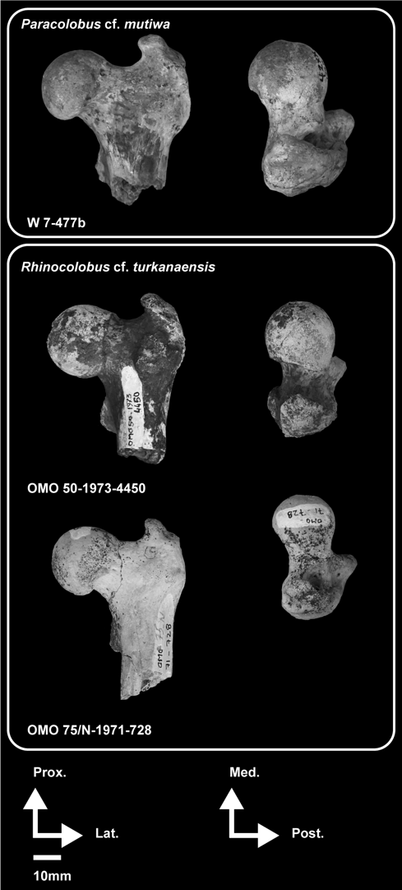The femoral head of the large Omo colobines are globular, particularly that of OMO 75/N-1971-729 and OMO 50-1973-728. Extensive encroachment of the femoral head on the neck is visible in OMO 75/N-1971-729 and OMO 50-1973-728 (Table 19 and Appendix 29). Comparatively, clearer delineations between the neck and femoral head are observed in *P. mutiwa*, *Ce. coronatus* and *Ce. williamsi* (Appendix 30). An extension of the femoral head onto the neck is frequently seen in extant colobines but is distinct from the typical morphology of *Papio* (Table 19 and Appendix 31).

**Fig. 17**. – Photographs of the femoral anatomy of colobines from Usno and Shungura. Abbreviations: Ant: Anterior, Lat: Lateral, Med: Medial, Prox: Proximal, Post: Posterior. Scale: 10 mm.

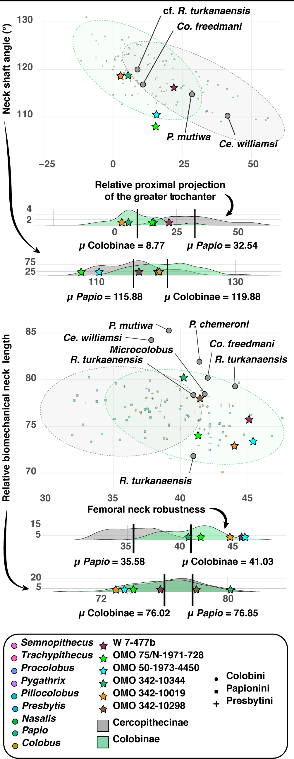

**Fig. 18**. – Scatterplots of proximal femoral indices of extant and extinct colobines and extant *Papio* spp. 95 % normal confidence ellipses (given a multivariate normal distribution) are drawn for colobines and *Papio* spp. Kernel density estimates are given for each axis below the scatterplots. A.) Regression of the collodiaphyseal angle on the relative projection of the greater trochanter in extant colobines (*n* = 78), *Papio* spp. (*n* = 27) and fossil colobines. and B.)Regression of the biomechanical neck length on neck robustness in extant colobines (*n* = 73), *Papio* spp. (*n* = 27) and fossil colobines.

A significant difference is observed between *Papio* and extant colobines regarding neck-shaft angle, with relatively more acute angle in *Papio* (*p* < 0.01, Fig. 18A). The collodiaphyseal angle of OMO 75/N-1971-729 and OMO 50-1973-728 is acute, in contrast to most extant colobines (Appendix 31) but similar to *P. mutiwa* and *Ce. williamsi* (Fig. 18A). Indeed, with respective index values of 110.5° and 108°, OMO 50-1973-728 and OMO 75/N-1971-729 are much closer to the mean value of *Papio* (µ = 115.3 ± 4.1°, Table 19) than that of *Co. guereza* (µ = 118.6 ± 3.8°, Table 19).

Extant colobines differ significantly from *Papio* by presenting a robust femoral neck (*p* < 0.01, Fig. 18B). Although non-significant, we also observed a tendency for colobines to present a shorter neck compared to *Papio* (Fig. 18B). The femoral necks of OMO 75/N-1971-728, OMO 50-1973-728 and W 7-477B are short and robust, as also observed in extant colobines, but unlike *Ce. williamsi* and *Ce. meaveae* (Fig. 18B and Appendix 30). With neck robustness index values superior to 41, OMO 75/N-1971-728, OMO 50-1973-728 and W 7477B are outside the range of variation of extant *Papio* (µ = 35.6 ± 2.3, Table 19) but within the range of variation of *Co. guereza* (µ = 40.0 ± 2.5, Table 19).

The enthesis of the *m. vastus lateralis* of OMO 75/N-1971-729 and OMO 50-1973-4450 is not as laterally projected as that of extant primate leapers (Table 19; Fleagle & Simons, 1995; Cooke & Tallman, 2012) and extant colobines (Appendix 31). In contrast, this enthesis is prominent in both W 7-477B and *P. mutiwa* (Appendix 30), and also comparable in morphology to that of *Co. guereza*, *N. larvatus* and *S. entellus* (Appendix 31).

**Table 19. –** Qualitative and quantitative morphological observations of the proximal femur of extant cercopithecids and early colobines.

|  |  |  |  |  |  |  |
| --- | --- | --- | --- | --- | --- | --- |
| **Taxa**  **(in bold, Omo taxa)** | **Greater trochanter proximal projection** | **Femoral neck morphology (length, robustness and collodiaphyseal angle [i.e., CDA])** | **Extension of the femoral head onto the neck and placement of the fovea capitis** | **Lateral projection of the m. vastus lateralis enthesis** | **Trochanteric fossa morphology (overall dimension and placement)** | **Lesser trochanter morphology (placement on the shaft and orientation)** |
| **1*R.* cf. *turkanensis*** | **Moderate proximal projection** | **Short, and robustly built neck with an acute CDA** | **Marked extension of the femoral head onto the neck, and centrally-set fovea capitis** | **Projected** | **Large and proximally-set** | **Distally-set, and medially facing** |
| **2*P*. cf. *mutiwa*** | **Moderate proximal projection** | **Long, and shallow neck with an acute CDA** | **Moderate extension of the femoral head onto the neck, and eccentrically-set fovea capitis** | **Projected** | **Large and distally-extended** | **Distally-set, and posteriorly facing** |
| **3cf. *Colobus* sp. indet.** | **Poor to moderate proximal projection** | **Short, and robustly built neck with an acute CDA** | **Moderate extension of the femoral head onto the neck, and centrally-set fovea capitis** | **Projected** | **Short and distally-extended (slit-like)** | **Proximally-set, and medially facing** |
| *P. chemeroni* | NA. | Short, and robustly built neck with an acute CDA | Marked extension of the femoral head onto the neck, and centrally-set fovea capitis | Projected | Large and distally-extended | Proximally-set, and medially facing |
| *P. mutiwa* | Moderate proximal projection | Moderately long neck, with a robust and acute CDA | Moderate extension of the femoral head onto the neck, and centrally-set fovea capitis | Projected | Large and distally-extended | Distally-set, and medially facing |
| *Ce. williamsi* | Marked proximal projection | Long, and shallow neck with an acute CDA | Moderate extension of the femoral head onto the neck, and eccentrically-set fovea capitis | Non-projected | Large and distally-extended | Distally-set, and posteriorly facing |
| *Ce. meaveae* | Marked proximal projection | Long, and shallow neck with an acute CDA | NA. | Non-projected | Large and distally-extended | Distally-set, and posteriorly facing |
| *Ce. coronatus* | NA. | Long, and shallow neck with an acute CDA | NA. | NA. | NA. | Distally-set, and posteriorly facing |
| *Ce. bruneti* | NA. | NA. | NA. | NA. |  | NA. |
| *R. turkanaensis* | NA. | NA. | NA. | NA. | NA. | NA. |

**Table 19 (following). –** Qualitative and quantitative morphological observations of the proximal femur of extant cercopithecids and early colobines.

|  |  |  |  |  |  |  |
| --- | --- | --- | --- | --- | --- | --- |
| **Taxa (in bold, Omo taxa)** | **Greater trochanter proximal projection** | **Femoral neck morphology (length, robustness and collodiaphyseal angle [i.e., CDA])** | **Extension of the femoral head onto the neck and placement of the fovea capitis** | **Lateral projection of the m. vastus lateralis enthesis** | **Trochanteric fossa morphology (overall dimension and placement)** | **Lesser trochanter morphology (placement on the shaft and orientation)** |
| *Co. freedmani* | Moderate proximal projection | Short, and robustly built neck with an acute CDA | Moderate extension of the femoral head onto the neck, and centrally-set fovea capitis | Projected | Short and distally-extended (slit-like) | Proximally-set, and posteriorly facing |
| *Microcolobus* sp. | Poor proximal projection | Short, and robustly built neck with an obtuse CDA | NA. | Projected | Short and distally-extended (slit-like) | NA. |
| *Co.* sp. indet. Asbole | Moderate proximal projection | Short, and robustly built neck with an acute CDA | Moderate extension of the femoral head onto the neck, and centrally-set fovea capitis | Projected | Short and distally-extended (slit-like) | Proximally-set, and posteriorly facing |
| *Colobus* spp. | Poor to moderate proximal projection (***µ* = 13.3** ± 8.0, *n* = 25; Figure 18A) | Short to moderately long neck, robustly built neck (***µ* = 40.0** ± 2.5, *n* = 26; Figure 18B), and acute CDA (***µ* = 118.6** ± 3.8°, *n* = 25; Figure 18A) | Moderate to marked extension of the femoral head onto the neck, and centrally-set fovea capitis | Projected | Short and distally-extended (slit-like) | Proximally-set, and posteriorly facing (***µ* = 31.41** ± 5.9, *n* = 19; Figure 19) |
| *Nasalis larvatus* | Poor to moderate proximal projection (***µ* = 14.1** ± 10.0, *n* = 6; Figure 18A) | Short neck, robustly built neck (***µ* = 41.3** ± 2.1, *n* = 6; Figure 18B), and acute CDA (***µ* = 118.5** ± 4.1°, *n* = 6; Figure 18A) | Moderate to marked extension of the femoral head onto the neck, and centrally-set fovea capitis | Projected | Short and distally-extended (slit-like) | Proximally-set, and medially facing (***µ* = 23.24** ± 3.1, *n* = 6; Figure 19) |
| *Semnopithecus* spp. | Moderate to marked proximal projection (***µ* = 18.3** ± 10.1, *n* = 3; Figure 18A) | Long neck, robustly built neck (***µ* = 39.0** ± 1.8, *n* = 6; Figure 18B), and acute CDA (***µ* = 116.6** ± 1.5°, *n* = 3; Figure 18A) | Moderate to marked extension of the femoral head onto the neck, and eccentrically-set fovea capitis | Projected | Large and distally-extended | Distally-set, and medially-facing (***µ* = 28.93** ± 2.8, *n* = 5; Figure 19) |
| *Papio* spp. | Marked proximal projection (***µ* = 32.5** ± 11.3, *n* = 26; Figure 18A) | Long neck, gracile neck (***µ* = 35.6** ± 2.3, *n* = 26; Figure 18B), and highly acute CDA (***µ* = 115.3** ± 4.1°, *n* = 26; Figure 18A) | Poor extension of the femoral head onto the neck, and eccentrically-set fovea capitis | Non-projected | Large and distally-extended | Distally-set, and posteriorly facing (***µ* = 34.40** ± 3.9, *n* = 14; Figure 19) |
| 1*R.* cf. *turkanaensis* indet. include the following specimens: OMO 50-1973-4450 and OMO 75/N-1971-728  2*P.* cf. *mutiwa* include W 7-477b  3cf. *Colobus* sp. indet. include the following specimens: OMO 342-10019, OMO 342-10344, OMO 342-10298 | | | | |

The fovea capitis of OMO 75/N-1971-729 and OMO 50-1973-4450 is located centrally on the femoral head whereas it is placed more eccentrically in W 7-477B (Table 19 and Appendix 32). *P. mutiwa*, *Ce. williamsi* and the presumed *Rhinocolobus* specimen KNM-ER 551 present a centrally placed fovea distinct from that of W 7-477B (Appendix 32). The centrally placed fovea of OMO 75/N-1971-729 and OMO 50-1973-4450 is more comparable to that of *N. larvatus* while W 7-477B is more similar to *Co. guereza* and *S. entellus* (Appendix 31).

Although proximally restricted, the trochanteric fossa of OMO 75/N-1971-729 and OMO 50-1973-4450 is wide, as in *Ce. williamsi*, *P. chemeroni* and *R. turkanaensis* (Table 19 and Appendix 30). In comparison, the fossa of W 7-477B is more restricted mediolaterally. The mediolaterally short fossa of W 7-477B is reminiscent of the morphology of *Co. guereza* while the wide fossa of OMO 75/N-1971-729 and OMO 50-1973-4450 is similar to *N. larvatus* (Appendix 31).

An enlarged enthesis of the ischiofemoral ligament is set on the medial border of the trochanteric fossa of W 7-477B, a morphology also observed in *Co. guereza* (Appendix 31).

A palpable femoral tubercle for the attachment site of the illiofemoral ligament is present in all the large Omo colobines. This enthesis is particularly rugose and enlarged in OMO 50-1973-4450, similarly to *Ce. williamsi* (Appendix 30). Although the illiofemoral tubercle can be salient in extant colobines(see *Se. entellus* and *Co. guereza* in Appendix 31), none of the extant colobines from our comparative dataset matches the size and shape of the illiofemoral tubercle of OMO 50-1973-4450. A pitted area is located proximal to the lesser trochanter in OMO 50-1973-4450, OMO 75/N-1971-729, and W 7-477B along with a well-defined distal portion of the intertrochanteric crest. This combination of character (pitted area and pronounced distal portion of the intertrochanteric crest) is also observed in *P. mutiwa* and in the presumed *Rhinocolobus* femur KNM-ER 551 (Appendix 30).

The proximal aspect of the intertrochanteric crest is more robust in W 7-477B than in OMO 50-1973-4450, OMO 75/N-1973-4450, KNM-ER 551, and *P. mutiwa* (Appendix 30). The quadrate tubercle of W 7-477B is nonetheless poorly developed compared to *P. mutiwa* (Appendix 30).

Extant colobines are significantly distinct from *Papio* by presenting a proximally extended greater trochanter (*p* < 0.01, Fig. 18B). The proximal projection of the greater trochanter is moderate in OMO 50-1973-4450 and OMO 75/N-1971-728 but pronounced in W 7-477B (Fig. 19A). More precisely, OMO 50-1973-4450, with an index value of 15.7, and OMO 75/N-1971-728, with an index value of 5.50, are close to the mean value of *N. larvatus* (µ = 14.1 ± 10.0°, Table 19). W 7-477B, with an index value of 22.0, stands between *S. entellus* (µ = 18.3 ± 10.1°, Table 19) and *Papio* (µ = 32.5 ± 11.3°, Table 19). *Ce. williamsi* is the only colobine that has a projection of the greater trochanter similar to that of *Papio* (Fig. 19A).

The lesser trochanter of *Papio* is significantly more developed and projected posteriorly than that of extant colobines (*p* < 0.01, Fig. 19). The lesser trochanter is oriented medially in W 7-477B, OMO 50-1973-4450 and OMO 75/N-1973-4450 (Figs 17; 19). The Omo colobines resemble their extant counterparts in this aspect as their lesser trochanter is significantly more medially projected than that of extant *Papio* spp. (Fig. 19). In their degree of projection and development, the lesser trochanters of W 7-477B, OMO 50-1973-4450 and OMO 75/N-1973-4450 are more similar to those of KNM-ER 551 (cf. *Rhinocolobus*) and *P. mutiwa* than those of *Ce. williamsi* and *Ce. meaveae* (Appendix 30). None of the Omo colobines present a lesser trochanter as large and as proximally located as that of *P. chemeroni* (Appendix 30).

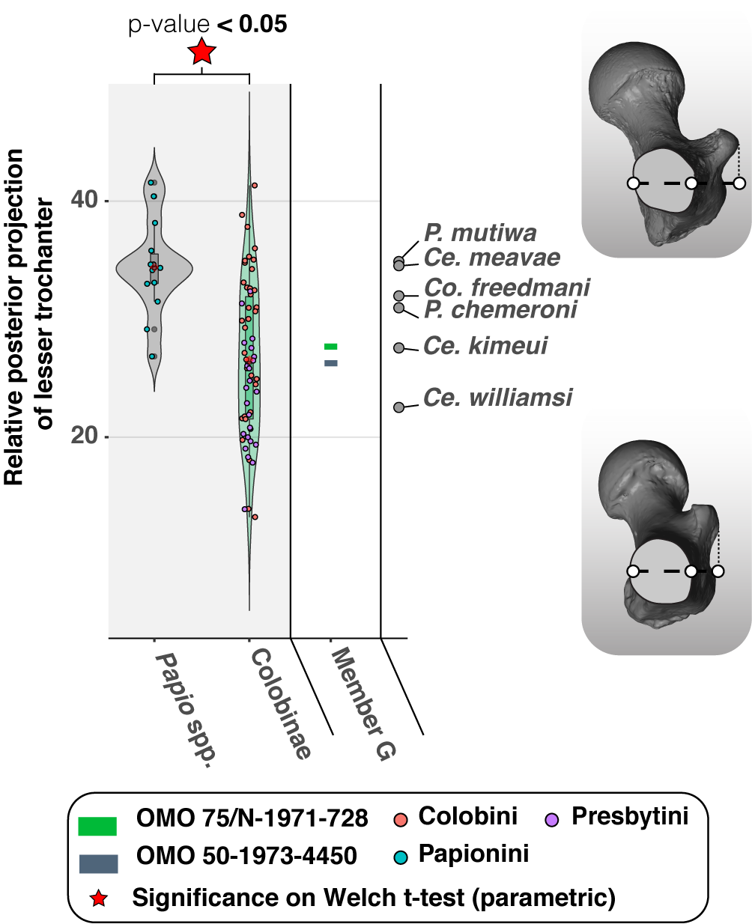

**Fig. 19**. – Violin plots and boxplots of the posterior projection of the lesser trochanter in extant colobines (*n* = 55), *Papio* spp. (*n* = 12) and fossil colobines. Morphologies associated with minimum and maximum values are shown on the left of the graph. Means (red diamonds), medians (black rectangles), first quartile and third quartile as well as maximum and minimum values.

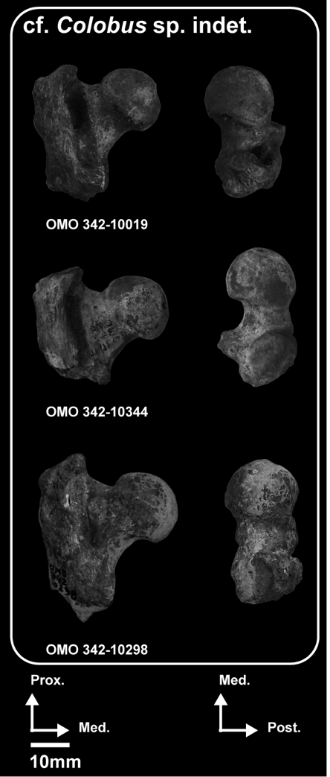Small femoral specimens from Member L (Fig. 20, and Appendix 34 and 46) are reminiscent of the extant colobine anatomy by having a short and robust femoral neck, obtuse collodiaphyseal angles, proximally and medially restricted trochanteric fossae, medially oriented lesser trochanters, a centrally placed fovea capitis, enlarged attachment sites for the illiofemoral, ischiofemoral and pubofemoral ligaments, and a laterally projected *m. vastus lateralis* enthesis(Fig. 18A, B, Table 19). Their morphology matches that of *Co. freedmani*, *Microcolobus* and *Colobus* from Asbole (Appendix 33).

**Fig. 20**. – Photographs of the femoral anatomy of colobines from Member L. Abbreviations: Ant: Anterior, Med: Medial, Lat: Lateral, Prox: Proximal, Post: Posterior. Scale: 10 mm.

*Comparative anatomy of the proximal tibial epiphysis*

A complete tibia is known from a specimen from the Member L (OMO 377-10024 in Fig. ure 21) similar in size to extant *Colobus* spp. (Table 20 and Appendix 48).

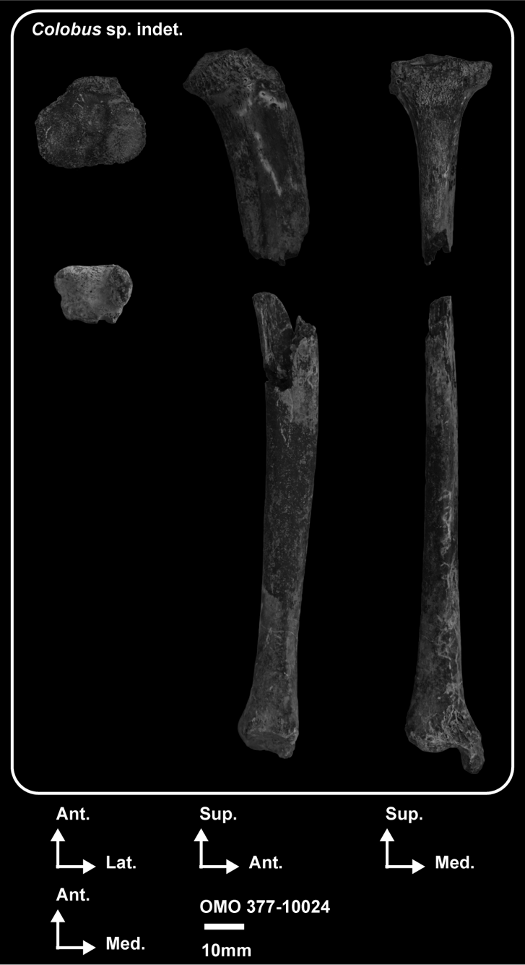

**Fig. 21**. – Photographs of the tibial anatomy of a colobine from Member L. Abbreviations: Ant: Anterior, Med: Medial, Lat: Lateral, Prox: Proximal, Post: Posterior. Scale: 10 mm.

The tibial plate of OMO 377-10024 is retroflexed and both condyles are concave, with no difference in depth between them (Appendix 35), as in the similarly sized *Co. freedmani* but unlike the large colobine *R. turkanaensis* (Appendix 36). The proximal tibia of OMO 377-10024 is also characterized by widely spaced, and blunt tibial spines that show virtually no height differential and are connected by a straight, rather than oblique, transverse line as in *Co. freedmani*.

The tibial tuberosity of OMO 377-10024 is extended distally, as in extant colobines (Appendix 37), although the precise level of distal extension of the cnemial crest is difficult to assess due to missing portions of the shaft proximal to the mid-diaphysis.

The transverse cross-sections of the proximal metaphysis of *Co. guereza* and *S. entellus* are also extended anteroposteriorly and contrast with the more rounded cross-section of *N. larvatus* (Appendix 37). Marked concavities for the insertion of the *m. tibialis anterior* and *m. tibialis posterior* are seen on the proximal diaphysis of OMO 377-10024 (Appendix 35). A particularly enlarged *m. tibialis anterior* enthesis is also visible in *Co. freedmani* (Appendix 36), *Co. guereza* and *S. entellus*, but the *m. tibialis posterior* is nonetheless much less developed in these fossil and extant specimens than that of OMO 377-10024 (Appendix 37).

**Table 20. –** Measurements (in mm) of the tibia OMO 377-10024

|  |  |  |  |  |  |  |  |  |  |  |  |  |
| --- | --- | --- | --- | --- | --- | --- | --- | --- | --- | --- | --- | --- |
|  | **Specimen** | **TPEML** | **MTPML** | **LTPML** | **MshAP** | **MshML** | **DEML** | **DEAP** | **MAP** | **MML** | **TFMxML** | **TFMnML** |
|  | OMO 377-10024 | 27.6 | 10.1 | 11.6 | 12.4 | 8.6 | 17.6 | 13.7 | 9.8 | 5.6 | 11.4 | 8.8 |

*Comparative anatomy of the tibial diaphysis*

Only the curvature of the shaft distal to the mid-diaphysis is assessable in OMO 377-10024 and the observed pattern is that of a straight diaphysis, similar to that of *Co. freedmani*. The transverse cross-section set at the mid-diaphysis is elliptical, and not as robust as that of *Co. freedmani* nor as triangular as that of *Co. guereza* (Appendix 36 and 37).

*Comparative anatomy of the distal tibial diaphysis*

The fibular notch of OMO 377-10024 is weakly expressed, as in extant (Appendix 37) and fossil colobines (Appendix 36).

OMO 377-10024 also has a a proximodistally elongated depression on the anterior portion of the lateral side of the malleolus, presumably for a developed anterior tibiotalar ligament. No other obvious evidence of a developed ligamentous attachment area is detected on this specimen. Extensive depressions for the anterior tibiotalar ligament are also visible in the *Papio*, *S. entellus* and *N. larvatus* specimens illustrated in Appendix 37.

The large and blunt anterior tibial beak of OMO 377-10024 is not as pronounced as that of the putative *Rhinocolobus* tibia from Laetoli (Laird *et al.* 2018), and that of *N. larvatus* and *Co. guereza* (Appendix 37 and Table 21). When viewed anteriorly, the tibial malleolus of OMO 377-10024 is flared, a feature that may be related to a more angular medial facet of the astragalus. A similarly flared malleolus is observed in *Co. guereza* (Appendix 37).

**Table 21. –** Qualitative morphological observations of the tibia of extant cercopithecids and early colobines.

|  |  |  |  |  |  |
| --- | --- | --- | --- | --- | --- |
| **Taxa (in bold, Omo taxa)** | **Deltoid ligaments imprinting** | **Malleolar morphology (robustness and distal extension)** | **Development of the anterior process of the tibial distal epiphysis** | **Shape of the distal epiphysis** | **Tibial plate depth differential** |
| **1cf. *Colobus* sp. indet.** | **Moderate** | **Gracile malleolus with a poor distal extension** | **Moderate** | **Rectangular-shaped** | **Poor depth differential between the condyles** |
| *P. chemeroni* | Moderate | Gracile malleolus with a moderate distal extension | Marked | Rectangular-shaped | Poor depth differential between the condyles |
| *Ce. meaveae* | NA. | NA. | Moderate | Rectangular-shaped | Poor depth differential between the condyles |
| *R. turkanaensis* | Poor | Robust malleolus with a poor distal extension | Moderate | Rectangular-shaped | Marked depth differential between the condyles |
| *Co. freedmani* | Moderate | Robut malleolus with a poor distal extension | Moderate | Rectangular-shaped | Marked depth differential between the condyles |
| *Colobus* spp. | Moderate to marked | Gracile malleolus (***µ* = 196.99** ± 23.8, *n* = 19; Figure 22A) with a poor distal extension | Moderate to marked | Rectangular-shaped (***µ* = 128.22** ± 6.93, *n* = 17; Figure 22B) | Poor depth differential between the condyles |
| *Nasalis larvatus* | Moderate to marked | Robust malleolus (***µ* = 176.90** ± 16.2, *n* = 7; Figure 22A) with a moderate distal extension | Moderate to marked | Square-shaped (***µ* = 119.77** ± 4.10, *n* = 7; Figure 22B) | Marked depth differential between the condyles |
| *Semnopithecus* spp. | Moderate to marked | Robust malleolus (***µ* = 172.60** ± 21.2, *n* = 4; Figure 22A) with a distal extension | Moderate | Rectangular-shaped (***µ* = 128.64** ± 1.94, *n* = 3; Figure 22B) | Moderate depth differential between the condyles |
| *Papio* spp. | Marked | Gracile malleolus (***µ* = 193.22** ± 20.6, *n* = 26; Figure 22A) with a distal extension | Moderate | Square-shaped (***µ* = 118.51** ± 5.47, *n* = 25; Figure 22B) | Moderate depth differential between the condyles |

1cf. *Colobus* sp. indet. include OMO 377-10024

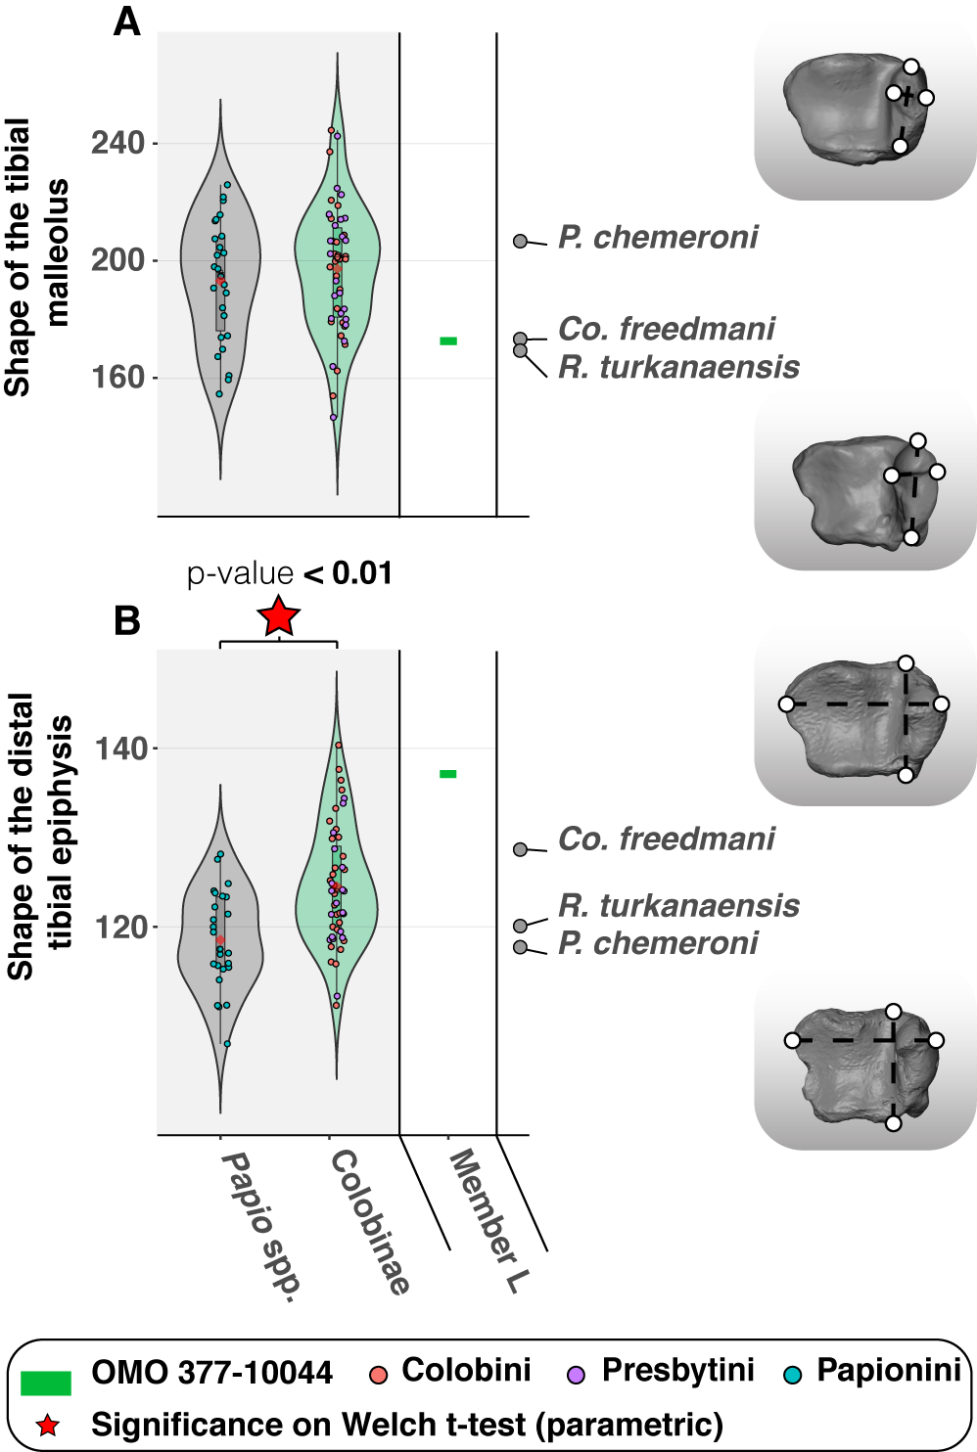

**Fig. 22**. – Violin plots and boxplots of morphometric indices of distal tibia of extant and extinct colobines and extant *Papio* spp. Morphologies associated with minimum and maximum values are shown on the right of the graph. A.) Shape of the distal tibial epiphysis in extant colobines (*n* = 48), *Papio* spp. (*n* = 26) and fossil colobines, and B.)Shape of the tibial medial malleolus in extant colobines (*n* = 51), *Papio* spp. (*n* = 27) and fossil colobines. Means (red diamonds), medians (black rectangles), first quartile and third quartile are plotted. When there are significant differences (*p* < 0.05) between taxa, the associated *p*-values are given.

No significant difference is detected in our extant cercopithecid sample concerning malleolar shape (Fig. 22A), but the malleolar shape index of OMO 377-10024 is nonetheless in the lowest range of variation of extant colobines. The low index value of OMO 377-10024 demonstrate the robustness of its malleolus (Table 21). High index values are associated with anteroposteriorly elongated and mediolaterally shallow malleoli. With an index value of 172.6, OMO 377-10024 is close to the mean value of *N. larvatus* (µ = 176.90 ± 16.2, Table 21) and *Semnopithecus* spp. (µ = 172.60 ± 21.2, Table 21) but is distinct from the more anteroposteriorly elongated and mediolaterally narrow malleolus of *Colobus* spp. (µ = 196.99 ± 23.8, Table 21 and Appendix 37). The malleolar shape of OMO 377-10024 is quite similar to that of *Co. freedmani* and *R. turkanaensis* but distinct from the more elongated and shallow malleolus of *P. chemeroni* (Appendix 36).

In coronal cross-section, the shape of the tibial astragalar surface is asymmetric in OMO 377-10024, with a higher slope value for the lateral facet compared to the medial facet (Appendix 35). A similar level of asymmetry is observed in *Co. freedmani* and *P. chemeroni* (Appendix 36).

A significant difference is observed between *Papio* and extant colobines regarding the shape of the tibial distal epiphysis (*p* < 0.01, Fig. 22B). With low index values, the epiphysis of *Papio* is square shaped compared to the mediolaterally elongated epiphysis of colobines (Fig. 22B).

The distal epiphysis of OMO 377-10024 is mediolaterally extended, as in extant colobines (Fig. 22B). Precisely, OMO 377-10024, with an index value of 137.10, is closer to the mean value of *Colobus* spp. (µ = 128.22 ± 6.93, Table 21) than *Papio* spp. (µ = 118.51 ± 5.47, Table 21).

The asymmetry (in mediolateral dimension) of the anterior and posterior margins of the astragalar articular surface of OMO 377-10024 (i.e., trochlear wedging) is not as pronounced as that of *Co. freedmani* (Appendix 36), nor as that of *Co. guereza* and *N. larvatus* (Appendix 37).

In transverse cross-section, the shape of the distal metaphysis of OMO 377-10024 is triangular, similar to that of *Co. freedmani* (Appendix 38), and its interosseous crest is not as prominent as that of *R. turkanaensis* (Table 21 and Appendix 38). Compared to extant colobines, the distal metaphysis of OMO 377-10024 is more similar to the triangular shape of *Co. guereza* than to the more elliptical cross-section of *N. larvatus* (Appendix 37).

BODY MASS ESTIMATION AND GEOMETRIC SIZE COMPARISONS

*Body masses*

The estimated body masses of the distal humeral and femoral specimens described in this study range from ca. 5.2 kg for the femur OMO 342-10344 to ca. 35 kg for the distal humerus OMO 176-10006 (Fig. 23).

Body masses estimated from postcranial fossil specimens of members C (OMO 18-1967-135, OMO 18-1973-608 and OMO 165-1973-608) and L matches that of extant *Piliocolobus* spp. and *Colobus* spp.. In addition, *Co. freedmani* and Asbole specimens have inferred body masses that ranges, on average, from ca. 7 kg to ca. 9 kg (Appendix 40), a range consistent with that of the Member L postcranial specimens (Appendix 40).

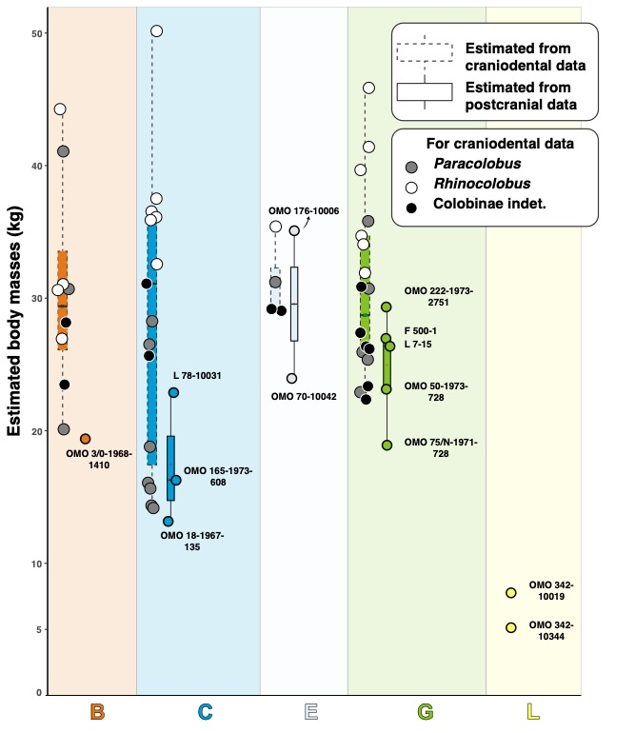

**Fig. 23**. – Boxplots of estimated body masses of fossil colobines from members B, C, E, G and L of the Shungura Formation obtained using dimensions from the distal humerus and proximal femur.

Body masses inferred from dental data are consistently higher than postcranial masses (Fig. 23) and ranges from ca. 14 kg for OMO 84-1970-107 (isolated M2 of a Colobinae indet. from Member C according to Leakey [1987]) to ca. 50 kg for OMO 18-1970-294 (M1 or M2 from a *P. mutiwa* specimen from Member C according to Leakey 1987, see also Appendix 40). The presumed body mass of dental specimens of *P. mutiwa* ranges from ca. 27 kg to ca. 50 kg and that of *R. turkanaensis* from ca. 22 kg to ca. 33 kg (Appendix 40).

*Geometric mean comparisons*

Comparison of geometric means of selected isolated Omo specimens to that of the male partial skeleton *R. turkanaensis* KNM-ER 1542 are made to explore sexual dimorphism within the Omo sample. In *N*. *larvatus*, female specimens are, on average, 25% to 30% smaller in geometric size to male specimens (Fig. 24A and B).

None of the Omo postcranial specimens morphologically similar to *R. turkanaensis* exceed KNM-ER 1542 in size (Fig. 24C). magnitude of differences our

magnitude of our

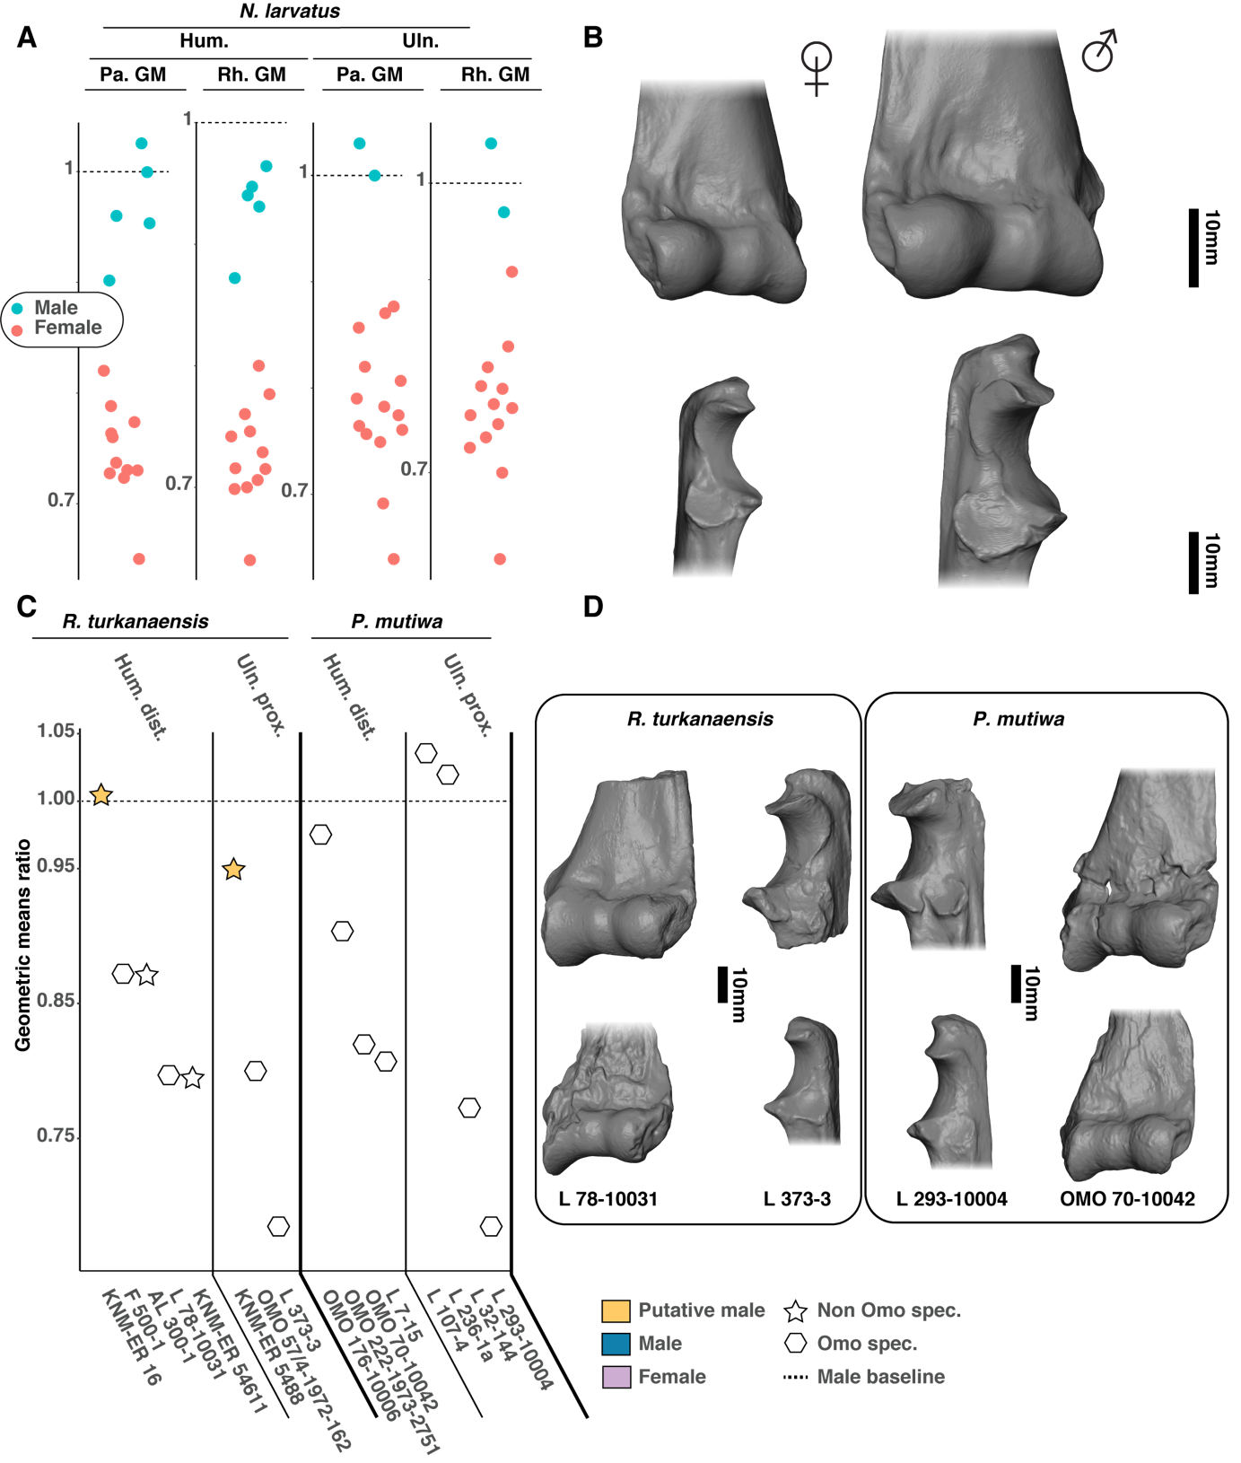

**Fig. 24**. – Dot plot of geometric mean ratio between fossil specimens and *N. larvatus*. Comparison is made between specimens of unknown sex with fossil male specimens of *P. mutiwa* and *R. turkanaensis*, KNM-WT 16827 and KNM-ER 1542, respectively.

## DISCUSSION

In regard to colobine evolutionary history, the end of the Pliocene and the beginning of the Pleistocene correspond to a phase of diversification both from a locomotor and taxonomic point of view (Table 1; Birchette 1982, Harris *et al.* 1988, Frost & Delson 2002, Hlusko 2006, Frost *et al.* 2007, Jablonski & Leakey 2008a&b, Gilbert *et al.* 2010, Nakatsukasa *et al.* 2010, Pallas *et al.* 2019). Indeed, five large-bodied species belonging to the genera *Cercopithecoides*, *Paracolobus* and *Rhinocolobus* are documented in this time range. Among them, *Cercopithecoides williamsi* and *Cercopithecoides coronatus* are described as primarily terrestrial while *Rhinocolobus turkanaensis* is described as arboreal. *Paracolobus chemeroni* and *Paracolobus mutiwa* show postcranial anatomy indicating less stereotyped substrate preferences compared to *Rhinocolobus* and *Cercopithecoides*. Our study demonstrates that the colobines from Usno and Shungura display body masses ranging from ca. 7 kg to ca. 35 kg, locomotor preferences for mixed and arboreal substrates, and positional behaviors including leaping, climbing and possibly suspension. Overall, this indicates the presence of a functionally and ecomorphologically diverse colobine paleocommunity.

For the time interval covered by the Omo Group deposits (ca. 4 Ma to ca. 1 Ma), insights into the locomotor repertoire of Plio-Pleistocene colobines were inferred from the associated partial skeletons of *Paracolobus*, *Rhinocolobus* and *Cercopithecoides*, among others (Table 1). The Shungura and Usno formations include several postcranial specimens in the size range of these genera. Our taxonomic scheme is tentative and needs to be tested in the future by conjoint evaluation of craniodental and postcranial specimens. Nevertheless, the strong morphological similarities of the specimens discussed here with known fossil colobines from eastern Africa raise important points of discussion regarding the functional anatomy, paleoecology, and evolutionary history of Plio-Pleistocene colobines.

Functional interpretations and taxonomy

*Functional interpretations and taxonomy of the humeral specimens*

Based on our functional analyses, we identified seven humeral morphotypes, three of which can be associated with *P. mutiwa*, *R. turkanaensis* and *Colobus*.

A first morphotype includes *n* = 5 specimens from members E (OMO 70-10042, OMO 176-10006, and L 5/6-41) and G (L 7-15 and OMO 222-1973-2751). The morphological features shared by these specimens are the following: large entheses for the *mm. teres major* and *brachioradialis*, depth of the radial fossa, large and projected medial epicondyle, developed capitular tails and narrow medial humeral pillar. Altogether, these features indicate an enhanced climbing ability. The enlarged and distally set enthesis of the *m. teres major* illustrates powerful arm adduction and medial rotation (Fleagle & Simons, 1982a). Also, the enlarged and proximally extended enthesis of the *m. brachioradialis* indicates powerful forearm flexion capabilities (Koukoubis *et al.* 1995, Boland and Spigelman 2008), and is further suggestive of frequent climbing behaviors (Fleagle & McGraw 1999, 2002). Their large medial epicondyles indicate the presence of a developed musculature for the wrist flexors (Lague *et al.* 2019) and its medial projection implies enhanced rotational capabilities of the forearm (Ibáñez-Gimeno *et al.* 2014). In addition, the proximal extension of their medial epicondyles maximizes the lever arm of *m. pronator teres* when the elbow is flexed and the hand supinated (Ibáñez-Gimeno *et al.* 2014). Their enlarged capitular tails are another line of evidence supporting increased stabilization of the humeroradial joint during full elbow flexion (Gebo 1989). Finally, deep supratrochlear fossae also indicate increased elbow flexion capabilities (Fleagle & Simons 1995). This combination of anatomical characters is also present on the humeral anatomy of *P. mutiwa* KNM-WT 16827. Given 1) the morphological affinities of the Omo specimens with KNM-WT 16827, 2) the identification of *P. mutiwa* craniodental specimens in members E and G, 3) the congruence between craniodental and postcranial body masses inferred from *P. mutiwa* specimens from the Omo, and 4) the presence of ulnar and femoral morphs referable to *P. mutiwa* in the E and G members (see the following paragraphs), we allocate the above-mentioned specimens in the *P. mutiwa* hypodigm. The specimens from members E and G would represent temporally younger (*i.e.*, *ca.* 240,000 and *ca.* 455,000 years younger, respectively) *P. mutiwa* specimens compared to the partial skeleton from Nachukui (i.e., KNM-WT 16927).

A second morphotype is documented by specimens from members C (L 78-10031; Fig. 6) and G (F 501-1; Fig. 6). These specimens differ from the second morphotype (attributed here to *P. mutiwa*) in having a deeper zona conoidea, a shallower coronoid fossa, a faintly developed enthesis for the *m. brachioradialis*, a mediolaterally narrow trochlea, and absence of proximal extension of the olecranon fossa. These characteristics reflect moderate elbow flexion capabilities and stabilization of the humeroradial joint in various hand postures. Indeed, the excavated zona conoidea and globular capitulum indicate a mobile and stabilized humeroradial joint (Rose 1988, Rose *et al.* 1992, Tallman & Cooke 2016, Takano *et al.* 2018). The narrow trochlea of these specimens also suggests a minor role for the humeroulnar joint in withstanding transarticular forces (Birchette 1982, MacPhee and Meldrum 2006, Takano *et al.* 2018). Found at the upper part of Member G, in unit G-29, the morphology of F 500-1 is similar to that of *R. turkanaensis* specimens from the Upper Burgi Member of Koobi Fora. Interestingly, F 500-1 shares with *R. turkanaensis* an equal breadth of the humeral pillars and differs from *P. mutiwa* and extant colobines in this aspect.

A third morphotype includes two proximal humeral specimens (i.e*.*, OMO 342-10052 and OMO 342-10335) that are smaller compared to *Paracolobus* and *Rhinocolobus*. These specimens were found in Member L and present a mobile glenohumeral joint, as demonstrated by the presence of a wide humeral head articular surface and an obtuse intertuberosity angle. They also exhibit an asymmetric shape of their surgical neck. All, these characteristics are also seen in *Colobus guereza*, *Co. freedmani*, *Colobus* specimens from Asbole, and a taxonomically indeterminate cercopithecid from Konso. The Shungura specimens are also in the size range of the above-mentioned fossil *Colobus* specimens. Altogether, these observations allow specimens OMO 342-10052 and OMO 342-10335 to be provisionally assigned to the genus *Colobus*.

A fourth humeral morphotype of a medium-sized colobine is found in Member C and is represented by specimens OMO 18-1967-135, OMO 18-1971-702 and OMO 165-1973-608. These specimens have a stabilized humeroulnar and humeroradial joints, both designed to withstand mediolateral joint reaction forces. They also present a medial epicondyle reduced in size, a trait frequently seen in *Nasalis larvatus,* and which may be related to a weak musculature of the digit and carpal flexors. Indeed, the *m. flexor carpi ulnaris,* which insert on the medial epicondyle, is described by Schultz (1986) as moderately developed in *N. larvatus* compared to the African colobine *Procolobus verus* Van Beneden, 1838. OMO 18-1967-135, OMO 18-1971-702 and OMO 165-1973-608 are notably reminiscent of *Ce. meaveae* and *Paracolobus enkorikae* Hlusko, 2007 from Lemudong’o regarding the above mentioned characteristics (Appendix 14). Pending additional discoveries of postcranial and craniodental specimens, OMO 18-1967-135, OMO 18-1971-702 and OMO 165-1973-608 provide new evidence for the presence of a colobine distinct from *Colobus*, *Paracolobus* *mutiwa* and *Rhinocolobus turkanaensis* in the Omo.

A fifth morphotype is represented by OMO 3/O-1968-1410, a partial humerus from the Member B (Fig. 7), which was previously identified as a colobine by Ciochon (1993) based on multivariate morphometric analyses. This specimen is in the size range of *Ce. meaveae* in absolute humeral dimensions (Appendix 41). Functionally, the posterior orientation of its medial epicondyle implies a reorientation of the torques of hand and carpal flexors posteriorly compared to the medialized epicondyle of extant and fossil arboreal colobines. Similarly, its deep zona conoidea, robust humeral pillars and anteriorly projected medial trochlear keel help in withstanding high joint reaction forces and stabilizing the elbow in the parasagittal plane during quadrupedal movement on terrestrial substrates (Schmitt 2003). The humeral anatomy of OMO 3/O-1968-1410 also displays evidence of arboreal locomotor substrate preferences. This statement is supported by two characteristics: first, its proximodistally short medial trochlear keel indicates a substantial mobility of the humeroulnar joint compared to extant *Papio*. Second, its shallow coronoid fossa is similar to extant arboreal colobines and reflects reduced capabilities for flexion. Taken independently, the above mentionned anatomical characteristics of OMO 3/O-1968-1410 can be found in early colobines, but their combination has not yet been described. More precisely, the anteroposteriorly deep and mediolaterally narrow distal humeral articular surface of OMO 3/O-1968-1410 is most similar to *P. chemeroni*, *K. hafu*, *Ce. meaveae* and *Ce. williamsi* than to *P. mutiwa* and *R. turkanaensis*. However, the Omo specimen can be distinguished from *P. chemeroni*, *K. hafu* and *Ce. meaveae* by its robust medial pillar and retroflexed medial epicondyle and it can also be distinguished from *Ce. williamsi* by its globular capitulum. Given the similarity of OMO 3/O-1968-1410 with several fossil colobines, we support an assignment of this specimen to Colobinae as a working hypothesis, but a precise generic assignment is ruled out pending recovery of additional specimens.

The sixth morphotype is only represented by OMO 294-10006, a specimen discovered at the top of Member C (Appendix 2) and in the size range of OMO 3/O-1968-1410 and *Ce. meaveae* (Appendix 41). This specimen differs from *R. turkanaensis* and *P. mutiwa* in having a mediolaterally restricted distal articular surface, a deep articular surface at the level of zona conoïdea and a less globular capitulum. OMO 294-10006 also differs from *Papio* by presenting a shallow medial trochlear keel, a large posterior trochlear articular surface and a medialized medial epicondyle. This combination of characteristics may reflect a partial terrestrial habitus or phylogenetic inertia with characters inherited from a more terrestrial colobine ancestor. Similar to OMO 3/O-1968-1410, the attribution of OMO 294-10006 to a colobine is regarded here as a working hypothesis.

A seventh morphotype includes two proximal humeral specimens (i.e*.*, OMO 18inf-10063 and F 501-1) that show a mediolaterally extended humeral head and well-developed humeral tuberosities. This combination of features is also observed in *R. turkanaensis* and reflects mobility of the glenohumeral joint and a longer lever arm for the rotator cuff muscules. OMO 18inf-10063 differs from F 501-1 in having an elliptical and mediolaterally extended surgical neck compared to the more rounded surgical neck of the latter specimen. The anteroposteriorly compressed surgical neck of OMO 18inf-10063 is also observed in *P. mutiwa* KNM-WT 16827, *P.* cf. *mutiwa* OMO 222-1973-2751, and *Co. guereza* and may be related to a developed musculature of the *m. triceps brachii*, *m. brachialis* and *m. teres major* on the upper part of the humeral shaft. Such a well-developed musculature agrees with the functional interpretation of the elbow of *P. mutiwa* KNM-WT 16827 and *P.* cf. *mutiwa* from the Omo. OMO 18inf-10063 differs from *P.* cf. *mutiwa* OMO 70-10042, however, by showing more proximally developed humeral tuberosities and a mediolaterally expanded humeral head. These features suggest that OMO 18inf-10063 illustrates a more mobile glenohumeral joint compared to OMO 70-10042 but given the small number of proximal humeral specimens of large colobines identified here (*n* = 3) compared to distal humeral specimens (*n* = 12), any taxonomic distinctions based on the proximal humerus shape would be considered tentative. Similarly, while F 501-1 is phenetically similar to *R. turkanaensis* KNM-ER 1542 in exhibiting a rounded surgical neck, more data are needed to understand the range of variation in surgical neck shape among extant colobines. In conclusion, we assign OMO 18inf-10063 and F 501-1 to large Colobinae gen. indet. and sp. indet., pending further analysis on the glenohumeral joint of large Plio-Pleistocene colobines.

*Functional interpretations and taxonomy of the ulnar specimens*

Distinct ulnar morphologies are observed in specimens from members C (*i.e.*, L 293-10004, L 373-3, L 107-4 and L 32-144) and E (*i.e.*, L 236-1a & OMO 57/4-1972-164). Two morphotypes, similar to *P. mutiwa* and *R. turkanaensis* can be identified.

A first ulnar morphotype, represented by L 107-4, L 32-144, L 293-10004 and L 236-1a, has a proximally extended olecranon process, an anteroposteriorly buttressed sigmoid notch with anteriorly projecting anconeal and coronoid processes, asymmetrical margins of the anconeal, an enlarged posterior aspect of the coronoid process, a laterally projected radial notch, a moderate distal inclination of the coronoid, a complete or partial subdivision of the radial notch, and a poorly extended enthesis for the *m. brachialis*. The proximal extension of their olecranon would have increased the leverage of the *m. triceps brachii*, allowing for powerful extension of the elbow (Harrison 1989, Fleagle & Simons 1995). The anteroposterior buttressing of their sigmoid notch indicates that the ulnar side of their elbow was adapted to withstand substantial compressive transarticular stresses. Similarly, the anteriorly protruding anconeal and coronoid processes and the asymmetrical anconeal margins support the view of a stabilized elbow against transversely directed stresses (Birchette 1982; Rose 1983; Schmitt 2003; MacPhee & Meldrum, 2006). The wide posterior portion of the articular surface of the coronoid process indicates an ability to withstand significant transarticular stress in a flexed or semi-flexed elbow posture (Takano *et al.* 2018). The lateral projection of their radial notches will also have increased joint stability in pronated hand postures, as observed in large terrestrial cercopithecids (Richmond *et al.* 1998). In addition, the partially or fully subdivided radial notches of these specimens indicate reduced rotational capabilities of the forearm (Rose 1988; Harrison 1989; Gebo & Sargis, 1994), especially compared to the first morphotype (e.g., L 373-3). The distally inclined medial portion of their coronoid processes would also likely have accommodated a salient humeral medial trochlear keel, further enhancing elbow stabilization in a fashion typical to that of terrestrial cercopithecids (Schmitt 2003). Conclusively, the morphological features exhibited by the Omo cf. *P. mutiwa* point to a stable humeroulnar joint, primarily loaded in a flexion posture. Such adaptations corroborate slow and cautious climbing with a flexed elbow and quadrupedal walking on arboreal substrates. These specimens are provisionally allocated to *Paracolobus mutiwa* given their 1) similar size and anatomy compared to the partial skeleton of *P. mutiwa* KNM-WT 16827, 2) the presence of similar-sized craniodental specimens of *P. mutiwa* in members C and E, and 3) by their chronological setting regarding the partial skeleton KNM-WT 16827 as the Omo specimens are ca. 240,000 years and ca. 110,000 years older than KNM-WT 16827.

A second ulnar morphotype, represented by L 373-3 and OMO 57/4-1972-164, is characterized by a marked reduction of the olecranon process and a wide, undivided radial notch. Short olecranon processes are related to pronounced extension abilities at the elbow (Su & Jablonski, 2009) while the undivided radial notch suggests increased rotational abilities of the forearm (Rose 1983, 1988, Gebo & Sargis 1994). The proximal part of their olecranon is also slightly retroflexed to increase the lever arm of the *m. triceps brachii* during elbow extension postures (Drapeau 2004). Moreover, the anterior expansion of the coronoid process of OMO 57/4-1972-164 would have facilitated stress dissipation in elbow extension postures. The distally extended enthesis of the *m. brachialis* of L 373-3 also indicates powerful and frequent forearm flexion (Rose *et al.* 1996). Altogether, these features are consistent with frequent use of the elbow in extended postures, perhaps during suspension behaviors, extended-elbow climbing or overhead food retrieval. Interestingly, overhead food retrieval is more common in *Piliocolobus badius* Kerr, 1792 than in the sympatric *Colobus* *polykomos* Zimmerman, 1780 in the Taï Forest (Dunham *et al.* 2016).

Overall, the morphology of L 373-3 and OMO 57/4-1972-164 is congruent with that of *R. turkanaensis.* When compared to previously described postcranial specimens, their reduced size rules outany assignmenttoa male individual. However, the size differences between the specimens does not exceed the level observed in *N. larvatus* (Fig. 24). Given our observations and analyses, L 373-3 and OMO 57/4-1972-164 might represent the first described ulnae of *R. turkanaensis* females.

*Functional interpretations and taxonomy of the radial specimens.*

We demonstrated in the previous section that the ulnar anatomy of L 236-1a corresponds to that presented by thepartial skeleton of *P. mutiwa* KNM-WT 16827 (SI.27). The proximal ulna L 236-1a is associated with a proximal radius (L 236-1b) that is hence also provisionally assigned to *P. mutiwa*. Unfortunately, only a few preserved portions of L 236-1b are commonly shared with KNM-WT 16827, which prevents extensive comparative work. L 236-1a present a distal extension of the peripheral articular margin, just above its bicipital tuberosity, which differs from the other radius assignable to a large colobine, OMO 2-10029 (see below), and functionally indicates of a close packing of the proximal radioulnar joint in a pronated hand posture in L 236-1, similar to terrestrial cercopithecids.

A second morphotype, represented by the sub-complete radius OMO 2-10029, is morphologically distinct from *Paracolobus.* spp., *Cercopithecoides.* spp., and L 236-1a by the following combination of anatomical characteristics: an angulated shaft with a poorly developed interosseous crest, an elongated neck, a deep fovea and a tilted head with a marked beveled surface on its medial margin. The angulated shaft of OMO 2-10029 is diagnostic of increased rotational capabilities of the forearm (Ibáñez-Gimeno *et al.* 2014). Its smooth interosseous crest suggests a weakly developed musculature of the *m. flexor pollicis longus* and *m. abductor pollicis longus*, and perhaps a poor reliance on manipulative behaviors (Fleagle & McGraw 2002). The elongated radial neck of OMO 2-10029 indicates the presence of a powerful lever arm for the *m. biceps brachii*, which differs from the reduced lever arm observed in terrestrial cercopithecids (Birchette 1982, Harrison 1989, Rose *et al.* 1992). Its deep radial fovea would have ensured stability of the humeroradial joint in various hand postures, as in arboreal colobines. The presence of a bevel on the anteromedial portion of its radial head is characteristic of a stabilized humeroradial joint in a pronated posture while its extension on the perimeter of the head indicates joint stability in forearm rotation (Rose *et al.* 1992, Patel 2005). The inclination of the radial head of OMO 2-10029 is also linked to stabilization of the humeroradial joint in a pronated posture (Rose *et al.* 1992). Collectively, these features indicate preferences for quadrupedalism on arboreal substrates and enhanced capabilities for forearm rotation. Thus far, no radial remains were included with confidence in the hypodigm of *R. turkanaensis* but OMO 2-10029 1) is similar in size to *R*. *turkanaensis*, 2) matches with the arboreal substrate preferences previously inferred for *R. turkanaensis*, 3) is from a time interval (upper part of Member G) that includes craniodental remains of *Rhinocolobus* and 4)is anatomically congruent with a humeral specimen close in age and attributed here to *Rhinocolobus* cf. *turkanaensis* (i.e., specimen F 500-1 from G-28). Indeed, the humeral specimen F 500-1 has a deeply excavated humeral zona conoidea that could have corresponded to the bevel of the radial head of OMO 2-10029. Conclusively, our data point at a more parsimonious assignment of OMO 2-10029 to *R. turkanaensis*.

*Functional interpretations and taxonomy of the femoral specimens.*

Three femoral morphotypes from Usno and lower Member G were identified on size and anatomical differences. These three morphotypes can be associated with *P. mutiwa*, *R. turkanaensis* and *Colobus*.

The specimen W 7-477B from the White Sands level of the Usno Formation is associated with an isolated M3 (W 7-477A) referred to *P. mutiwa* by Leakey (1987). If this taxonomic allocation is correct, W 7-477A and -B might represent the oldest occurrence of *P. mutiwa*. To date, no securely associated craniodental and postcranial specimens were attributed to *P. mutiwa* within the corresponding time interval (3.40 Ma - 3.10 Ma). Functionally, the short and robust femoral neck of W 7-477B denote the need for its proximal femur to resist significant mechanical stress (Nakatsukasa 1994, Tallman & Cooke 2016), as also observed in leaping primates (Cooke & Tallman 2012). The acute collodiaphyseal angle of W 7-477B reflects hip motions restricted to the parasagittal plane and accords with leaping and cursorial behaviors (Ward 1993, Gebo & Sargis 1994, Fleagle & Simons 1995, Bacon 2001, Cooke & Tallman 2012). Its narrow trochanteric fossa also reflects a hip joint used preferentially in the parasagittal plane. This narrow trochanteric fossa is associated with a developed trochanteric crest and quadrate tubercle that indicates the presence of a powerful *m. quadratus femoris*, a lateral rotator of the thigh. Its developed enthesis for the ischiofemoral ligament suggests a stabilized hip joint, especially during internal rotation and hip abduction (Hidaka *et al.* 2014, Fleagle & Simons 1995). Its medially facing and enlarged lesser trochanter would have facilitated recruitment of the *m. iliopsoas* and facilitated the flexion of the thigh (Bacon, 2001). Finally, the moderate proximal projection of the greater trochanter is consistent with a mobile joint and contrasts with the restricted hip joint (and thus the highly projected greater trochanter) of terrestrial cercopithecids.

A second femoral morphotype from the lower part of Member G is represented by specimens OMO 75/N-1971-728 and OMO 50-1973-4450. These specimens are morphologically similar to KNM-ER 551 and KNM-ER 40058, two putative *Rhinocolobus* specimens from the KBS Member of Koobi Fora. They differ from W 7-477B in having an extensive encroachment of the femoral head onto the neck, a centrally-placed fovea capitis, an enlarged insertion site of the illiofemoral ligament and a larger trochanteric fossa. The articular surface of the femoral head impinging on the neck indicates that the head was well embedded into the acetabulum, probably with extensive contact during external rotation and abduction of the hip (Anemone 1990, Ward 1993, Nakatsukasa 1994). The centrally placed fovea capitis of the Omo cf. *R.* *turkanaensis* also suggests habitual use of the thigh in various postures while the eccentrically placed fovea of W 7-477B is more informative of a hip usually positioned in abduction (Jenkins & Camazine 1977, Ward 1993, Nakatsukasa 1994). The shape of the trochanteric fossa impacts the recruitment of several ischio-trochanteric muscles. Deep, wide fossae, such as those in the Omo cf. *R. turkanaensis*, are indicative of versatile thigh postures and powerful recruitment of the *m. obturator externus* (Bacon 2001). Their developed enthesis for the illiofemoral ligament also indicates a hip stabilized against frequent extension and external rotation (Hidaka *et al.* 2014). The proximal projection of the greater trochanter in these specimens is moderate and agrees with a mobility of the hip similar to most extant arboreal colobines (Harrison 1989, Nakatsukasa 1994). Conclusively, the functional picture of the hip of the Omo cf. *R. turkanaensis* is that of a frequently abducted and externally rotated mobile joint. Taxonomically, this study supports the placement of OMO 75/N-1971-729 and OMO 50-1973-4450 in the hypodigm of *R. turkanaensis*. Our argument is strengthened by the presence of craniodental specimens of *R. turkanaensis* in the temporal frame of Shungura (2.19 Ma - 2.06 Ma) in which these specimens were recovered.

A third morphotype is represented by small-sized specimens from Member L (i.e., OMO 342-10298, OMO 342-10344 and OMO 342-10019; Fig.19). These specimens differ from *Co. freedmani* and *Colobus* sp. indet. from Asbole in the increased robustness of their necks and the enlargement of their entheses (i.e., illiofemoral ligament and *m. vastus lateralis*). These differences reflect greater reliance in leaping behaviors in Omo colobines. Overall, the functional anatomy and age of the proximal femora from Member L support their attribution to *Colobus*.

*Functional interpretations and taxonomy of the tibial specimens.*

The tibial anatomy of the Shungura colobines is known only from OMO 377-10024, a nearly complete tibia from Member L that matches extant *Colobus* in size.

Functionally, the marked concavity of its condyles would have increased the stability of its knee relative to the parasagittal plane, a characteristic seen in leaper and runner monkeys (Fleagle & Simons, 1982b). Its retroflexed proximal epiphysis indicates a knee preferentially placed in a semi-flexed posture, as is typical of arboreal monkeys (Fleagle & Simons 1995). The angulation and spacing of the intercondylar spines are related to the rotational capacity of the knee joint, and specifically to the independent rotation of the femur on the tibia (Tardieu 1983,White & Gebo 2004). Subsequently, the widely spaced intercondylar spines of OMO 377-10024 indicate substantial knee rotation capabilities. Additionally, the mediolateral extension of its posterior intercondyloid area could be related to a developed posterior cruciate ligament, thus limiting any extensive tibial posterior translation. The distal extension of the tibial tuberosity (attachment site of the patellar ligament) impacts the lever arm of the *m. quadriceps femoris* (Frelat *et al.* 2017, Laird *et al.* 2018). The distal imprinting of the tibial tuberosity in the Omo specimen is therefore suggestive of powerful extension of the thigh.

The developed enthesis of the *m. tibialis anterior* and *posterior* located on the proximal diaphysis of OMO 377-10024 also suggest a well-developed musculature for dorsiflexion and plantarflexion of the foot. The marked mediolateral constriction of the proximal metaphysis and mid-diaphysis of OMO 377-10024 is consistent with behaviors that exert bending stresses in the parasagittal plane, such as leaping and running (Fleagle & Simons 1995).

The distal extension of the bony eminence present at the anterior border of the distal articular surface of the tibia is linked to the stability of the talocrural joint in dorsiflexion (Harrison 1989, DeSilva *et al.* 2010). The weak development of this tubercle in OMO 377-10024 implies a moderate stabilization of its talocrural joint in dorsiflexion. The malleolar robustness is an indicator of the loading regime that is applied to the ankle. A robust malleolus is related to frequent inversion of the foot, a posture of the ankle adopted during vertical climbing (DeSilva 2008). The robust malleolus of OMO 377-10024 indicates frequent ankle loading in inverted posture, likely during climbing.

OMO 377-10024 is in the size range of *Co. freedmani*, *Colobus* sp. indet from Asbole and extant Colobini (i.e., *Piliocolobus* spp. and *Colobus* spp.). It differs from *Co. freedmani* by minor morphological variations (i.e., the size of the posterior intercondyloid area, the orientation of the intercondylar septum and the entheseal development on the proximal metaphysis). Such features may translate a greater reliance on leaping for the Omo specimen compared to *Co. freedmani*. This hypothesis is in line with our functional interpretation of the Member L *Colobus* femoral morphotype.

Implications for our understanding of the taxic diversity and paleobiology of the plio-pleistocene fossil colobines

Paracolobus mutiwa

Our only source of information concerning the postcranial anatomy of *Paracolobus mutiwa* comes from the associated male partial skeleton KNM-WT 16827 from the Lomekwi Member of the Nachukui Formation (Harris *et al.* 1988, Anderson 2021). Despite the description of *n* = 42 craniodental specimens spanning an extensive temporal interval (from ca. 3.6 Ma to ca. 1.9 Ma according to Leakey 1987), no postcranial specimens of *P. mutiwa* have been yet published from Usno and Shungura. Here, we provide morphological and functional arguments in favor of a taxonomic allocation of *n* = 10 specimens to the species *P. mutiwa*. Humeral, ulnar and femoral specimens with morphological resemblance to the *P. mutiwa* partial skeleton KNM-WT 16827 were found in members C, E and G of the Shungura Formation and in the White sands locality of the Usno Formation. KNM-WT 16827 provided critical information on the substrate preferences of *P. mutiwa* and the previous functional analysis of Anderson (2021) hypothesized that it was mainly terrestrial based on, among the anatomical characters also preserved in the Omo specimens, a robust deltoid tuberosity, a retroflexed humeral epicondyle, a deep ulnar sigmoid notch, a prominent femoral greater trochanter and an asymmetrical astragalar trochlea. Our functional interpretation of *P. mutiwa* is more balanced and demonstrate that its elbow was likely adapted to tree climbing and overall, that its anatomy was consistent with mixed locomotor substrate preferences.

The most distinct morphological aspects of the *Paracolobus* cf. *mutiwa* from the Omo are their enlarged *m.* *brachioradialis* enthesis (and hence enlarged lateral supracondylar crest) and their deep supratrochlear fossae, features unknown in this state of development in other colobines apart for the partial skeleton of *P. mutiwa* KNM-WT 16827. A broad and proximally developed lateral supracondylar crest was interpreted in relation to manual foraging and climbing in the papionines *Mandrillus* and *Cercocebus* (Fleagle & McGraw 2002) and climbing in fossil and extant anthropoids (Fleagle & Simons 1982, Senut *et al.* 2001, Koukoubis *et al.* 1995) and carnivores (Gardin *et al.* 2021). Given the primary role of the *m. brachioradialis* as an elbow flexor (Boland and Spigelman 2008), we interpret here the developed lateral supracondylar crest of the Omo specimens and KNM-WT 16827 as evidence for climbing behaviors instead of terrestrial quadrupedalism, as proposed by Anderson (2021). Similarly, a deep sigmoid notch would have stabilized the elbow during slow and cautious climbing (Nakatsukasa *et al.* 1996; Drapeau 2008; Alba *et al.* 2012). The morphology of the supratrochlear fossae and medial epicondyle also supports our functional hypothesis regarding climbing abilities. The large size of *P. mutiwa* implies osteological and behavioral adaptations to dwell in trees. Specifically, we hypothesize that *P. mutiwa* presents osteological adaptations related to enhanced abilities to maneuver and climb on vertical arboreal supports with a flexed elbow.

While minor morphological variation is observed in *P.* cf. *mutiwa* specimens from the Omo, substantial differences in size and mass were noticed based on geometric mean comparisons and body mass inferences. These observations demonstrate the presence of a high sexual dimorphism and thus identification of presumably large male individuals (i.e., OMO 176-10006) and smaller female individuals (i.e., OMO 70-10042 and L 293-10004) according to the lower and upper range of size variation of our sample. Apart from KNM-WT 16827, no canine of *P. mutiwa* are preserved (i.e., only the lower portion of the upper canine crown is preserved in KNM-ER 3843). Thus, on the sole basis of canine dimensions, we cannot confidently assess the level of sexual dimorphism in *P. mutiwa*. According to our postcranial specimens, the degree of sexual dimorphism in *P. mutiwa* would be as high as that of *Nasalis larvatus*. Sexual dimorphism in frequencies of substrate use and locomotor behaviors is known for extant cercopithecids (e.g., described for *Cercocebus agilis* in Shah 2003, for *Rhinopithecus bieti* in Isler & Grüter 2006, and for *Rhinopithecus strykeri* in Yang *et al.* 2021). Our functional results have significant implications on this aspect as the specimen L 293-10004, which is assumed to be from a female *P.* cf. *mutiwa* individual, presents a distinct morphology from the male *P.* cf. *mutiwa* individuals. Indeed, its overall gracility, enhanced mobility of its proximal radioulnar joint, and lack of marked stabilization of the humeroulnar joint reflect a greater utilization of arboreal substrates regarding putative male ulnar specimens. Subsequently, this suggests sexual dimorphism in locomotor substrate use in conjunction with body mass differences in the fossil species *P. mutiwa*.

Rhinocolobus turkanaensis

Hypotheses regarding the locomotor repertoire and locomotor substrate use of *R. turkanaensis* were primarily based on the partial male skeleton KNM-ER 1542 (Jablonski & Leakey, 2008b), but isolated remains from Koobi Fora (Jablonski & Leakey 2008b), Hadar (Ciochon 1986, Frost & Delson 2002) and Laetoli (Harrison 2011, but see Frost *et al.* 2022) are also part of the hypodigm of *R. turkanaensis*. Although the taxonomic allocations of ulnar and humeral specimens of *Paracolobus* cf. *mutiwa* have been confidently demonstrated, the case is noticeably different for *R. turkanaensis* since the specimens discussed here (with the exclusion of the cf. *Rhinocolobus* sp. from Laetoli) span a time interval of ca. 600,000 years for the Omo specimens and 1.84 million years for asserted and presumed *Rhinocolobus* comparative specimens.

Regarding forearm bones, the morphotype from members C and E that we likened to *Rhinocolobus* suggests increased forearm extension and rotational capabilities compared to *P. mutiwa*. Our knowledge of the postcranial anatomy of *Rhinocolobus* comes primarily from male specimens (Jablonski & Leakey 2008b). Our data support the hypothesis of sexual dimorphism to explain the differences between *Rhinocolobus* specimens from the Omo and Koobi Fora, as their size difference does not exceed that of *Nasalis larvatus*.

The *R.* cf. *turkanaensis* femora identified from lower Member G exhibits a morphology reminiscent to that of an isolated femur from Koobi Fora putatively identified as *Rhinocolobus* sp. (KNM-ER 551). A nearly complete radius (OMO 2-10029) from unit G-29 has anatomical characteristics in line with a frequent use of arboreal substrates and enhanced forearm mobility. Its radial head anatomy is a perfect fit with its congruent portion on the distal part of a sub-complete humerus from G-28 (F 500-1). The nearly complete humerus F 500-1 fits the morphology and size of the comparative sample of *Rhinocolobus* from Koobi Fora, particularly to KNM-ER 45611.

As for the functional anatomy and paleoecology of *Rhinocolobus*, our analysis corroborates previous studies (Table 1) and supports: 1) increased arm extension capabilities and mobility of the humeroradial and glenohumeral joints, 2) preferential use of arboreal substrates, and 3) significant hip mobility.

*Early* Colobus *from Member L*

Our knowledge of the appearance of the genus *Colobus* is based on fossils spanning from the lower Pliocene of Kanam East (if we assume the stratigraphic context is correct) to the Upper Pleistocene of the Asbole deposits (Harrison 1996, Frost & Alemseged 2007). Prominently, specimens from the Koobi Fora Formation (Okote Member) and Asbole Formation, are at least 380,000 years older and up to 450,000 years younger, respectively, than the fossil colobines from Member L. Fossils from the Okote Member represent *Co. freedmani*, a species distinct from any modern species, whereas the taxonomic status of the Asbole sample is not precisely asserted (*Piliocolobus* spp. or *Colobus* spp. but excluding *Co. guereza*). In any case, no definitive assignment of cranial, dental nor postcranial fossils to *Co. guereza* has been established with certainty in the Pliocene and early Pleistocene of Africa. The molecular dating of the separation of *Co. guereza* from its sister taxa *Co. polykomos* and *Co. vellerosus* to ca. 1.60 ± 0.40 Ma (Ting, 2008) overlaps the time interval corresponding to Member L deposition (1.38 Ma - 1.05 Ma).

Numerous craniodental specimens similar in morphology and size to *Colobus* have been identified in the members K and L of the Shungura Formation (Leakey 1987). The postcranial specimens of early *Colobus* described here from Member L present unambiguous morphological adaptations for arboreal locomotor substrate preferences. Nevertheless, minor morphological differences have been demonstrated in Shungura specimens, mostly related to higher abilities for leaping compared to *Co. freedmani*. A humerus from Konso (KGA 4-418), previously identified as an indeterminate Cercopithecidae by Frost (2014), is also hypothesized here to be a colobine similar in morphology to extant and fossil *Colobus*. Moreover, KGA 4-418 bears a close resemblance with the *Colobus* collection from Shungura. A precise taxonomic allocation is impossible based on the postcranial specimens recovered so far from Shungura, and we recognize the limitation of our comparative dataset in identifying significant postcranial differences between *Colobus* and *Piliocolobus*. Indeed, our *Piliocolobus* sample is dominated by female individuals and by populations predominantly coming from central Africa. Future studies focusing on the morphological distinction between *Colobus* and *Piliocolobus* could potentially clarify the taxonomic status of Shungura specimens.

As forest-dependent cercopithecids, contraction and expansion of forest cover as well as changes in the hydrographic system may have significantly influenced the taxonomy and distribution of early *Colobus* representatives. If we consider Koobi Fora, Asbole and Omo specimens to have different taxonomic status, then this taxonomic diversity may reflect distinct forest refugia, similar to the pattern inferred from molecular data in Cercopithecini (Tosi 2008). Future studies of craniodental fossils of the small colobines from Member L may resolve the issue of the taxonomy of the earliest Shungura *Colobus* representatives.

*Taxonomically indeterminate specimens from Usno and the Member B*

Previously identified as a colobine (Ciochon 1993), the humerus OMO 3/O-1968-1410 has a puzzling mosaic of characters and its taxonomic assignment is treated with caution here. If we accept the colobine status of this specimen, then it provides evidence of a partly terrestrial colobine in the time frame covered by unit B-12 (ca. 2.92 Ma). The recognition of a new partially terrestrial colobine will further add to the ecomorphological diversity documented hitherto among this subfamilly (Jablonski & Leakey 2008a&b, Pallas *et al.* 2019). Until now, evidence for the ulnar anatomy of early medium-sized colobines from the late Pliocene in eastern Africa has been meager (Frost & Delson 2002, Hlusko 2006, 2007).

Ulnar specimens of a medium-sized colobine from the lower part of the Member B (P 732-1) and Usno (B-818A) demonstrate the presence of arboreal colobines during this period in the northern part of the Turkana Depression.

*Taxonomically indeterminate specimens from the Member C*

Intriguing postcranial specimens that differ in size and shape from *Rhinocolobus* and *Paracolobus* were identified in Member C. The morphological distinctiveness of OMO 165-1973-608, OMO 18-1967-135 and OMO 18-1971-702 confirms taxonomic diversity among the colobine paleocommunity of Shungura Member C, a period that also includes *Rhinocolobus* and *Paracolobus*. These specimensmay represent the same taxon as Colobinae gen. indet. sp. indet. known from isolated dental specimens in Member C (*n* = 13 specimens spanning units C-4 to C-8, and from locality OMO 18 according to Leakey 1987). This last point is strengthened by the adequacy of body masses inferred from postcranial and dental data.

In functional terms, the morphology of the humerus of the indeterminate colobine from the Member C reflects a combination of mobility and stabilization of the humeroradial and humeroulnar joint. The closest morphological similarity is with *Ce. meaveae* and with specimens from Lemudong’o assigned to *P. enkorikae* (Hlusko 2007), although the Omo specimens are larger than the latter. Considering the meager postcranial data we have for this Colobinae gen. indet. sp. indet., it seems difficult to assess taxonomic hypotheses with confidence but further comparisons with *Ce. meaveae* are needed.

Implications for the paleoenvironments, paleoecology, and evolution of the plio-pleistocene fossil fauna

The presence of taxonomically distinct, mainly arboreal, large colobines in members C, E, Lower G, and Upper G and the existence of small colobines in Member L have implications for our interpretations of contemporaneous paleoecosystems. Although cercopithecids with terrestrial postcranial traits (e.g., *Allenopithecus*) can be found in closed environments (Maisels et al. 2006), the presence of large arboreal colobines adds a further line of evidence for paleoenvironmental hypotheses and allows discussion of niche partitioning among the catarrhine fauna, and early hominins in particular. As with fossil colobines, great taxonomic diversity is documented for early hominins during the Plio-Pleistocene (Wood and Boyle, 2016), leaving open the question of niche partitioning between arboreal colobines and partly arboreal hominins.

The depositional contexts of Member C correspond to a fluvial environment (i.e., the meandering paleo-Omo river) and floodplains along with paleosols indicating a drier climate compared to pre 2.9 Ma (Haesaerts et al. 1983). This drying trend is confirmed by the C4 enriched diets of bovids, suids and hippopotamids (Bibi et al. 2012; Negash et al. 2020), but the abundance of the bovid Tragelaphini and its mixed feeding habits rather indicate the presence of closed and mesic habitats (Reed 1997; Bobe and Eck 2001; Alemseged 2003; Negash et al. 2015; Blondel et al. 2018). The presence of fossilized wood and a palynological spectrum dominated by grasses, from C-9 to C-7, further confirms the presence of a mosaic of habitats in Member C (Bonnefille and Deschamps 1983). Fossil specimens attributed to *Australopithecus* sp. indet. and *Paranthropus* *aethiopicus* have been documented in Member C (Suwa et al. 1996; Wood and Leakey 2011). The depositional contexts of Member E are similar to those of Member C, although the environment is drier in E-1, as shown by pedogenic data (Haeserts et al. 1983). Compared with Member D, *Theropithecus* show a shift in diet towards one enriched in C4 plants, similar to tragelaphins (Blondel et al. 2018) and in line with the presence of bovid ankle remains adapted to open environments (Barr 2015). Fossilized woods are documented in conjunction with a high percentage of grass pollen (Bonnefille and Deschamps 1983). The presence of *Homo*-like dental remains in E-2 and E-5 also testifies to change in the hominin fossil record (Suwa et al. 1996; Wood and Leakey 2001). The depositional contexts of the Lower G Member are distinct from those of the members C and E, with deltaic conditions in G-11 and G-13 and lacustrine conditions in G-12. Paleobotanical data indicate the presence of a marshy gallery forest bordered by savannah (Bonnefille and Deschamps 1983) and the bovid Reduncini shows grazing habits (Blondel et al. 2022). Lower G witnesses the appearance of *Paranthropus boisei* in Shungura (Suwa et al. 1996; Wood and Leakey, 2011). The Upper G Member is characterized by a major shift in depositional context, with lacustrine conditions up to G-27 but deltaic conditions from G-28 onwards (Haesaerts et al. 1983). A return to fluviatile conditions is seen in the lower part of the Member L, with loessic sediments demonstrating dry conditions. Ostracods in the upper part of Member L, indicative of lacustrine conditions, contrast with those of the lower part of Member L. Bovids shows marked grazing habits (Negash et al. 2020) throughout the Member L sequence, and palynological spectra are dominated by grass pollens.

The description of climbing and arboreal quadrupedal traits on humeral and ulnar specimens attributed to *P*. cf. mutiwa and *R*. cf. *turkanaensis* from members C, E, Lower G and Upper G agree with the presence of at least a moderate forest cover during these time intervals. This result mitigates the idea of dry environments in Member E, specifically in E-1, E-3 and E-4 where we documented humeral and ulnar remains of *Paracolobus* and *Rhinocolobus*. Similarly, the presence of a small colobine attributed to *Colobus* in Member L support the presence of forested environments, in agreement with lacustrine conditions, but mitigating the biogeochemical results obtained from ungulate teeth. Based on dental and postcranial data, *Paracolobus* and *Rhinocolobus* are documented in presumed sympatry from Member C to Upper G, with the addition of a third, smaller, sympatric colobine in Member C. The presence in Member C of at least three colobine taxa with an estimated body mass superior to 10 kg, and reaching over 30 kg in some cases, implies the presence of a highly productive ecosystem to sustain such a diversity of colobines, not to mention the diversity of cercopithecines and hominins. The results of this study also illustrate that Shungura has no modern analog in African ecosystems. The presence of climbing-related traits in *Paracolobus* and elbow extension in *Rhinocolobus*, particularly visible on the ulna, demonstrate subtle differences in locomotor behaviors but the lack of data on other articular complexes precludes any definitive conclusion. Nevertheless, our results provide new insights into the niche partitioning of colobines and early hominins. *Paranthropus* and early *Homo*, which are documented in presumed sympatry with *Paracolobus* and *Rhinocolobus*, have upper limb features compatible with climbing, presumably for sheltering or nesting in trees (Ruff 2009; Green et al. 2018; Lague et al. 2019; Richmond et al 2020; Alemseged 2023). The arboreal adaptations of *Paracolobus* and *Rhinocolobus* demonstrated here imply that competition for access to forest cover between catarrhines should not be neglected and may have engendered selective pressures for a greater reliance on ground-based activities in early hominins, especially in periods of climatic fluctuations when forest cover availability diminished.

## CONCLUSION

In the present study, we described fore- and hindlimb fossils with close morphological affinities to associated postcranial specimens of *Rhinocolobus turkanaensis* and *Paracolobus mutiwa*, adding to the knowledge of the functional anatomy and paleoecology of these large extinct colobines. A diversity of size and morphologies is highlighted in our *Rhinocolobus* cf. *turkanaensis* sample while our description of isolated specimens presumably assigned to *P. mutiwa* provides valuable information on the functional aspect of the postcranial anatomy of this species, particularly in regard to its climbing abilities. Among others, we described a partial elbow of a possible *Paracolobus mutiwa* individual (L 236-1a&b), sub-complete humeri of specimens possibly belonging to *Paracolobus mutiwa* and *Rhinocolobus turkanaensis*, the second most complete radius of a large colobine and a sub-complete tibia of a colobine similar in size to *Colobus*. Evidences for enhanced foream extension capabilities were highlighted in ulnar specimens from the members C and E (*e.g.*, L 373-3 and OMO 57/4-1972-164) while climbing and leaping are characterized in specimens from Lower G (*e.g.*, OMO 222-1973-2751) and Member L (*e.g.*, OMO 342-10019), respectively. This analysis confirms the arboreal substrate preferences of *Rhinocolobus* and add new insights regarding the mixed substrate preferences of *P. mutiwa* and its climbing abilities. By documenting morphologically distinct specimens in presumed sympatry in members C, E and Lower G, the present work also appears as a first step towards a better understanding of the niche partitioning of the early colobines. This last point is of tremendous value given the diverse Plio-Pleistocene primate paleocommunity hitherto documented within African paleoecosystems.

**Acknowledgements**

We are grateful to the National Museum of Ethiopia/Ethiopian Heritage Authority (ex-ARCCH, Ministry of Tourism) for allowing to access collections and perform research. We deeply thank the NME staff (T. Getachew, S. Selassie, and G. Tekle Yemanebirihan) for guidance and support with collection study. We are thankful to the curators of various institutions who allowed us to study extant specimens under their care (E. Gillisen, RMCA; J. Cuisin, MNHN; L. Costeur and F. Dammeyer, NMB; D. Berthet MHNL; C. Zollikofer and M. Ponce de León UZH-MA; J. Kibii, NMK). We thank William Kimbel and Kaye Reed for providing access to the Hadar cercopithecid fossil collection. L. Pallas is grateful to the doctoral school Theodore Monod (Faculty of Fundamental and Applied Sciences, University of Poitiers) and Groupement de Recherche (GDR) Rift for financial support. We thank the CFEE and PALEVOPRIM staff for administrative support (M. Bridonneau, A.-L. Goujon, F. Guy, C. Ménard, L. Painault, G. Reynaud, H. Seyoum, A. Solomon). We are grateful to M. Nakatsukasa, J. Braga, L. Shapiro, A. Houssaye, G. Thiery, and C. Grohé for insightful comments on an earlier version of this manuscript. We are deeply indebted to the hundreds of people who participated to the fieldwork missions of the IORE, of the OGRE and of other research programs, who managed collections and databases, who prepared specimens, who contributed to their study, who provided financial support, who helped with administrative processes, and who provided advice and moral support. The OGRE is a joint program of PALEVOPRIM, the CFEE and the EHA principally funded by the Ministry of Europe and Foreign Affairs, the National Research Agency, the Région Nouvelle-Aquitaine, CNRS INEE, PALEVOPRIM, and the Fyssen Foundation. The OGRE is extremely grateful to the EHA, the SNNPR, the South Omo Zone, the Nyangatom and Dassanetch Weredas and their people for their help and reception.

## BIBLIOGRAPHY

Alba, D. M., Almécija, S., Casanovas-Vilar, I., Méndez, J. M., & Moyà-Solà, S. 2012. A partial skeleton of the fossil great ape Hispanopithecus laietanus from Can Feu and the mosaic evolution of crown-hominoid positional behaviors. *PLoS One* 7: e39617. <https://doi.org/10.1371/journal.pone.0039617>

Alemseged Z. 2003. An integrated approach to taphonomy and faunal change in the Shungura Formation (Ethiopia) and its implication for hominid evolution. *Journal of human evolution* 44:451-478.

Alemseged Z. 2023. Reappraising the palaeobiology of *Australopithecus*. *Nature* 617:45-54.

Anderson M. 2019. – *Functional morphology, variation, and niche separation in the large-bodied fossil colobines*. Ph.D. Dissertation, University of Oregon, Eugene, 180 p.

Anderson M. 2021. – An assessment of the postcranial skeleton of the *Paracolobus mutiwa* (Primates: Colobinae) specimen KNM-WT 16827 from Lomekwi, West Turkana, Kenya. *Journal of Human Evolution* 156: 103012. https://doi.org/10.1016/j.jhevol.2021.103012

Anemone R. 1990. – The VCL Hypothesis Revisited: Patterns of Femoral Morphology Among Quadrupedal and Saltatorial Prosimian Primates. *American Journal of Physical Anthropology* 83: 373-393. https://doi.org/10.1002/ajpa.1330830310

Arenson J. L., Sargis E. J., Hart J. A., Hart T. B., Detwiler K. M., & Gilbert C. C. 2020. Skeletal morphology of the lesula (Cercopithecus lomamiensis) and the evolution of guenon locomotor behavior. *American Journal of Physical Anthropology* 172: 3-24.

Arias‐Martorell J. 2019. The morphology and evolutionary history of the glenohumeral joint of hominoids: A review. *Ecology and Evolution* 9: 703-722.

Bacon A.-M. 2001. – *La locomotion des primates du Miocène d’Afrique et d’Europe*. Cahiers de Paléoanthropologie, CNRS Éditions, Paris, 138 p.

Barr W.A. 2015. Paleoenvironments of the Shungura Formation (Plio-Pleistocene: Ethiopia) based on ecomorphology of the bovid astragalus. *Journal of human evolution* 88:97-107. https://doi.org/10.1016/j.jhevol.2015.05.002

Benefit B.R. 1999. – *Victoriapithecus*: the key to Old World monkey and catarrhine origins. *Evolutionary Anthropology: Issues, News, and Reviews* 7: 155-174. [https://doi.org/10.1002/(SICI)1520-6505(1999)7:5<155::AID-EVAN2>3.0.CO;2-D](https://doi.org/10.1002/(SICI)1520-6505(1999)7:5%3c155::AID-EVAN2%3e3.0.CO;2-D)

Bibi F., Souron A., Bocherens H., Uno K. & Boisserie J.-R. 2012. – Ecological change in the lower Omo Valley around 2.8 Ma. *Biology Letters* 9: 1-4. https://doi.org/10.1098/rsbl.2012.0890

Birchette M.G. 1981. – Postcranial remains of *Cercopithecoides*. *American Journal of Physical Anthropology* 54: 201.

Birchette M.G. 1982. – *The* *postcranial skeleton of Paracolobus chemeroni*. Ph.D. Dissertation, Harvard University, Harvard, 494 p.

Bismark M. 2010. – Proboscis Monkey (*Nasalis larvatus*): Bio-ecology and Conservation, *in* Gursky S. & Supriatna J. (eds), *Indonesian Primates*. Springer, New York, pp. 217-233.

Blondel C., Rowan J., Merceron G., Bibi F., Negash E., Barr W.A. & Boisserie J.-R. 2018. – Feeding ecology of Tragelaphini (Bovidae) from the Shungura Formation, Omo Valley, Ethiopia: Contribution of dental wear analyses. *Palaeogeography, Palaeoclimatology, Palaeoecology* 496: 103-120. <https://doi.org/10.1016/j.palaeo.2018.01.027>

Blondel C., Merceron G., Rowan J., Surault J., & Boisserie J.R. 2022. Dietary ecology of Reduncini (Bovidae) from the Shungura Formation, Lower Omo Valley, Ethiopia. *Palaeogeography, Palaeoclimatology, Palaeoecology* 587:110789. https://doi.org/10.1016/j.palaeo.2021.110789

Bobe R., Eck G.G. 2001. Responses of African bovids to Pliocene climatic change. *Paleobiology* 27:1-47.

Bobe R. & Leakey M.G. 2009. – Ecology of Plio-Pleistocene Mammals in the Omo—Turkana Basin and the Emergence of *Homo*, *in* Grine F.E., Fleagle J.G. & Leakey, R.E. (eds), T*he First Humans – Origin and Early Evolution of the Genus* Homo. Springer Netherlands, Dordrecht, pp. 173-184.

Boisserie J.-R., Delagnes A., Beyene Y. & Schuster M. 2010. – Reconstructing the African background to human expansions in Eurasia: New research in the Shungura Formation, Ethiopia. *Quaternary International* 223-224: 426–428. https://doi.org /10.1016/j.quaint.2009.07.013

Boisserie J.-R., Guy F., Delagnes A., Hlukso L.J., Bibi F., Beyene Y. & Guillemot C. 2008. – New palaeoanthropological research in the Plio-Pleistocene Omo Group, Lower Omo Valley, SNNPR (Southern Nations, Nationalities and People Regions), Ethiopia. *Comptes Rendus Palevol* 7: 429-439. <https://doi.org/10.1016/j.crpv.2008.07.010>

Bonnefille R., Deschamps R. 1983. Data on fossil flora *in* de Heinzelin J. (eds), *The Omo Group – Archives of the International Omo Expedition*. Annales du Musée Royale de l’Afrique Centrale, Tervuren, Belgique, pp. 191-207.

Boyer D.M. & Seiffert E.R. 2013. – Patterns of astragalar fibular facet orientation in extant and fossil primates and their evolutionary implications: Fibular Facet Orientation in Primates. *American Journal of Physical Anthropology* 151: 420-447. https://doi.org/10.1002/ajpa.22283

Brasil M. F., Monson T. A., Taylor C. E., Yohler R. M., & Hlusko L. J. 2023. Hundreds of Colobus (Cercopithecidae: Primates) fossils from the later Pleistocene of Ethiopia's Middle Awash study area. *American Journal of Biological Anthropology* 180: 77-114.

Brown F.H. & Heinzelin J. de 1983. – The Lower Omo Basin *in* de Heinzelin J. (ed.), *The Omo Group - Archives of the International Omo Expedition*. Annales du Musée Royal de l’Afrique Centrale, Tervuren, Belgique, pp.7-21.

Cerling T.E., Levin N.E. & Passey B.H. 2011a. Stable Isotope Ecology in the Omo-Turkana Basin. *Evolutionary Anthropology: Issues, News, and Reviews* 20: 228-237. https://doi.org/10.1002/evan.20326

Cerling T.E., Wynn J.G., Andanje S.A., Bird M.I., Korir D.K., Levin N.E., Mace W., Macharia A.N., Quade J. & Remien C.H. 2011b. Woody cover and hominin environments in the past 6 million years. *Nature* 476: 51-57. https://doi.org/10.1038/nature10306

Ciochon R.L. 1993. – Evolution of the Cercopithecoid Forelimb: Phylogenetic and Functional Implications from Morphometric Analyses. *University of California Publications in Geological Sciences* 138: 1-251.

Cooke S.B. & Tallman M. 2012. – New endemic platyrrhine femur from Haiti: Description and locomotor analysis. *Journal of Human Evolution* 63: 560-567. http://dx.doi.org/10.1016/j.jhevol.2012.05.008

Dagosto M. & Schmid P. 1996. Proximal femoral anatomy of omomyiform primates. *Journal of Human Evolution* 30: 29-56.

Delson E., Terranova C.J., Jungers W.L., Sargis E.J., Jablonski N.J. & Dechow P.C. 2000. – Body mass in Cercopithecidae (Primates, Mammalia): estimation and scaling in extinct and extant taxa. *Anthropological Papers of the American Museum of Natural History* 83: 1-159.

DeSilva J.M., Morgan M.E., Barry J.C. & Pilbeam D. 2010. – A hominoid distal tibia from the Miocene of Pakistan. *Journal of Human Evolution* 58: 147-154. https://doi.org/10.1016/j.jhevol.2009.11.002

DeSilva J.M. 2008. – *Vertical climbing adaptations in the anthropoid ankle and midfoot: implications for locomotion in Miocene catarrhines and Plio-Pleistocene hominins*. Ph.D. Dissertation, University of Michigan, Michigan, 363 p.

Drapeau M.S.M. 2004. – Functional anatomy of the olecranon process in hominoids and plio-pleistocene hominins. *American Journal of Physical Anthropology* 124: 297-314. <https://doi.org/10.1002/ajpa.10359>

Drapeau M.S.M. 2008. – Articular morphology of the proximal ulna in extant and fossil hominoids and hominins. *Journal of Human Evolution* 55: 86-102. https://doi.org/10.1016/j.jhevol.2008.01.005

Dunham N.T., Kane E.E. & McGraw W.S. 2017. Humeral correlates of forelimb elevation in four West African cercopithecid monkeys. *American Journal of Physical Anthropology* 162: 337-349.

Elton S., Jansson A.-U., Meloro C., Louys J., Plummer T. & Bishop L.C. 2017. – Exploring morphological generality in the Old World monkey postcranium using an ecomorphological framework. *Journal of Anatomy* 228: 534-560. https://doi.org/10.1002/ajpa.23123

Feibel C.S., Brown F.H. & McDougall I. 1989. – Stratigraphic context of fossil hominids from the Omo Group Deposits: Northern Turkana Basin, Kenya and Ethiopia. *American Journal of Physical Anthropology* 78: 592-622. https://doi.org/10.1002/ajpa.1330780412

Fashing, P.J., 2017. – Guereza, *in* Rowe N. & Myers M. (eds), All the World’s Primates. Pogonias Press, Charlestown, Rhode Island, pp. 524-527.

Fleagle J.G. & McGraw W.S. 1999. – Skeletal and dental morphology supports diphyletic origin of baboons and mandrills. *Proceedings of the National Academy of Sciences of the United States of America* 96: 1157-1161. https://doi.org/10.1073/pnas.96.3.1157

Fleagle J.G. & McGraw W.S. 2002. – Skeletal and dental morphology of African papionins: unmasking a cryptic clade. *Journal of Human Evolution* 42: 267-292. https://doi.org/10.1006/jhev.2001.0526

Fleagle J.G. & Simons E.L. 1995. – Limb Skeleton and Locomotor Adaptations of *Apidium phiomense*, an Oligocene Anthropoid from Egypt. *American Journal of Physical Anthropology* 3: 235-289. https://doi.org/10.1002/ajpa.1330970303

Fleagle J.G. & Simons E.L. 1982a. The Humerus of *Aegyptopithecus zeuxis*: A Primitive Anthropoid. *American Journal of Physical Anthropology* 59: 175-193. https://doi.org/10.1002/ajpa.1330590207

Fleagle J.G. & Simons E.L. 1982b. Skeletal Remains of *Propliopithecus chirobates* from the Egyptian Oligocene. *Folia Primatologica* 39: 161-177. https://doi.org/10.1159/000156075

Ford S.M. 1988. – Postcranial adaptations of the earliest platyrrhine. *Journal of Human Evolution* 17: 155-192. <https://doi.org/10.1016/0047-2484(88)90053-X>

Frost S.R. 2001. – *Fossil Cercopithecidae of the Afar Depression, Ethiopia: species systematics and comparison to the Turkana basin*. Ph.D. Dissertation, The City University of New York, New York, 428 p.

Frost S.R. & Delson E. 2002. – Fossil Cercopithecidae from the Hadar Formation and surrounding areas of the Afar Depression, Ethiopia. *Journal of Human Evolution* 43: 687-748. https://doi.org/10.1006/jhev.2002.0603

Frost S.R. & Alemseged Z. 2007. Middle Pleistocene fossil Cercopithecidae from Asbole, Afar Region, Ethiopia. *Journal of Human Evolution* 53: 227-259. https://doi.org/10.1016/j.jhevol.2007.02.003

Frost S.R., Haile-Selassie Y. & Hlukso L.J. 2007. Cercopithecidae, *in* Haile-Selassie Y. & WoldeGabriel G. (eds), Ardipithecus kadabba*: Late Miocene Evidence from the Middle Awash, Ethiopia*. University of California Press, Berkeley, pp 135-158.

Frost S.R., Jablonski N.G. & Haile-Selassie Y. 2014. – Early Pliocene Cercopithecidae from Woranso-Mille (Central Afar, Ethiopia) and the origins of the *Theropithecus oswaldi* lineage. *Journal of Human* *Evolution* 76: 39-53. https://doi.org/10.1016/j.jhevol.2014.05.003

Frost S.R. 2014. – Fossil Cercopithecidae of the Konso Formation, *in* Suwa G., Beyene Y. & Asfaw B. (eds), Konso-Gardula Research Project. Vol 1. – Paleontological Collections: Background and Fossil Aves, Cercopithecidae and Suidae. The University Museum, The University of Tokyo, 47, pp. 41-72.

Frost S. R., Gilbert C. C., & Nakatsukasa M. 2022. The colobine fossil record *in* Matsuda I., Grueter C. C. & Teichroeb J. A. (eds), *The Colobines: Natural History, Behaviour and Ecological Diversity*. Cambridge University Press, Cambridge, pp. 13–31.

Fujiwara S. I. 2009. Olecranon orientation as an indicator of elbow joint angle in the stance phase, and estimation of forelimb posture in extinct quadruped animals. *Journal of Morphology* 270: 1107-1121.

Gebo D.L. 1989. – Postcranial Adaptation and Evolution in Lorisidae. *Primates* 30: 347-367. https://doi.org/10.1007/BF02381259

Gebo D.L. & Sargis E.J. 1994. – Terrestrial adaptations in the postcranial skeletons of guenons. *American Journal of Physical Anthropology* 93: 341-371. https://doi.org/10.1002/ajpa.1330930306

Gebo D.L. & Chapman C.A. 1995. – Positional behavior in five sympatric Old World monkeys. *American Journal of Physical Anthropology* 97: 49-77. https://doi.org/10.1002/ajpa.1330970105

Gebo D. & Chapman C.A. 2000. – Locomotor behavior in Ugandan monkeys, in Whitehead P.F. & Jolly C.J. (eds), Old World Monkeys. Cambridge University press, pp. 480-495.

Gilbert C.C., Goble E.D. & Hill A. 2010. – Miocene Cercopithecoidea from the Tugen Hills, Kenya. *Journal of Human Evolution* 59: 465-483. <https://doi.org/10.1016/j.jhevol.2010.05.005>

Green D.J., Chirchir H., Mbua E., Harris J.W., Braun D.R., Griffin N.L., & Richmond B.G. 2018. Scapular anatomy of *Paranthropus* *boisei* from Ileret, Kenya. *Journal of Human Evolution* 125:181-192. https://doi.org/10.1016/j.jhevol.2017.06.013

Haesaerts P., Stoops G., & Van-Vliet Lanoe B. 1983. Data on sediments and fossil soils *in* de Heinzelin J. (eds), *The Omo Group – Archives of the International Omo Expedition*. Annales du Musée Royale de l’Afrique Centrale, Tervuren, Belgique, pp.149-185.

Harris J.M., Brown F.H. & Leakey M.G. 1988. – Stratigraphy and paleontology of Pliocene and Pleistocene localities west of Lake Turkana, Kenya*. Contributions in science* 399: 1-125.

Harrison T. 1989. – New postcranial remains of *Victoriapithecus* from the middle Miocene of Kenya. *Journal of Human Evolution* 18: 3-54. https://doi.org/10.1016/0047-2484(89)90022-5

Harrison T. 2011. – Cercopithecids (Cercopithecidae, Primates), *in* Harrison T. (ed.), Paleontology and Geology of Laetoli: Human Evolution in Context. Fossil Hominins and the Associated Fauna. Springer, Dordrecht, pp. 83-140.

Hidaka E., Aoki M., Izumi T., Suzuki D. & Fujimiya M. 2014. – Ligament strain on the iliofemoral, pubofemoral, and ischiofemoral ligaments in cadaver specimens: Biomechanical measurement and anatomical observation. *Clinical Anatomy* 27: 1068-1075. https://doi.org/10.1002/ca.22425

Hlusko L.J. 2007. – A new large Pliocene colobine species (Mammalia: Primates) from Asa Issie, Ethiopia. *Geobios* 39: 57-69. https://doi.org/10.1016/j.geobios.2004.09.001

Hlusko L.J. 2007. A new Late Miocene species of *Paracolobus* and other Cercopithecoidea (Mammalia: Primates) fossils from Lemudong’o, Kenya. *Kirtlandia, The Cleveland Museum of Natural History* 56: 72-85.

Howell F.C. & Coppens Y. 1974. – Inventory of remains of Hominidae from Pliocene/Pleistocene formations of the lower Omo basin, Ethiopia (1967-1972). *American Journal of Physical Anthropology* 40: 1-17. https://doi.org/10.1002/ajpa.1330400102

Ibáñez-Gimeno P., Galtés I., Manyosa J., Malgosa A. & Jordana X. 2014. – Analysis of the forearm rotational efficiency in extant hominoids: New insights into the functional implications of upper limb skeletal structure. *Journal of Human Evolution* 76: 165-177. https://doi.org/10.1016/j.jhevol.2014.08.004

Isler K. & Grüter C.C. 2007. – Arboreal locomotion in wild black-and-white snub-nosed monkeys (*Rhinopithecus bieti*). *Folia Primatologica* 77: 195-211.

Jablonski N.J. & Leakey M.G. 2008a. Systematic paleontology of the large colobines, *in* Jablonski N.J. & Leakey M.G. (eds), *Koobi Fora Research Project. The Fossil Monkeys, vol. 7.* California Academy of Sciences, San Francisco, pp. 31-102.

Jablonski N.J. & Leakey M.G. 2008b. Systematic paleontology of the small colobines, *in* Jablonski N.J. & Leakey M.G. (eds), *Koobi Fora Research Project. The Fossil Monkeys, vol. 7*. California Academy of Sciences, San Francisco, pp.12-30.

Jenkins F.A. & Camazine S. 1977. Hip structure and locomotion in ambulatory and cursorial carnivores. *Journal of Zoology* 181: 351-370. https://doi.org/10.1111/j.1469-7998.1977.tb03249.x

Kawabe M. & Mano T. 1972. – Ecology and behavior of the wild proboscis monkey, *Nasalis larvatus* (Wurmb), in Sabah, Malaysia. *Primates* 13: 213-227. https://doi.org/10.1007/BF01840882

Kidane T., Brown F.H. & Kidney C. 2014. – Magnetostratigraphy of the Fossil-Rich Shungura Formation, southwest Ethiopia. *Journal of African Earth Sciences* 97**:** 207-223. https://doi.org/10.1016/j.jafrearsci.2014.05.005

Kingdon J. & Groves C.P. 2013. – Subfamily COLOBINAE – Colobines: Colobus Monkeys, *in* Kingdon J., Butynski T.M. & Kalina J. (eds), *Primates, Mammals of Africa Volume II.* Bloomsbury Publishing, London, pp. 165-167.

Krentz H.B. 1993. – Postcranial anatomy of extant and extinct species of *Theropithecus*, *in* Jablonski N.G. (ed.), Theropithecus*: The Rise and Fall of a Primate Genus*. Cambridge University Press, Cambridge, pp. 383-424.

Lague M.R., Chirchir H., Green D.J., Mbua E., Harris J.W.K., Braun D.R., Griffin N.L. & Richmond B.G. 2019. – Cross-sectional properties of the humeral diaphysis of Paranthropus boisei: Implications for upper limb function. *Journal of Human Evolution* 126: 51-70. https://doi.org/10.1016/j.jhevol.2018.05.002

Laird M.F., Kozma E.E., Kwekason A. & Harrison, T. 2018. – A new fossil cercopithecid tibia from Laetoli and its implications for positional behavior and paleoecology. *Journal of Human Evolution* 118: 27-42. https://doi.org/10.1016/j.jhevol.2018.02.005

Langdon J.H. 1987. – Functional Morphology of the Miocene Hominoid Foot. *Contributions to Primatology* 22: 1-226.

Latimer B., Ohman J.C. & Lovejoy O.C. 1987. Talocrural Joint in African Hominoids: Implications for *Australopithecus afarensis*. *American Journal of Physical Anthropology* 74: 155-175. https://doi.org/10.1002/ajpa.1330740204

Leakey M.G. 1987. Colobinae (Mammalia, Primates) from the Omo Valley, Ethiopia, *in* Coppens Y. & Howell F.C. (eds), *Les faunes plio-pléistocènes de la vallée de l’Omo (Éthiopie)*. Tome 3. Cahiers de Paléontologie, pp. 149-169.

Leakey M.G., Teaford M.F. & Ward C.V. 2003. – Cercopithecidae from Lothagam, in Leakey M.G. & Harris J.M. (eds), *Lothagam, The Dawn of Humanity in Eastern Africa*. Columbia University Press, pp. 201-248.

MaClatchy L., Gebo D., Kityo R. & Pilbeam D. 2000. – Postcranial functional morphology of Morotopithecus bishopi, with implications for the evolution of modern ape locomotion. *Journal of Human Evolution* 39: 159-183. https://doi.org/10.1006/jhev.2000.0407

MacPhee R.D.E. & Meldrum J. 2007. – Postcranial Remains of the Extinct Monkeys of the Greater Antilles, with Evidence for Semiterrestriality in *Paralouatta*. *American Museum Novitates* 3516: 1-65.

Madar S.I., Rose M.D., Kelley J., MacLatchy L. & Pilbeam D. 2002. – New Sivapithecus postcranial specimens from the Siwaliks of Pakistan. *Journal of Human Evolution* 42: 705-752. https://doi.org/10.1006/jhev.2002.0554

Martin F., Plastiras C.-A., Merceron G., Souron A. & Boisserie, J.-R. 2018. – Dietary niches of terrestrial cercopithecines from the Plio-Pleistocene Shungura Formation, Ethiopia: evidence from Dental Microwear Texture Analysis. *Scientific Reports* 8: 14052. <https://doi.org/10.1038/s41598-018-32092-z>

Maisels F., Blake S., Fay M., Mobolambi G. & Yako, V. 2006. A Note on the Distribution of Allen’s Swamp Monkey, *Allenopithecus nigroviridis*, in Northwestern Congo. *Primate Conservation* 21:93–95. https://doi.org/10.1896/0898-6207.21.1.93

Maslin M.A. & Trauth M.H. 2009. – Plio-Pleistocene East African Pulsed Climate Variability and Its Influence on Early Human Evolution, *in* Grine F.E., Fleagle J.G. & Leakey, R.E. (eds), *The First Humans – Origin and Early Evolution of the Genus* Homo. Springer Netherlands, Dordrecht, pp. 151-158.

Matsuda I., Chapman C.A., Shi P., Chua Y., Mun S., John C. & Clauss M. Primate resting postures: constraints by foregut fermentation? *Physiological and Biochemical Zoology* 90: 383-391. https://doi.org/10.1086/691360

McDougall I. & Brown F.H. 2008. – Geochronology of the pre-KBS Tuff sequence, Omo Group, Turkana Basin. *Journal of the Geological Society* 165: 549-562.

McDougall I., Brown F.H., Vasconcelos P.M., Cohen B.E., Thiede D.S. & Buchanan M.J. 2012. – New single crystal 40 Ar/ 39 Ar ages improve time scale for deposition of the Omo Group, Omo–Turkana Basin, East Africa. *Journal of the Geological Society* 169: 213-227. https://doi.org/10.1144/0016-76492010-188

McQuinn A. 2017. – Bengal Sacred (Hanuman) Langur, *in* Rowe N. & Myers M. (eds), *All the World’s Primates*. Pogonias Press, Charlestown, Rhode Island, pp. 578-579.

Nakatsukasa, M., Shimizu, D., Nakano, Y., & Ishida, H. 1996. Three-dimensional morphology of the sigmoid notch of the ulna in *Kenyapithecus* and *Proconsul*. *African study monograph - Supplementary issue* 24: 57-71.

Nakatsukasa M. 1994. – Morphology of the humerus and femur in African mangabeys and guenons: functional adaptation and implications for the evolution of positional behavior. *African Study Monographs* 21: 1-61.

Nakatsukasa M., Takai M. & Setoguchi T. 1997. Functional morphology of the postcranium and locomotor behavior of Neosaimiri fieldsi, a Saimiri‐like Middle Miocene platyrrhine. *American Journal of Physical Anthropology* 102: 515-544.

Nakatsukasa M., Mbua E., Sawada Y., Sakai T., Nakaya H., Yano W. & Kunimatsu Y. 2010. – Earliest colobine skeletons from Nakali, Kenya. *American Journal of Physical Anthropology* 143: 365-382. <https://doi.org/10.1002/ajpa.21327>

Negash E.W., Alemseged Z., Bobe R., Grine F., Sponheimer M., & Wynn J. G. 2020) Dietary trends in herbivores from the Shungura Formation, southwestern Ethiopia. *Proceedings of the National Academy of Sciences* 117:21921-21927. <https://doi.org/10.1073/pnas.2006982117>

Negash E.W., Alemseged Z., Wynn J.G., & Bedaso Z.K. 2015. Paleodietary reconstruction using stable isotopes and abundance analysis of bovids from the Shungura Formation of South Omo, Ethiopia. *Journal of Human Evolution* 88:127-136. https://doi.org/10.1016/j.jhevol.2015.07.009

Pallas L., Daver G., Mackaye H.T., Likius A., Vignaud P. & Guy F. 2019. – A window into the early evolutionary history of Cercopithecidae: Late Miocene evidence from Chad, Central Africa. *Journal of Human Evolution* 132: 61-79. https://doi.org/10.1016/j.jhevol.2019.03.013

Patel B.A. 2005. – The hominoid proximal radius: re-interpreting locomotor behaviors in early hominins. *Journal of Human Evolution* 48: 415-432. https://doi.org/10.1016/j.jhevol.2005.01.001

Patel B.A., Ruff C.B., Simons E.L.R. & Organ J.M. 2013. – Humeral Cross-Sectional Shape in Suspensory Primates and Sloths: Long Bone Cross-Sectional Shape. *The Anatomical Record* 296: 545-557. https://doi.org/10.1002/ar.22669

Polk J.D. 2002. – Adaptive and phylogenetic influences on musculoskeletal design in cercopithecine primates. *Journal of Experimental Biology* 205: 3399-3412. https://doi.org/10.1242/jeb.205.21.3399

R Core Team. 2018. *R: A language and environment for statistical computing*. R Foundation for Statistical Computing, Vienna, Austria. URL https://www.R-project.org/.

Rahman M., Jaman F., Khatun T., Alam M., Kayum R. & Uddin M. 2015. – Substrate utilization by Bengal Sacred Langur *Semnopithecus entellus* (Dufresne, 1797) in Jessore, Bangladesh: effect of resource type on feeding in urban and rural groups. *International Journal of Pure and Applied Zoology* 3: 162-172.

Reed K.E. 1997. Early hominid evolution and ecological change through the African Plio-Pleistocene. *Journal of human evolution* 32:289-322. https://doi.org/10.1006/jhev.1996.0106

Reed K.E. & Russak S.M. 2009. – Tracking Ecological Change in Relation to the Emergence of *Homo* Near the Plio-Pleistocene Boundary, *in* Grine F.E., Fleagle J.G. & Leakey R.E. (eds), The First Humans – Origin and Early Evolution of the Genus Homo. Springer Netherlands, Dordrecht, pp. 159-171.

Richmond B.G., Fleagle J.G., Kappelman J., & Swisher III, C. C. 1998. First hominoid from the Miocene of Ethiopia and the evolution of the catarrhine elbow. *American Journal of Physical Anthropology* 105 : 257-277. <https://doi.org/10.1002/(SICI)1096-8644(199803)105:3<257::AID-AJPA1>3.0.CO;2-P>

Richmond B.G., Green D.J., Lague M.R., Chirchir H., Behrensmeyer A.K., Bobe R., ... & Braun, D. R. 2020. The upper limb of *Paranthropus boisei* from Ileret, Kenya. *Journal of Human Evolution* 141:102727. https://doi.org/10.1016/j.jhevol.2019.102727

Ripley S. 1967. The leaping of langurs: A problem in the study of locomotor adaptation. *American Journal of Physical Anthropology* 26: 149-170. https://doi.org/10.1002/ajpa.1330260206

Rose M.D. 1979. – Positional behavior of natural populations: some quantitative results of a field study of *Colobus guereza* and *Cercopithecus aethiops*, *in* Morbeck M.E., Preuschoft H. & Gomberg N. (eds), *Environment, Behavior and Morphology: Dynamic Interactions in Primates*. Gustav Fisher, New York, pp. 95-117.

Rose M.D. 1983. – Miocene Hominoid Postcranial Morphology: Monkey-like, Ape-like, Neither, or Both? *in* Ciochon R.L. & Corruccini R.S. (eds), *New Interpretations of Ape and Human Ancestry*. Springer US, Boston, MA, pp. 405-417.

Rose M.D. 1988. – Another look at the anthropoid elbow. *Journal of Human Evolution* 17: 193-224. https://doi.org/10.1016/0047-2484(88)90054-1

Rose M.D. 1989. – New postcranial specimens of catarrhines from the Middle Miocene Chinji Formation, Pakistan: descriptions and a discussion of proximal humeral functional morphology in anthropoids. *Journal of Human Evolution* 18: 131-162. https://doi.org/10.1016/0047-2484(89)90067-5

Rose M.D., Leakey M.G., Leakey R.E.F. & Walker A.C. 1992. – Postcranial specimens of *Simiolus* *enjiessi* and other primitive catarrhines from the early Miocene of Lake Turkana, Kenya. *Journal of Human Evolution* 22: 171-237. https://doi.org/10.1016/S0047-2484(05)80006-5

Rose M.D., Nakano Y. & Ishida H. 1997. – *Kenyapithecus* postcranial specimens from Nachola, Kenya. *African Study Monographs* 24: 3-57. https://doi.org/10.14989/68384

Rowan J., Martini P., Likius A., Merceron G. & Boisserie J.-R. 2018. – New Pliocene remains of *Camelus grattardi* (Mammalia, Camelidae) from the Shungura Formation, Lower Omo Valley, Ethiopia, and the evolution of African camels. *Historical Biology* 31: 1-12. https://doi.org/10.1080/08912963.2017.1423485

Ruff C.B. 2003. – Long bone articular and diaphyseal structure in Old World monkeys and apes. II: Estimation of body mass. *American Journal of Physical Anthropology* 120: 16-37. <https://doi.org/10.1002/ajpa.10118>

Ruff C. 2009. Relative limb strength and locomotion in *Homo habilis*. *American Journal of Physical Anthropology* 138:90-100. https://doi.org/10.1002/ajpa.20907

Schmitt D. 1998. – Forelimb mechanics during arboreal and terrestrial quadrupedalism in Old World Monkeys, *in* Strasser E., Fleagle J.G., Rosenberger A.L. & McHenry H.M. (eds), *Primate Locomotion*. Springer US, Boston, pp. 175-200.

Schmitt D. 2003. – Mediolateral reaction forces and forelimb anatomy in quadrupedal primates: implications for interpreting locomotor behavior in fossil primates. *Journal of Human Evolution* 44: 47-58. https://doi.org/10.1016/S0047-2484(02)00165-3

Senturia S. J. 1995. Morphometry and allometry of the primate humerus. *Primates* 36: 523-547.

Schultz M. 1986. The forelimb of the Colobinae, *in* Swindler R. (ed), *Comparative Primate Biology Vol. 1 Systematics, Evolution, and Anatomy.* Alan R. Liss., New Yorl, pp. 559-569.

Simpson S.W., Levin N.E., Quade J., Rogers M.J. & Semaw S. 2019. – *Ardipithecus ramidus* postcrania from the Gona Project area, Afar Regional State, Ethiopia. *Journal of Human Evolution* 129: 1-45. https://doi.org/10.1016/j.jhevol.2018.12.005

Souron A., Balasse M. & Boisserie, J.-R. 2012. – Intra-tooth isotopic profiles of canines from extant Hippopotamus amphibius and late Pliocene hippopotamids (Shungura Formation, Ethiopia): Insights into the seasonality of diet and climate. *Palaeogeography, Palaeoclimatology, Palaeoecology* 342-343: 97-110. https://doi.org/10.1016/j.palaeo.2012.05.007

Strasser E. 1988. – Pedal evidence for the origin and diversification of cercopithecid clades. *Journal of Human Evolution* 17: 225-245. https://doi.org/10.1016/0047-2484(88)90055-3

Su D.F. & Jablonski N.G. 2009. – Locomotor Behavior and Skeletal Morphology of the Odd-Nosed Monkeys. *Folia Primatologica* 80: 189-219.

Suwa G., White T.D., & Howell F.C. 1996. Mandibular postcanine dentition from the Shungura Formation, Ethiopia: Crown morphology, taxonomic allocations, and Plio‐Pleistocene hominid evolution. *American Journal of Physical Anthropology* 101:247-282. https://doi.org/10.1002/(SICI)1096-8644(199610)101:2%3C247::AID-AJPA9%3E3.0.CO;2-Z

Swedell L. & Chowdhury S. 2017. – Hamadryas Baboon *in* Rowe N. & Myers M. (eds), All the World’s Primates. Pogonias Press, Charlestown, Rhode Island, pp. 436-437.

Takano T., Nakatsukasa M., Kunimatsu Y., Nakano Y., Ogihara N. & Ishida H. 2018. – Forelimb long bones of *Nacholapithecus* (KNM-BG 35250) from the middle Miocene in Nachola, northern Kenya. *Anthropological Science* 126: 135-149. https://doi.org/10.1537/ase.181022

Tallman M. & Cooke S.B. 2017. – New endemic platyrrhine humerus from Haiti and the evolution of the Greater Antillean platyrrhines. *Journal of Human Evolution* 91: 144-167. https://doi.org/10.1016/j.jhevol.2015.10.010

Tardieu C. 1983. – L’articulation du genou des primates catarhiniens et hominides fossiles. Implications phylogenetique et taxinomique. *Bulletin et Mémoires de la Société d’Anthroplogie de Paris* 10: 355-372.

Ting N. 2001. – *A functional analysis of the hip and thigh of* Paracolobus chemeroni *and* Paracolobus mutiwa. M.A. Dissertation, University of Missouri, Missouri, 79 p.

Ting N. 2008. – Mitochondrial relationships and divergence dates of the African colobines: evidence of Miocene origins for the living colobus monkeys. *Journal of Human Evolution* 55: 312-325. https://doi.org/10.1016/j.jhevol.2008.02.011

Tosi A.J. 2008. – Forest monkeys and Pleistocene refugia: a phylogeographic window onto the disjunct distribution of the *Chlorocebus lhoesti* species group. *Zoological Journal of the Linnean Society* 154: 408-418. https://doi.org/10.1111/j.1096-3642.2008.00419.x

Ward C.V. 1993. – Partial Skeleton of *Proconsul nyanzae* from Mfangano Island, Kenya. *American Journal of Physical Anthropology* 90: 77-111. <https://doi.org/10.1002/ajpa.1330900106>

Wood B., & Leakey M. 2011. The Omo‐Turkana Basin fossil hominins and their contribution to our understanding of human evolution in Africa. *Evolutionary Anthropology: Issues, News, and Reviews* 20:264-292. <https://doi.org/10.1002/evan.20335>

Wood B., & Boyle E. 2016. Hominin taxic diversity: Fact or fantasy? *American Journal of Physical Anthropology* 159: 37–78. https://doi.org/10.1002/ajpa.22902

White J.L. & Gebo, D.L. 2004. – Unique proximal tibial morphology in strepsirrhine primates. *American Journal of Primatology* 64: 293-308. https://doi.org/10.1002/ajp.20079

White T.D., Ambrose S.H., Suwa G., Su D.F., DeGusta D., Bernor R.L., Boisserie J.-R., Brunet M., Delson E., Frost S., Garcia N., Giaourtsakis I.X., Haile-Selassie Y., Howell F.C., Lehmann T., Likius A., Pehlevan C., Saegusa H., Semprebon G., Teaford M. & Vrba E. 2009. – Macrovertebrate Paleontology and the Pliocene Habitat of *Ardipithecus ramidus*. *Science* 326: 67-67, 87-93. https://doi.org/10.1126/science.1175822

Yang Y., Youlatos D., Behie A. M., Belbeisi R. A., Huang Z., Tian Y., Wang B., Zhou L., Xiao W. 2021. – Positional behavior and canopy use of black snub-nosed monkeys *Rhinopithecus strykeri* in the Gaoligong Mountains, Yunnan, China. *Current Zoology* 68: 401-409. https://doi.org/10.1093/cz/zoab071

Yapuncich G.S., Feng H.J., Dunn R.H., Seiffert E.R. & Boyer D.M. 2019. – Vertical support use and primate origins. *Scientific Reports* 9: 1-10. https://doi.org/10.1038/s41598-019-48651-x

Youlatos D. & Koufos G.D. 2010. – Locomotor evolution of *Mesopithecus* (Primates: Colobinae) from Greece: evidence from selected astragalar characters. *Primates* 51: 23–35. https://doi.org/10.1007/s10329-009-0161-2

Youlatos D., Couette S. & Koufos G.D. 2012. – A functional multivariate analysis of Mesopithecus (Primates: Colobinae) humeri from the Turolian of Greece. *Journal of Human Evolution* 63: 219-230. https://doi.org/10.1016/j.jhevol.2012.05.007

Yeager C.P., Booratana R. & Groves C.P. 2017. – Proboscis Monkey in Rowe N. & Myers M. (eds), *All the World’s Primates*. Pogonias Press, Charlestown, Rhode Island, pp. 630-631.